After studying this theme, the participants should be able to express in their own words:
The Goal
- What a paradigm is,
- how our paradigms can limit our effectiveness,
- how some of the paradigms in our churches may be detrimental to fulfilling the Great Commission,
- what new paradigms we must adopt to be able to fulfill the Great Commission, and
- how to be a global Christian.
The “Paradigm Changes” chapter is an excellent way to start the course Your Church Can Change the World. Every chapter in this
©Depositphotos.com/Chuvilo Mykhailo
book challenges us to analyze some paradigm that we commonly accept in the evangelical church and change it in light of new information. Let us start with an activity that helps us experience the importance of our paradigms. (Note: The numbers in brackets [1] refer to the appropriate PowerPoint slide. We recommend you highlight them in this book to help change the slides at the right time, as seen on this page.)

I. What is a paradigm?
Instead of starting the day by reading the definition of a para-digm, direct the group in solving the riddle presented on the left. [1] It is very important that you, the mobilizer, try to solve this riddle by yourself before looking at the solution on the next page. That way you, too, will experience the limitations of our inadequate paradigms. Take a few minutes to struggle with this riddle!
Connect the nine dots with four straight lines, without lifting your pencil from the paper.

Why is this riddle so important? Everyone tries to solve it using ingrained habits (paradigms) which will not work. These habits make it impossible to solve the riddle, yet people are not even aware that they have them. The solution is simple, but their deficient paradigms prevent them from seeing it.
While the participants are working to solve the riddle, interrupt them for a moment and project this definition of a paradigm. [2]
A paradigm is a way of thinking, acting, and working that is so much a part of us that we are not even aware of it, much less question it.

Explain to the participants that the reason they cannot solve the riddle is because they are thinking and working in accordance with their paradigms. Let them struggle with the riddle for a few more minutes. Walk around the room as people are trying to solve the riddle, looking over their shoulders, to see how they are working. Does everyone give up? Alright, now you can see the solution on the next page.

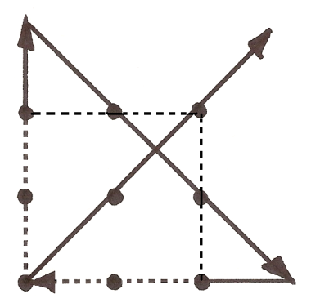
It works best to show them the solution using a blackboard or a whiteboard. If none are available, you can use the PowerPoint slides. [3,4,5,6,7, and 8] See how easy it was?! Almost all of them were working within an imaginary square formed by the eight outer dots, represented by the dotted line in the second figure. [9] Their mental map for solving the riddle (and their useful space on the sheet of paper) are limited to that imaginary square.
Start here
The Solution
Usually, the first reaction to seeing the solution to the riddle is laughter. Then they will start commenting: “You went outside the lines! You went outside the square!” Then you can respond, “What lines? What square? I never said anything about a box or a square or a rectangle.” (When leading this activity, be very careful not to use any word that would give them the idea of a square.) The purpose of this activity is to ask them, “Where did that imaginary square come from that made it impossible for you to solve the riddle?” [10] After a few moments of reflection they will respond:
- “From our childhood.”
- “From primary school.” [11]
- “We were always told to
color within the lines.”
- “We used to do
The Limiting Paradigm
connect-the-dot exercises.”
_{©Depositphotos.com/tuulijuma}

II. How Our Paradigms Can Limit Us
How does this apply to us? In the same way that we acquired paradigms (habits, mental maps) in school that made it impossible for us to solve this riddle, today we have many paradigms in our churches that do not allow us to fulfill the Great Commission. The purpose of Your Church is to identify these paradigms and change them.
ethnic
groups
For example, when Jesus said, “all nations,” the meaning he intended for the word nations [12] falls into the striped triangle in the figure on the left. He meant “ethnic groups,” yet the church tries to understand him from within its imaginary square and thinks he meant “countries.” Another example [13]: If we have no idea how many unreached ethnic groups exist in the world, the word all, in “all nations,” is beyond our capacity to understand.
It would be hard to find a pastor or congregation that says, “We do not obey the Great Commission here!” In their hearts they want to follow God’s word completely. The problem is that their paradigms do not allow them to understand what really needs to be done to finish the Great Commission. Jesus is speaking from the striped triangles and the churches are interpreting his words from within their imaginary square. Jesus is transmitting in FM and they are trying to listen with AM antennas.
all

[14] This activity shows the importance of these paradigm changes and the reason why most people do not fully understand the Great Commission. You can project this text box on the wall [15] and say, “This is how we understand the Great Commission in our churches. Each blank space represents a word or concept that we only half understand. The result of multiplying all these misunderstandings is that 30% of the world’s population cannot hear about Jesus in their own language and culture.”
It is time to play…
“Fill in the blanks!”

Then ______ came to them and said, “…Therefore ___ and make ________ of _____ ______.” Matthew 28:20

The following is an explanation of each word that is left blank.
- Jesus - His name means “savior.” The one who saved us tells us to go. If we understand the word Jesus as merely a name, we do not feel the same impact.
- Go - We do not know where to go. Most of the time people understand: “Go to your neighbor, or go to your co-worker,” instead of really understanding the present situation of the world’s unreached ethnic groups and where they are found. We also do not understand how to go to the ethnic groups because we are unaware of the mission structures that already exist in Mexico. Nor do we know who is supposed to go. The biblical word for missionary is apostle but that word has a different meaning in many churches today.
1/32 is very little understanding!
- Disciples - There is a poor understanding in our churches about the true nature of discipleship, especially as it applies to the different cultures that we find on the mission field.
- All - Most Christians do not know about the ethnic groups of the world - how many there are and how many are still unreached. The word all has no practical meaning for them.
- Nations - People think this means “countries” and the passage loses all significance.
All these misunderstandings multiply, leaving us confused about the Great Commission. A good way to finish this activity is to show the cumulative effect of only half understanding each concept. [16] Have them multiply ½ x ½ x ½ x ½ x ½ =? (You will probably have to remind them how to multiply fractions!) The answer is 1/32! The figure on the left shows how small 1/32 actually is. [17]
Next, we will summarize the paradigms we hope to change with Your Church.
Old Paradigms | New Paradigms | Corresponding chapters in Your Church
Only Jesus spoke about the Great Commission, and only once! | From Genesis to Revelation the Bible reveals God’s plan to glorify himself in all the earth and to reach all the ethnic groups. | Old Testament  New Testament  The Local Church
We read the Bible in small fragments, without sequence or logic. | We will see the Bible as one unified, missionary story, with a logical development from beginning to end. | Old Testament  New Testament
Many Christians have a self-centered spiritual life. | We will become global Christians. | Paradigm Changes
The study of history is boring and irrelevant. | The study of missionaries from other generations is inspiring and gives us a new perspective. | History of Missions
It cannot be done! The task is too big. | We can do it! God has given us the necessary resources. | Missionary Testimony  Needs in Mexico  World Needs  Adopt-A-People
The church exists to take care of the sheep. | The church was born with the command to tear down the gates of hell. | The Local Church  New Testament
Mexico first! | Jerusalem, all Judea, Samaria, and the ends of the earth are simultaneous mission fields. | Needs in Mexico  World Needs  New Testament  Adopt-A-People
The Christians of those countries should evangelize their own people. | There are 7,000 ethnic groups that do not  have Christians or a church to evangelize them. | Definitions  World Needs
We pray for our needs and the salvation of Mexico. | We will also pray for missions among the unreached ethnic groups of Mexico and the rest of the world. | Praying for the World
We are too poor to send  missionaries. | God has given us the resources to do our part in fulfilling the Great Commission. | Financing Missions
By evangelizing in my neigh-borhood I will eventually reach all the people of the world. | We must finance and send well-trained, cross-cultural missionaries to the unreached ethnic groups to overcome the barriers to evangelization. | Definitions
But we do not know how to  do it! | There already exists a missions structure to facilitate the sending of missionaries. | Local Church  Missions Committee  Definitions  Adopt-A-People
III. Paradigms that will Change [18]

IV. From Worldly Christians to Global Christians [19]
In the parable of the sower, Jesus talked about the reaction caused by preaching the gospel. The people represented by the path and the rocks will not be part of our consideration in this chapter,
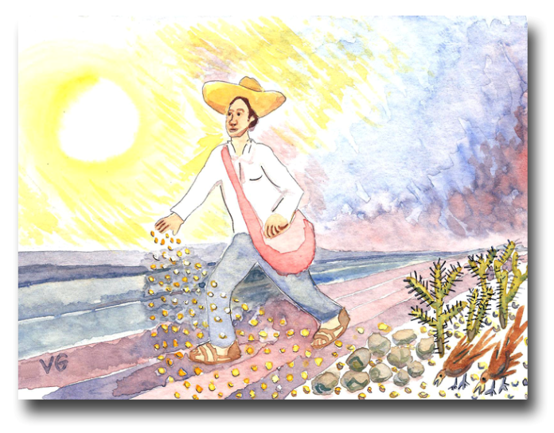
because they would never bother to come to a Missions Saturday! The people represented by the thorns and the good soil are those that are found in our churches, some bearing fruit and some not. We will now direct our attention to these people.
The people represented by the thorns receive the word but “they are choked by life’s worries, riches and plea-sures, and they do not mature” (Luke 8:14). We will call these “worldly Christians.” A worldly Christian is one who accepts the basic message of salvation but whose lifestyle, priorities, and needs are molded by self-interest. This person has experienced salvation personally and knows all his rights and privileges as a Christian - abun-dant life, blessings, joy, love, patience, peace, and eternal life. The danger is that he does not move beyond that.
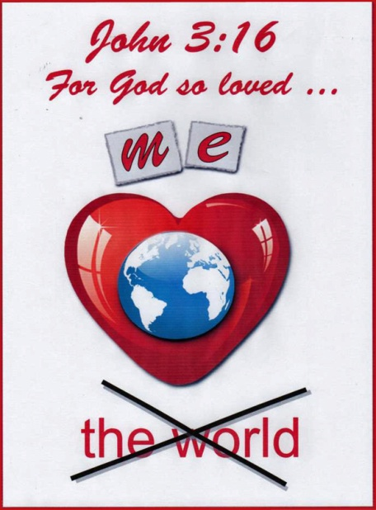
The selfish spirit of our times leads him to seek God and the Bible only for personal blessing and satisfaction. He usually prays for personal needs and sees the Christian faith as a way to get God on his side. [20] The worldly Christian does not worry about evangel-ism or serving others, let alone the Great Commission. He can reject getting involved in missions but the consequences are clear:
- He will find himself sitting on the sidelines instead of playing the game. Being left out means that his life will be ineffective as a child of God. It is less than what God has for him.
- He will lose authenticity as a Christian. He would say that Jesus is his Lord, but at the same time would be failing in a particularly important area.
- He will be poorly prepared for the day of final judgment when our works will be tested by fire, and only the gold, silver, and precious stones will survive (1 Corinthians 3:12-15).
On the other hand, people represented by the good soil produce much fruit - thirty, sixty, or one hundred to one. We will call these people “fruitful Christians.” [21] These are Christians who strive to grow God’s kingdom in both quality and quantity. They obey the will of God as it is expressed in these passages:
©Depositphotos.com/Nelson Marques/Market Olya
- John 15:12,13 - “My command is this: Love each other as I have loved you. Greater love has no one than this, that he lay down his life for his friends.”
The challenge to become a world Christian was adapted from the book:
Bryant, David. In the Gap. Madison,Wis.: Inter-Varsity Missions, 1979

- Ezekiel 33:9 - “But if you do warn the wicked man to turn from his ways and he does not do so, he will die for his sin, but you will be saved yourself.”
- James 5:20 - “Remember this: Whoever turns a sinner from the error of his way will save him from death and will cover a multitude of sins.”
God wants us to love the people of the world just as he does. We must stop thinking only about ourselves and start acting for the benefit of others. Fruitful Christians pour out their lives in prayer for others, both for their salvation as well as their growth in Christ. They evangelize at every opportunity they get; they even go out of their way and out of their comfort zone to start new works. Only when we get to heaven will we really know how much fruit they have produced with their lives.
_{©Depositphotos.com/Pakowacs}
There could be many fruitful Christians who have made this commitment to Jesus, focusing their lives on the needs of others instead of their own needs, but even that is not enough to fulfill the Great Commission. Even a fruitful Christian needs to change many of his paradigms to become a “global Christian!” [22]
We could define a global Christian as the following…
A global Christian is a fruitful Christian (one who produces fruit thirty, sixty, and one hundred to one) who has extended his or her faith, prayers, finances, and ministry to advance daily the kingdom of God among the unreached ethnic groups of the world.

©Depositphotos.com/Nelson Marques

As global Christians, we extend our vision, open our minds and hearts, and understand the greatness of God in a way that we had never experienced before. Focusing our attention outwards and growing daily as global Christians is not an option. Knowing the needs and the opportunities in the world in the same way that God does is an important part of our identification with him. Just like Peter in Acts 10, we will find God using us in ways that surpass our understanding. If we are open to God and break out of the old paradigms, we can launch into a great adventure as global Christians.

V. How to be a Global Christian
Even though global Christians would say that the Holy Spirit inspires a cross-cultural missions vision, there are some disciplines we must practice to keep the flame burning. [23]
A. Have intimate communion with the Lord. - For global Christians, life begins with God, not with the world around us, not even with the tremendous needs for world evangelization. Their intimate relationship with God produces an outpouring of love and concern for all peoples.
B. Take on the Great Commission personally as your life’s purpose. - Why not? Is there something better you could do with your life? Will we say to God, “Here I am, send me,” or will we say as Moses did at first, “Oh Lord, please send someone else!” (Exodus 4:13)? We are not saying that all global Christians need to go personally to the mission field. God will indicate to each and every global Christian whether he or she could have more impact by going or by serving those who go.
C. Cultivate the missions vision. - No one can say that he or she has received all that God has for them, and this is true for global Christians. We have to cultivate that vision by reading books about missions, attending missions events, studying maps and statistics, serving in some missions ministry and attempting ever bolder projects in order to fulfill the Great Commission.
©Depositphotos.com/Vladimir Gorban

D. Impact the world every day. - Every day we should pray for some missionary or for some unreached ethnic group. Every day we should try to save money for the Great Commission, even if it is just a few coins. Every day we should become more involved in missions projects. This becomes a habit, like dressing or eating.
E. Spread the vision. - On the one hand, we have to commit ourselves to the Great Commission as though we were the only obedient people on earth. On the other hand, we have to realize that we cannot do it alone. We need to share the missions vision with other fruitful Christians so they also become global Christians.
The first step for launching into this missionary adventure is to study this simple course that you have in your hands. [24] You can impact this world for Jesus! Your Church Can Change the World! Are you ready for a great adventure? On your marks…get set…
©Depositphotos.com/Yuriy Tikhonovskyy

Juan 3:16

For God so loved …

the world

©Depositphotos.com/Nelson Marques/Market Olya
©Depositphotos.com/Nelson Marques ©Depositphotos.com/Market Olya

