After studying this chapter, the participant will be able to show:
The Goal
- That the basis of the Bible is missions,
- how to apply good methods of biblical interpretation,
- that God gave the Great Commission in the Old Testament,
- that this was the reason for choosing Israel, and
- that God had various missionary strategies throughout Israel’s history.
©Depositphotos.com/Maksim Hintau
I. World Missions – The Basis of the Bible
Try asking this question to your listeners to start teaching this chapter: “What is the Bible all about?” [Slide #1 of the PowerPoint] They will respond with a flood of ideas, including God in three persons, his nature, his will, man, sin, good and evil, salvation, all the various ministries, angels and demons, and the church, among many other things! You could respond, “Absolutely, the Bible does talk about all these things, but if we consider it as one unified book, what is its story? In just a few words, what is the plot?”
_{©Depositphotos.com/julydfg}
God
Saving
Mankind
After thinking for a moment, they usually say something like, “God saving mankind through Jesus Christ.” [2] This summary is quite true, and all the churches arrive at this same conclusion. But this is just a theological or spiritual summary of the Bible. It does not capture the movement and the action of the Bible story, and therein lies one of the inadequate paradigms in our churches.
In the Bible, people are almost always presented as part of an ethnic group, and to reach these men and women God is always undertaking some sort of missionary project. A more precise summary of the plot of the Bible would be: [3]
The Bible tells the story of a missionary God and his strategy to take the gospel of salvation to all the ethnic groups of the world.

Many would say that cross-cultural missions are just one more among the many ministries of the church, such as Sunday school, worship, evangelism, youth, or men’s ministries. All these ministries are based in the Bible, but God’s mission to reach all the ethnic groups of the world is the basis of the Bible! For example, the tree of life disappeared from the Bible text after the fall of man but reappears in Revelation 22:2: “And the leaves of the tree are for the healing of the nations (ethnic groups).”
Collage by Jill Suzanne Hatcher

Here is a fun activity that will help emphasize this truth. [4] Start by mentioning the various ministries of the church and have the participants give you a Bible verse that serves as a basis for each ministry. On the left our master of ceremonies will explain how to direct this activity. It is fun and effective. It is important to remind them that each of these ministries is based in the Bible, but we will see that the missionary story is the basis of the Bible.
I am going to name various ministries in the local church, and you are going to give me a Bible verse that could serve as its basis. Ready?
Sunday School…
Counseling…
Worship…
Discipleship…
It is time to play…
Biblical Basis!

II. Good Methods of Bible Interpretation [5]
Before opening the Bible, we want to remember three important points for good biblical interpretation, which will help us discover this unifying missionary story in the whole Bible:
- The context of the passage,
- the motivation of the characters in the Bible story, and
- that the Bible should be seen as one unified story, developing logically from beginning to end.
A. The context of a passage is an especially important factor for understanding the full meaning of the text. [6] Pastors often preach sermons about Naaman the Syrian. They investigate in detail every aspect of Naaman’s personality, disease, and conversion, and rarely mention the brave young missionary girl who “went” to Syria and testified to Naaman’s wife.
A pastor once asked a member of COMIMEX, “How is it that you guys see missions on every page of the Bible?” He responded, “We give the proper importance to the context of the Bible stories, seeing the great missionary effort behind each meeting of individuals as an example for us to follow.”
We could use the 007 movies as an example. How many James Bond movies have there been? Twenty-five and count-ing! And each one has about the same plot:
- A rich bad guy wants to take over the world with some new secret weapon,
- they assign 007 to the case,
- he first goes to the shop for some new spy equipment,
- the bad guy catches 007 and is going to kill him,
- 007 takes out his new equipment and saves himself, and then …
- 007 saves the world!
007 teaches us
that the context
is important!
In 50 years they have not deviated from this plot, but people keep going to see whatever new adventure they will come up with next. Why? Because of the exotic places where the spy adventures unfold, in other words, the context. The context of the James Bond movies is the best part; we already know how the story will end before we even buy the ticket! Many of the Bible stories unfold in a completely missionary context, and that is an important part of their teaching and aplication.
B. The biblical characters (including God himself) frequently reveal the motivation in their hearts which causes them to act. [7] The motivation behind an action is a particularly important part of interpreting the act itself. We can often determine this motivation by noting the words so that (or that), as we see in the example of Psalm 67:1, 2: “May God be gracious to us and bless us... that your ways may be known on earth, your salvation among all the nations.” If we are attentive in looking for the biblical characters’ motivation, we will find that many passages fit into a great missionary plan. Let us consider the story of David and Goliath and ask ourselves, “What was the motivation in the courageous heart of young David?”
…and the whole world will know that there is a God in Israel!
C. If we are not aware of its basic missionary theme, the Bible might seem like just a collection of stories with no logic or continuity. What does King Darius have to do with the tree of life? What does the tower of Babel have to do with Mount Sinai? But if we look at the Bible through missionary eyes, we begin to see a wonderfully unified story. [8] All the events are connected. We even discover the elements of a fine piece of literature: an introduction, protagonists, antagonists, plot development, climax, resolution, and epilogue.
Now, with this basis for good biblical interpretation, we will take an exciting trip through the Old Testament to discover the story of God’s missionary plan.
III. Genesis 1-11: The Biblical Drama Unfolds [9]
As in the beginning of any story, the protagonists come out onto the stage. The Bible begins with: “In the beginning God created the heavens and the earth.” At the end of the creation story, God introduces the second protagonist, man. Chapter two ends with them enjoying a perfect relationship in an earthly paradise; a beautiful story begins with the hope of a happy ending.
©Depositphotos.com/Margaret Grissom
But in chapter three we are introduced to the antagonist, the serpent! If this were a movie, the music would change to a minor key as Satan slithers onto the stage. He contradicts God’s words and causes Eve to doubt him. All the universe and the heavenly host hold their breath to see what will happen next! Then the unimaginable happens - mankind disobeys God and falls into sin. Adam and Eve are expelled from the garden and forbidden access to the tree of life. The drama between God and Satan is established, and at this point it looks as though Satan is winning. A series of failures follows, making the situation look even more desperate.
- Human history starts with Cain and Abel, and after offering sacrifices to God, Cain kills Abel.

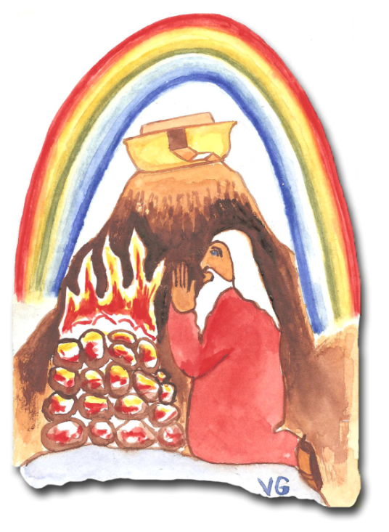
- Evil increases among men, reaching that sad commentary on human behavior in Genesis 6:5.
- In response to this situation, God judged humanity, sending the flood. It would appear that the story was finished and the devil had definitely won.
- Noah and his family leave the ark [10], offer sacrifices to God, a rainbow appears in the sky, and God establishes a pact with humanity. It seems for a moment that there are hopes of a new beginning, but no! Noah gets drunk and there are even indications of sexual sin (Genesis 9:18-24).
- The story continues up to the tower of Babel in Genesis 11. The desperate situation of man’s evil and his rebellion against God reaches a climax when God exclaims in verse 6, “Then nothing they plan to do will be impossible for them.”
One can feel the tension in the story as Satan appears to gain the victory again. He ruined paradise and caused man to rebel against God to the point where God annihilated mankind almost completely, and now they are provoking God again with their rebellion. What will God do?

IV. God’s Solution [11]
The story of the tower of Babel is one we always assign to Sunday school as though we gave it little theological importance. We give them a picture to color with their crayons. But in reality, it is the beginning (the first half) of God’s missionary strategy for the ethnic groups of the world! Let us analyze each verse to understand its importance.
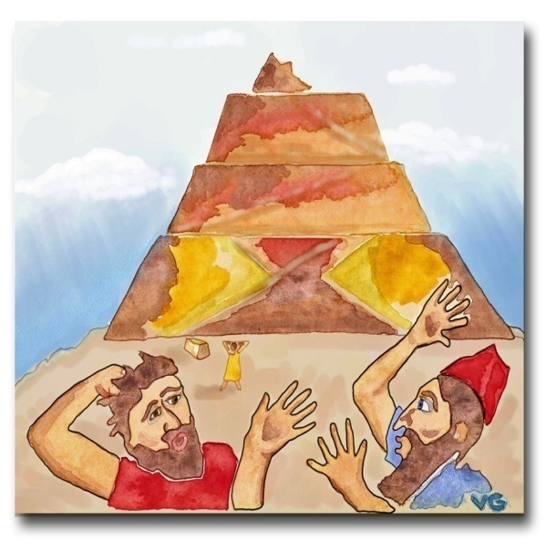
A. Note in Genesis 11:1 that the world’s population had the same language. In other words, it was one ethnic group. This unity is represented by the first circle on the following page in which all the people have access and commun-ication with each other. [12]
B. Verse 3 represents the technological advances of man, which, in and of themselves, do not imply anything evil. Humanity is now more sophisticated. [13]
C. Analyze verse 4 carefully with the class, asking questions like the following:
- Why would they want to build such a tall tower?
- What attitude can you detect in the words: “So that we may make a name for ourselves”? (Pride, rebellion, disobedience, arrogance, etc.)
- God had ordered them to fill the earth in Genesis 1:28 and now they say, “And not be scattered over the face of the whole earth.” What attitude does this demonstrate? (Disobedience.)

Humanity, unified and with new technology, is rebelling against God in a more premeditated and sophisticated way. Up until then man’s sins had been low and vile in nature, but now they are making architectural blueprints to sin against God!
D. In verse 6 God comments on the tower, saying, “Then nothing they plan to do will be impossible for them.” (Read this verse with feeling to emphasize just how frustrated God is!) After only a short time mankind is once again provoking God to anger and judgment. God notes that the problem of their unity is due to speaking the same language. They are cooperating in their evil-doing.
Humanity in
Genesis 11:1
E. God provided a solution in verse 7 when he said, “Come, let us go down and confuse their language so they will not understand each other.” [14] Suddenly they left their work on the tower and could no longer cooperate in their evil against God. In this creative act God formed the many ethnic groups of the world. The story of the tower of Babel is not just a fable made up to explain the existence of ethnic groups, but rather a strategic act of God to avoid and postpone his judgment and initiate his plan of redemption. This new situation can be represented in the second figure where the men are separated from one another.
F. This was only the first half of the solution, breaking up the unity of these stiff-necked people. But now, how will God reach all these ethnic groups? This situation is much more complex. The rest of chapter 11 focuses on the descendants of Shem (the Semites), verse 17 mentions Eber (from whom we get the Hebrews), and the chapter ends with Abram.
Humanity after
Genesis 11:7
It is important to note here the stark contrast between Genesis 11, where God divided humanity into many ethnic groups, and Genesis 12, where he chose his people. This is so important that Moses placed the three genealogies of chapter 10 before chapter 11, when they should have come after! Chapter 10 says three times, “Each with its own language” (verses 5, 20, and 31). How can there be different languages in chapter 10 when 11:1 says that the whole world had only one language? Moses related these events out of sequence in order to put the division of the ethnic groups in chapter 11 right next to the choosing of Israel in chapter 12. Now let us see the second half of God’s solution and his purposes for choosing his people.
Pastoral Purpose:
- I will make you into a great nation
- I will bless you
- I will make your name great
- I will bless those who bless you
- Whoever curses you I will curse
Missions Purpose:
- You will be a blessing
- and all peoples on earth will be blessed through you.
G. Genesis 12:1-3 recounts a decisive act in Israel’s history, the call of Abram, the birth of God’s chosen people. [15] What a privilege to be in Abram’s family - to be chosen by God to know him and follow him. We see in this text box that this calling included both pastoral and missionary purposes.
The word peoples in Hebrew carries the idea of ethnic groups (see the text box below). Here we see that in the calling of God’s chosen people his purposes for Israel are explicitly declared: To pastor them and to use them to bless all the ethnic groups of the earth. [16] Now we can finish the figure which represents God’s missionary strategy unfolding throughout the whole Bible - divide humanity into many ethnic groups, choose one of these groups, Israel, and through them bless all the other ethnic groups of the world!
We will see that in each period of Israel’s history God expressed his missionary purpose again, and on many occasions he did it during the precise ceremony that marked the beginning of each new period. He used different missionary strategies depending on the historical situation and the willingness and obedience of his people.
The Purpose of Israel in Genesis 12:3
It is striking to note God’s first word to his chosen people in Gen. 12:1: “Leave.”
Jesus’ last word: “Go.” We are a people called to travel!
V. The Period of the Patriarchs
This calling, or pact, was repeated to Abram, Isaac, and Jacob on various occasions, and it is important to note the way the words peoples and nations are interchanged. [17] In the box below you will see the usage of the Hebrew words goy (nations) and mishpacha (tribes). Neither of these words implies the concept of a nuclear family unit made up of just the father, mother and their children. Israel’s missionary purpose is declared in these ceremonies throughout this entire period.
Patriarch Text Hebrew English
Abram 12:2 goy a great nation (Israel)
12:3 mishpacha all the peoples of the earth
18:18 goy a great and powerful nation (Israel)
18:18 goy all nations on earth
22:18 goy all nations on earth
Isaac 26:3,4 goy all nations on earth
Jacob 28:14 mishpacha all peoples on earth

VI. The Exodus [18]
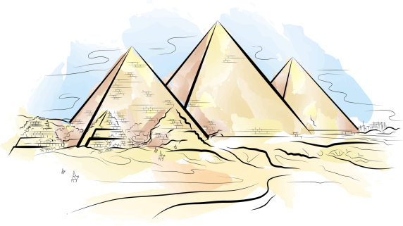
The exodus is an important, formative event in Israel’s history and God was always referring to this event to remind them of his love and power. We rarely stop and ask ourselves why God predestined these events to include a famine in Canaan, seeking refuge in Egypt, slavery, the plagues, and the exodus. Would it not have been easier to have Israel grow to two million people in some protected corner of the Arabian Peninsula without so many problems?
©Depositphotos.com/Liubov Bunakova
The explanation comes in Exodus 9:13-16 where God gives Pharaoh a message through Moses: “So you may know that there is no one like me in all the earth...But I have raised you up for this very purpose, that I might show you my power and that my name might
be proclaimed in all the earth.” God includes the rest of the Egyptian people in 7:5 and 14:18 when he says, “And the Egyptians will know that I am the LORD.” God arranged these events with the purpose of declaring his glory in all the earth, starting in Egypt. Observe how this worked when Jethro, Moses’ father-in-law from the people of Midian, received the people of Israel in chapter 18 after they had left Egypt with great signs and wonders. He ended up sacrificing burnt offerings to God. Jethro was the priest of Midian; certainly he established the worship of the one true God within that people group.
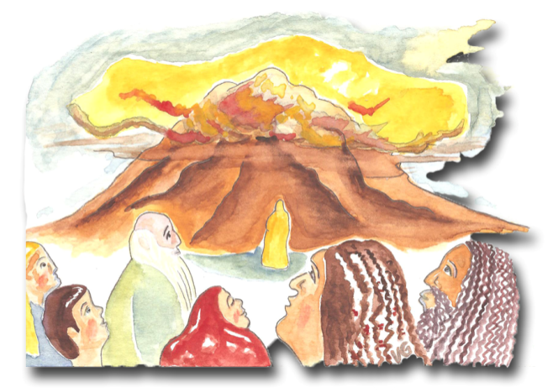
VII. Mount Sinai [19]
This story tells of the spiritual formation of Israel at Mount Sinai. Note how God emphasizes his missionary purpose for Israel in the solemn pact he makes with them in Exodus 19:5, 6. We know that the function of a priest is to represent God to the people, and the people before God, as shown in the diagram on the left. [20] (It is interesting to remind the class that in the Christian church we no longer have priests because we now have a direct relationship with God through the new covenant.)
But here God says something incredible, “You will be for me a kingdom of priests and a holy nation. These are the words you are to speak to the Israelites.” God is speaking to all the Israelites, not just to the tribe of Levi. If all the people of Israel function as priests, before whom are they going to represent God? The answer is the rest of the ethnic groups of the world! In this light, God’s words have more meaning: “Out of all nations you will be my treasured pos-session. Although the whole earth is mine...” God strongly declared his missionary purpose for Israel in this formative act. Psalms 67 dramatically demonstrates Israel’s priestly function over all nations.
Kingdom of priests
(the Israelites)
The rest of the ethnic groups of the world
Priest
God
God
Exodus 19:6
General definition
The people
VIII. The Conquest [21]
In Joshua a new era in Israel’s history begins, and as has been the pattern, it is marked with a solemn ceremony in which God’s missionary purpose through Israel is once more announced (Joshua chapters 3 and 4). There were several ways to cross the Jordan River.
God could have taught the people how to swim or, better yet, he could have given them plans for making a bridge, just like he gave Noah for the ark!
But God acted in a way that would bring glory to himself in the eyes of the Israelites as well as the rest of the world. Joshua explains the miracle in 4:24: “He did this so that all the peoples of the earth might know that the hand of the LORD is powerful (missionary purpose) and so that you might always fear the LORD your God” (pastoral purpose). Notice how the words so that reveal God´s missionary motivation.
Project: Jordan River Bridge
Date: 1400 B.C. Architect: God
©Depositphotos.com/Slobodan Djajic

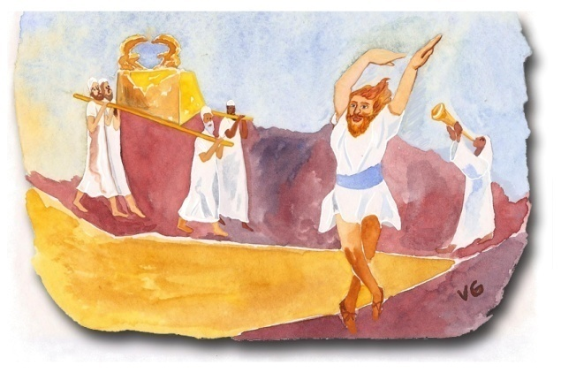
IX. The Ark Enters Jerusalem [22]
Here we have another ceremony marking the beginning of another period in Israel’s history, but this time it is a happy occasion! David dances with all his might before the presence of the Lord. We so often study this passage with an emphasis on music, dance, and worship, but rarely do our churches note the words of David’s song. Eight of the thirty verses of the song mention a global missions vision! Read 1 Chronicles 16.

X. Israel – “In the Center of the Nations” [23]
The fact that the people of Israel had a priestly function with respect to the nations of the earth is reflected in their strategic location. Ezekiel describes the importance of their location in great detail in Ezekiel 5:5-17 (note especially verses 5, 8, and 14), in Ezekiel 20 (note verses 9, 14, 22, and 41), and in 28:25. God says repeatedly, “I have set you in the center of the nations,” and, “in the sight of the nations.” This strategic location allowed Solomon to acquire his great riches, as described in 1 Kings 9:10-28 and 10:14-29.
Important trade routes went from the Euphrates Valley around the desert to Egypt, and between the seaports of Tyre and Sidon (with all the commerce of the Mediterranean Sea) to the kingdoms of the Arabian Peninsula. Israel was right at the intersection of these busy trade routes!
This understanding resolves a great enigma of the Old Testa-ment, God’s apparent cruelty towards the ethnic groups that inhabited the Promised Land. God wanted to establish his people in this well-transited land, and he waited until the behavior of the peoples who lived there reached the point where they deserved a complete judgment. The key is found in Genesis 15:16 where God said to Abram 400 years earlier, “For the sin of the Amorites has not yet reached its full measure.”
Israel
“…in the center of the nations.”
Ezekiel 5:5
Cush
Egypt
Sheba
Babylon
Phoenicia
Medo-Persia
Hittite
Greece
Rome
(Desert)
Edom
Syria
Assyria
Leviticus 18 describes the detestable practices of the Canaanites and the Egyptians of that time. (The greatest secret in the universities is the perversity of these ancient cultures!) God waited patiently for centuries until these peoples deserved judgment. God warned the Israelites that if they adopted those same practices, the land itself would become defiled and “it will vomit you out as it vomited out the nations that were before you” (Leviticus 18:28).
If we look at all the war, we could get the wrong impression that God hated non-Jewish peoples. In reality, God limited his wrath to seven ethnic groups, for a specific time period and for a specific purpose - to establish a missionary strategy “in the center of the nations.” This analysis will serve as the background to how Solomon’s temple functioned in God’s strategic missions plan.
XI. The Dedication of Solomon’s Temple [24]
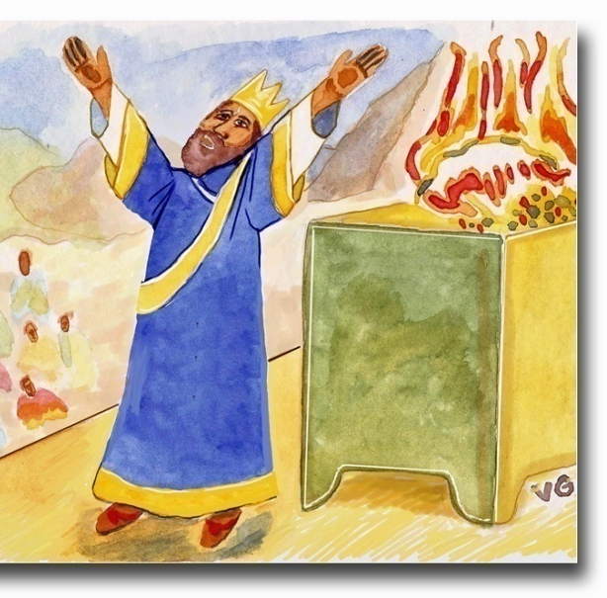
Here we find another solemn ceremony marking the be-ginning of a new era, the worship in Solomon’s temple. The climax of this great celebration comes in 1 Kings 8 when Solomon offers his prayer of dedication. He shows God’s missionary strategy in verses 41-43 when he intercedes for “the foreigner who... has come from a distant land because of your name,” asking God to answer the prayers of the foreigner, “so that all the peoples of the earth may know your name and fear you, as do your own people Israel.” After his prayer, he preaches to the crowd, mentioning the same missionary purpose in verses 59-61.
In chapter 10 we see the answer to this petition - the queen of Sheba comes from faraway lands “to test him with hard questions” (verse 1) and she “talked with him (Solomon) about all she had on her mind” (v. 2). She was overwhelmed at Solomon’s wisdom and wealth, including the worship in the temple (v. 5) and exclaimed, “Praise be to the LORD your God!” (v. 9). The queen of Sheba was not the only person converted through this missionary strategy. We also read in 10:23, 24: “The whole world sought audience with Solomon to hear the wisdom God had put in his heart.”
Solomon’s wisdom was renowned among the “men of all nations” (1 Kings 4:29-34), and he was warned that his disobedience against God would cause Israel to be ridiculed “among all peoples” (9:1-9). It is interesting to imagine how it would have been for these foreign travelers from distant lands. They would have to travel through pagan lands the likes of Sodom and Gomorra, fearing for their lives and seeing all the idolatry, temple prostitutes, and human sacrifices to pagan gods. Suddenly they would find themselves in Israel where people would welcome them with “Shalom!” and where there were no idols but only pure worship in the temple. Instead of being the Great Commission, which we will see in the New Testament, it was the Great Invitation: “Come to Jerusalem to know the one true God!” It was a very effective missionary strategy!
Chapter 10 of 1 Kings (especially verse 24) is the climax of the Old Testament. The kingdom of God is united, holy, and prosperous, and the whole world was coming to Jerusalem to know the one true God through Solomon. It seems impossible, but all this missionary strategy fell apart within a very short time. According to 1 Kings 11, Solomon fell into the worst kind of idolatry only five verses later!

XII. The Divided Kingdom [25]
God did not give up despite Solomon’s failure and bad testimony. This period of Israel’s history is full of missionary encounters that show how our missionary God was still working.
A. The widow of Zarephath - God sent Elijah to the region of Tyre and Sidon to minister to someone from another ethnic group, as we see in 1 Kings 17. The widow of Zarephath received the prophet and his word and was converted (verse 24). Jesus referenced this missionary event in Luke 4:16-30 as he began his public ministry, confronting the Jews for having failed in their missionary purpose.
B. Naaman the Syrian - During a period of idolatry in Israel, God sent a young Hebrew girl to the land of Syria. She was faithful in her testimony and was the instrument God used to arrange the meeting between Naaman and Elisha (2 Kings 5). Naaman, now converted, takes two donkey loads of dirt from Israel to establish worship of the true God in Syria (verses 17-19). Jesus also refers to this event in Luke 4.
C. Hezekiah and the Assyrians - In his prayer for the rescue of Jerusalem, King Hezekiah recognizes that a miracle would bring glory to the LORD among “all the kingdoms on earth” (2 Kings 19:14-19).
©Depositphotos.com/Jonathan Tichan
D. The Psalms [26] - The missions vision in the Psalms, par-ticularly Psalms 2, 67, and 96, is noteworthy. A more complete list of Psalms with a missionary emphasis is as follows: 18, 22, 33, 46, 47, 49, 57, 65, 66, 72, 82, 86, 87, 98, 99, 102, 105, 108, 113, 117, 126, and 148. There are many more which you will discover in your own reading. While reading, pay attention to the words nations, peoples, and the phrase all the earth. A lot of the songs we sing at church repeat the missionary vision using the Psalms and the prophets.
E. The Prophets - The prophets spoke frequently about God’s missionary heart. The following passages are a small sample:
- Isaiah [27] - 2:1-5; 11:9; 12:1-6; 14:1,2,26,27; 18:7; 19:18-25; 24:14-16; 25:6-8; 27:6; 37:14-20; 42:1-12; 45:22; 49:1-7; 51:4,5; 52:7-10,15; 55:3-5; 56:1-8; 60:3; 61:11; 62:2,10; 65:1 and 66:18-24, to name just a few!
- Jeremiah [28] - 1:5; 3:16,17; 4:1,2; 10:3-11; 12:14-17; 16:19-21 and 33:6-9.
- Jonah [29] - In this book we study many interesting themes, including disobedience, the sailors’ idolatry, the size of the fish, the possibility of surviving for three days inside a fish, and the meaning of the vine and the worm, without appreciating that the context was a missions trip! The lesson for the church today is that, like Jonah, we resist the command to go to the unreached.
The Great Fish
A new travel agency
for rebellious missionaries!
_{©Depositphotos.com/}
_{Matthew Cole/Daniel Cole}
- Habakkuk 2:14 [30] - “For the earth will be filled with the knowledge of the glory of the LORD, as the waters cover the sea.”

XIII. The Exile [31]
Israel reached such a degree of idolatry that God had to punish them with the exile to Babylon, but he still maintained his missionary zeal, working from a new base of operations. God is a missionary God, and he simply changed his strategy to take into account this new situation. Let us look at some examples.

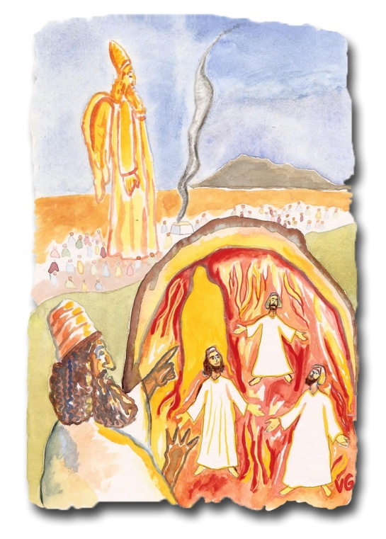
A. Nebuchadnezzar’s first dream - In Daniel 2, God shows this pagan king that He is the sovereign who establishes or removes empires, and that the “the rock that struck the statue became a huge mountain and filled the whole earth” (verse 35).
B. Shadrach, Meshach, and Abednego - In Daniel 3 we find another solemn ceremony, but here God is interrupting a pagan ceremony! Nebuchadnezzar wants to consolidate his empire, requiring representatives from all the conquered peoples to worship a statue he erected. Verses 4 and 7 show that “peoples, nations, and men of every language” were present. After the miraculous rescue, Nebuchadnezzar decrees that “the people of any nation or language” must not say anything against the one true God - a missionary message from the mouth of a pagan king! In our churches we only read up to verse 27, missing God’s missionary purpose in verse 29!
C. Nebuchadnezzar’s second dream - After his encounter with God in Daniel 4, the king sends his testimony “to the peoples, nations and men of every language, who live in all the world” (verse 1), recognizing that God is sovereign over all the kingdoms and individuals of the earth (verses 17, 25, and 34-37).
D. Daniel in the lions’ den [32] - The Babylonian Empire was conquered by the Medes and Persians and King Darius threw Daniel into the lions’ den. After seeing the miracle, the king sent forth an ordinance to “all the peoples, nations and men of every language throughout the world” declaring God’s greatness (Daniel 6:25-28). The laws of the Medes and Persians could not be repealed (6:12). The seriousness of these ordinances and the way they were translated for “all... men of every language throughout the world” can be seen dramatically in Esther 3:8-15 and 8:7-10.
_{©Depositphotos.com/Aleksander1}
E. Daniel’s vision in the night - In Babylon, God gave Daniel a vision of “all peoples, nations and men of every language” serving Jesus (Daniel 7:13, 14).

XIV. The Restoration [33]
The prophet Ezekiel was taken captive to Babylon with the first group of exiles. There he preached a hard message, because Israel had not fulfilled its purpose of glorifying God in the midst of the nations (see section X).
When at last the news arrived that Jerusalem had fallen, he began to prophesy about the restoration of Israel. Ez. 36:16-38 contains the famous passage about the change of heart from stone to flesh, but before this passage (verses 20-24) and afterwards (verse 36) God reveals his motivation for all these promises: “Then the nations will know that I am the LORD.”
In Ezekiel 37:15-28 God promises to unite Judah and Joseph under a single king (verse 28), and reveals his motivation: “Then the nations will know that I the LORD make Israel holy.” Looking toward a distant future, Ezekiel prophesies in chapters 38 and 39 against Gog, and in 39:26-29 God once again reveals the motivation behind his actions: “I will show myself holy to them in the sight of many nations.”
God has a missionary purpose in his dealings with Israel during the restoration. The prophet Zechariah said, “In those days ten men from all the languages and nations will take firm hold of one Jew by the hem of his robe and say, ‘let us go with you, because we have heard that God is with you’” (8:23). Haggai prophesied the coming of the Messiah calling him “the desired of all nations” (2:6-9).
Sadly, the Old Testament ends with a reprimand against Israel for having failed in its missionary purpose. [34] God says to them in Malachi 1:11, “My name will be great among the nations, from the rising to the setting of the sun. In every place incense and pure offerings will be brought to my name, because my name will be great among the nations…” But then He says directly to Israel, “But you profane it [my name] by saying...”

XV. The 400 Years between Malachi and Matthew [35]
This span of time is commonly referred to as “the silent period” because there were no great prophets bringing forth God’s word, but God was preparing the world to receive the seed of the gospel.
The Jewish Diaspora was a consequence of the conquest of Israel by the Assyrians and of Judah by the Babylonians, leaving Jewish communities scattered throughout the whole Roman Empire.
Several centuries before the New Testament, the Greek language was established as the trade and cultural language in the whole region, and the Old Testament was translated into Greek. When Paul began his missionary journeys he could take his Old Testament in Greek and preach in any city among the Jewish communities. This enabled him to overcome the cultural, linguistic, and social barriers (see page 37) and contributed to the rapid growth of the gospel.
Also during this time the Roman Empire was established all the way from England to the Persian Gulf. This allowed Paul to travel over modern Roman highways and in Roman ships with his Roman passport. During the silent period between the Old and New Testaments, God was ordering the historical events to promote his missionary purposes.
In the New Testament we will find this same missionary God working with the church to glorify himself in all the earth and reach all the nations with the message of salvation!

