The Goal
The purpose of this teaching is for the participants to learn the meaning of the words and concepts that are essential for fulfilling the Great Commission - words like nation (ethnic group), country, reached ethnic group, unreached ethnic group, 10/40 Window, evangelism, missions, apostle, missionary, mission agency, and culture, among others.

I. A Fun Activity [Slide #1 of the PowerPoint]
Many people will not understand the need to study a theme entitled “Definitions.” This activity will show them the importance of having a technical vocabulary in order to accomplish a difficult task, and fulfilling the Great Commission among the 7,000 unreached ethnic groups is a huge, difficult task!
©Depositphotos.com/Michael Brown
©Depositphotos.com/corneliap/Emir Semik/Khoon Lay Gan
Ask for a volunteer who has some kind of technical vocation. Ask them to share some of the technical words that they use every day at work. It is fun to show the group some of the misunderstandings that can happen if we do not use those words correctly! If a carpenter says the word nail you could say, “Maybe you could do my wife’s nails, the place where she usually gets her manicure just raised their prices!” If a dentist talks about a bridge you could say something like, “We need more bridges in this city. The traffic is terrible!”
The idea is to show that every area of work or study has its own technical vocabulary; how much more the Great Commission!? Here we find one of the most inadequate paradigms - the incorrect use of many key words, which prevents an effective understanding of the Great Commission.

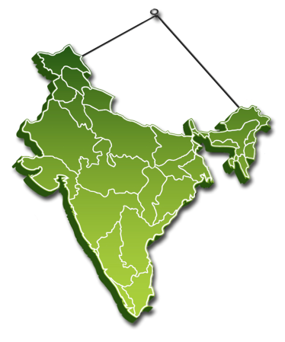
II. The Most Important Word – Nation [2]
When Jesus said, “Therefore go and make disciples of all nations” (Matthew 28:19), the great majority of Christians think they are obeying this commandment. They would say something like this: “Jesus told us to disciple all the countries in the world, and my country is Mexico. I will stay here. I am obeying the Great Commission. End of discussion!” Nothing could be further from the truth.
_{©Depositphotos.com/John Takai}

When Jesus said to make disciples “of all nations,” he used the Greek word ethne [3], which in English is best translated “ethnic groups.” [4] He wants us to plant the church in every ethnic group (nation), not just every country. What is the difference between a country and an ethnic group?
Imagine a ceramic map of India hanging on the wall. [5] Suddenly the map falls on the floor and shatters. [6] Now, which of the images best represents the spiritual reality of India - the map in one piece, neatly organized into its political states, or the mess on the floor? Biblically speaking, it is the mess on the floor! In India there are approximately 3,000 different tribes, castes, and dialects, each one separate from the others, like the fragments of the map all over the floor. According to the biblical meaning, these fragments are nations. Let us study this idea with the chart on the next page. [7]
Country: A large group of people ruled by a government, living within a geographical boundary, divided politically into states, and with a national flag, a common currency, an army, and a national anthem.

India:
one country

India:
3,000
nations!
(ethnic groups)

400 ethnic groups
with a church

2,600 ethnic groups
without a church

Nation
(ethnic group): A large group of
people with a strong, unique identity
because of their common history,
religion, language, caste, race, culture,
geography, social class, migrations,
or some combination of these factors.

©Depositphotos.com/Viktoria Protsak/John Takai
There are many words in the Bible that express the idea of ethnic groups: nations, Gentiles, peoples, tongues, families, tribes, and race. [8] The concept of countries as we know them today did not exist in Bible times; they were ethnic groups conquered by great empires. In books and videos about cross-cultural missions you will also see the terms people groups and ethno-linguistic groups. In this book we will continue to use the phrase ethnic groups.
I will name different groups of people and you will tell me if they are a country or an ethnic group. Ready?
Mexico…, Zapotecs…, China…, Kurds…, Guatemala…, Berbers…

It is time to play…
Country or Ethnic Group?

You will find that people already have a fairly good understanding of the difference between a country and an ethnic group. What they do not know is that when the Bible uses the word nation, it is referring to ethnic groups. To emphasize this idea, it is fun to play the game described on the left. [9] It is important that the participants understand that everyone is part of an ethnic group, not just the indigenous or tribal peoples. You can finish this part by mentioning that there are about 222 countries in the world, but about 24,000 ethnic groups! [10]
Country
Ethnic
group

III. The Importance of Thinking in Ethnic Groups
When Christians read the Great Commission in the Bible, they almost always try to obey it by doing local evangelism. They do not have the correct paradigms that allow them to get involved effectively in world missions. They think the world’s population is one great ocean of people! [11] With this mentality, they think that by evangelizing their family, friends, and neighbors, they are starting a perpetual chain of conversions which will eventually reach everyone in the world, like a virus spreading across the globe.
©Deposithotos.com/Nelson Marquez
The
Wrong Paradigm
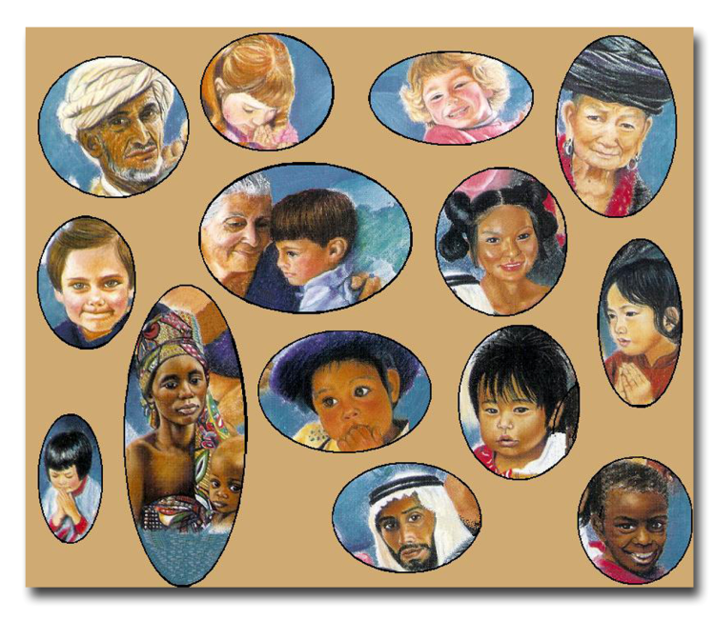
The favorite metaphor for this idea is like when you throw a stone into the ocean - the ripples will eventually reach all parts of the world. This metaphor might preach well in a sermon, but it has nothing to do with reality!
The world’s population is not one great ocean of individuals, but a series of many lakes filled with individuals - about 24,000 lakes to be exact! [12] You can throw a stone into one of these lakes, but the ripples will only reach the other side of the same lake. In the same way, local evangelism works well within an ethnic group, but is not sufficient for reaching those in another ethnic group. Therefore, every ethnic group that does not have a church requires a missionary effort from ethnic groups that do have churches.
Collage by Jill Suzanne Hatcher
The Correct Paradigm
The following is another definition of ethnic group, from a strategic perspective:
An ethnic group is the largest extension of a group of people through which the gospel can spread without encountering barriers of understanding or prejudice.

Has the church
been planted
in India?

Let us go back to the case of India. Has the church been planted in India? We have to ask the question: “Which India?” The 3,000 ethnic groups in India are isolated from one another. About 400 ethnic groups in India already have a church. Some tribes are over 97% Christian! But it is not easy for these 400 groups that have a church to reach the other 2,600 groups that are isolated from them by language and cultural barriers. Each one of these 2,600 ethnic groups requires its own team of cross-cultural missionaries to learn the language and customs to help them establish a church.
©Depositphotos.com/Viktoria Protsak/John Takai
Within an ethnic group, the gospel does spread like a virus through social contacts based on communication, understanding and trust. But when the gospel comes into contact with a different ethnic group, the process simply stops because there is no communication, understanding or trust. It is like they are immune to the message.

IV. Reached and Unreached Ethnic Groups [13]
To determine if an ethnic group is considered reached or not, we must first define the viable church (see the definition on the left). This implies a growing group of evangelizing, indigenous churches with a good portion of the Bible translated. An ethnic group that has a viable church is considered a reached ethnic group. There may still be much evangelistic work to do until every person in that ethnic group hears the gospel, but it will not depend on missionaries coming in from the outside. [14] Praise God that of the 24,000 ethnic groups in the world, 17,000 are considered reached!
The church that is strong enough to finish evangel-
izing its own ethnic group without more missionary help from the outside.
Viable Church
_{©Deposithotos.com/_13450650_s}
Those ethnic groups that do not have a viable church are called unreached ethnic groups. [15] These groups need missionaries to come into their group from reached ethnic groups, learn their language and culture, and plant a new, viable Christian church among them. There are about 7,000 ethnic groups that are currently considered unreached, comprising 30% of the world’s population. The great majority of these unreached ethnic groups is found in the famous 10/40 Window [16,17] which we will study on the next page.
The majority of the world’s unreached ethnic groups are found in five countries: China, India, Pakistan, Nepal y Bangladesh.
The 10/40 Window

The largest concentration of unreached ethnic
groups is found in a rectangular window!
The 10/40 Window is the region between the Atlantic and Pacific Oceans, between 10 and 40 degrees north latitude. It encompasses North Africa, the Middle East, a large part of Asia, and southern Europe.
The 10/40 Window contains:
- 60% of the world’s population,
- the majority of the least evangelized countries,
- the three major religious blocks: Muslims (1,300 million), Hindus (800 million), and Buddhists (400 million),
- 80% of the world´s poorest people, and
- only 7% of the world´s missionary force!

©Depositphotos.com/Maksym Yemelyanov
We have answered the question: “Where are the unreached ethnic groups?” Another import-ant question is: “What is it like to live in an unreached ethnic group?” [18] Although the Bible verses on the left could describe the condition of any non-Christian, the situation of those who live in unreached ethnic groups is doubly desperate because they do not have access to either the church or the gospel. It would be helpful to emphasize the difference between having access to the gospel and not having access to the gospel. [19]
What is it like to live in an unreached ethnic group?

Ephesians 2:12
- Separate from Christ
- Excluded from citizenship in Israel
- Foreignors to the covenants
- Without hope
- Without God in the world
Luke 1:78-79
- Living in darkness
- Living in the shadow of death
Matthew 9:36
- Harassed
- Helpless
- Like sheep without a shepherd
We would all say that before we came to Christ we were walking in darkness. But even so, there were Christian churches close to us that we perhaps passed by every day, there were Bibles we could read, and we knew people who were Christians. We were walking in darkness while having access to the gospel. The difference for the people in unreached ethnic groups is that they suffer all the curses of living and dying in darkness, but they do not even have access to the gospel.

V. The Difference Between Evangelism and Missions [20]
Evangelistic Activities
- Door-knocking
- Campaigns
- Cell groups
- Personal Evangelism
- Radio
- Literature
- Concerts
- Mime
- Clowns
- Visitation
- Social Action
Now that we understand the importance of seeing the world’s population as comprised of many ethnic groups, we will now define the distinct activities for taking the gospel to everyone. Let us start by considering a reached ethnic group which has a strong, viable church. A characteristic of that church is that it does not have elements from other cultures, such as using a saxophone in India! Nor does it impose denominational traditions that are not essential to the message of the gospel. For example, in India a wedding is considered a joyful occasion and the bride’s gown should be brightly colored, not white. There are no barriers to communication (language) or understanding (culture) between a viable church and the people in its ethnic group.
Evangelism, then, is when the believer need only cross a social barrier to present the gospel to the unbeliever. That social barrier can be understood as the difficulty of meeting people, gaining their trust, having meaningful conversations, and talking about spiritual matters. Evangelism includes all those activities we are already familiar with (see the text box on the left). [21]

The Difference between…
Evangelism and

Cross-cultural
Missions

The Social
Barrier between
the Christian and
the Unbeliever
The
Language
Barrier
The
Cultural
Barrier

Cross-cultural missions, on the other hand, is the activity of crossing the language and cultural barriers, in addition to the social barrier, to share the gospel. [Return to slide 20] At some point the missionary will find him/herself engaging in many of the evangelistic activities that we mentioned earlier, but before that, he or she must do the hard work of penetrating the ethnic group. On the left we see some of these activities. [22] (Obviously, we need to start with the first three activities, but the rest are simultaneous, and life-long!)
©Depositphotos.com/Milan Vasicek/Luca de Polo
Cross-Cultural Missions Activities
- Raise economic support.
- Leave family and friends behind.
- Travel.
- Learn a new language.
- Learn a new culture.
- Understand a new worldview.
- Look for ways to approach the people to share the gospel (social barrier/evangelism).
- Discern the best forms for the new church in the new culture.
- Learn new forms of music.
- Evaluate, then adapt or reject cultural practices in light of Christianity.
- Educate children in a different en- vironment that is sometimes hostile.
- Return to visit your own country and endure many misunderstandings.
- Return to your field of service.
The task of establishing a viable church in an unreached ethnic group is one of the most difficult on the face of the earth. It requires special preparation and a brave heart. A misunderstanding that arises many times is that the word missions in Mexico is used to describe the work of starting new churches, working in Spanish. That work should be called local missions or home missions, whereas we have already defined going to an unreached ethnic group and planting the church as cross-cultural missions.
The danger of not maintaining this distinction is that a local church can think it has a strong missions program, but it is not helping reach the unreached ethnic groups of the world.

VI. Apostles and Missionaries [23]
I am the apostle, and I declare that you are all missionaries!
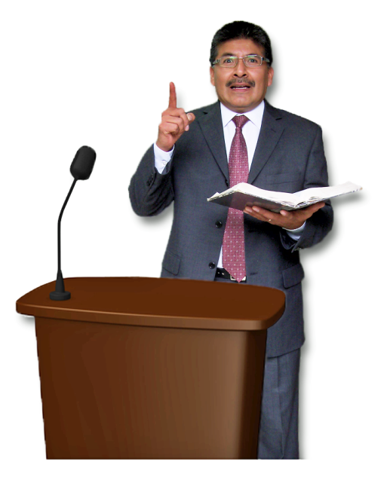
Now that we have defined the goal (unreached ethnic groups) and the method (cross-cultural missions), we need to clear up the confusion surrounding the name of the person we send. On the one hand, we know the word missionary, but we have all heard the sermon that says, “You are all missionaries!” What the pastor means is that all Christians should be servants and ministers. The problem is that the true meaning and impact of the word missionary is diluted and lost.
You will also note that the word missionary does not appear in the Bible; the biblical word for missionary is apostle. The problem with this word is that its biblical meaning, “the sent one,” has been lost in the current debate about leadership, authority, and spiritual power, yet nobody is talking about sending them to the unreached ethnic groups. Either way, the church has an inadequate under-standing of the role of the missionary and the apostle to the point that missionary candidates need to define and defend themselves while sharing their call to the nations.
©Depositphotos.com/Michael Bescec
The great importance of this dilemma can be shown in the fun activity described on the left. [24] In each of these situations, everybody knows exactly who to call, but when the urgent need is to evangelize the world, the church does not have a familiar, well-defined word to describe the indicated person.
I am going to describe some emergency situations and you are going to tell me who we should call. Ready?
I have a toothache…
The car will not start…
I have a stomachache…
There is a short circuit in the house…
There’s a gas leak…
Fire…
We need to evangelize the unreached ethnic groups…?
It is time to play…
Who Should We Call?
We can take any of the situations from this game to show how a familiar and well-defined word works in an emergency. If we have a stomachache, we can look in our directory under the letter “D” and there is the phone number for our own Doctor Smith. If that does not work we can at least drive around and look for a sign that says “doctor.” Without that word we would have to wander from door to door looking for someone to help us. It is almost that bad when we are talking about evangelizing the world’s unreached ethnic groups.
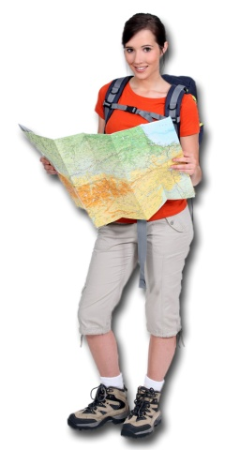
Although missionary work can have many different facets, an ideal definition [25] could be the following:
A missionary (or apostle) is the person God calls and the church sends to the unreached ethnic groups, crossing social, language, and cultural barriers, to plant a viable church.

©Depositphotos.com/photography33
©Depositphotos.com/Milan Vasicek

There is a wise saying that clears up this confusion: “Not all Christians are missionaries, but all Christians are called to participate in God´s global mission!” [26]

VII. Mission Organizations [27]
It might be difficult for a local church to send its own missionaries directly to an unreached ethnic group. Churches vary greatly in the level of development of their missions programs and structures. This can paralyze a church into frustration or inactivity. For this reason, God has raised up specialized parachurch organizations called mission agencies, which help churches channel their human, spiritual and financial resources to the unreached. Their functions are to:
Sending Mission Agencies
- Handle immigration logistics,
- channel finances,
- provide pastoral care for the missionaries,
- facilitate the missionaries’ work on the field, and
- process the flow of information between the missionary and his/her supporters.
These agencies are divided into sending agencies, which are in charge of sending the missionaries from their country of origin, and receiving agencies, which oversee the work in the unreached ethnic group. [28] It is helpful to show the participants some
_{©Depositphotos.com/}
_{Aleksei Elkin/}
_{Alexander Aisenstadt/}
_{S-E-R-G-O}
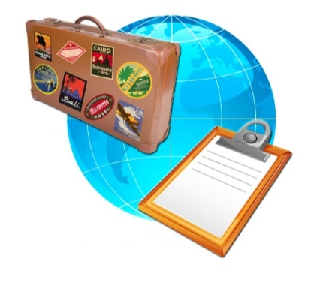
examples of these organizations with flyers and materials. There are different types of agencies: independent, inter-denominational, denominational, or as part of one mega-church. The churches need to know these agencies exist to help them take their first steps towards reaching the unreached ethnic groups, however small those steps may be.
Receiving Mission Agencies
God has also raised up missionary training institutes, [29] whose function is to train candidates in those specialized areas of study they would not normally learn in a Bible institute. We can see how all these organizations work together in the graph on page 88.
_{©Depositphotos.com/Christos}
Georghiou/Alexander Aisenstadt/
_{S-E-R-G-O}
Missionary Training Institutes
VIII. Other Important Definitions [30]
We have used the word culture many times without defining it. Below are definitions of some important words for the missions mobilizer and the churches.
A. Culture - is the integrated system of human behavior within an ethnic group which comprises how they think, speak, act, and manipulate their environment to fulfill their needs. This includes worldview, religion or witchcraft, dress, food, housing, perception and use of time, economy, agriculture, art, markets, communication, entertainment, music, social life, friendships, family relationships, relations between families (the community), and relations with other societies. Culture shock is the anxiety one feels when entering a different culture.
©Depositphotos.com/Aleksei Elkin/Patrick Bombaert/Mohamad Shahreen Amri/Oleksandr Lupol/Patrick Guénette/Vladimir Galantsev/Vladimir Galantsev/Alexander Aisenstadt
B. Castes - are strict, vertical divisions in Indian society esta-blished at birth by the Hindu religion. They determine vocation, who one may marry, and with whom one may associate. It is exceedingly difficult for the gospel to move from one caste to another.
More definitions are found in the chapter of World Needs:
- Evangelical Christian
- Nominal Christian
- World religions
- Language
- Dialect
C. Worldview – is the way in which an ethnic group perceives reality with respect to God (or gods), the origin of man, his purpose, time, the spirit world, and the afterlife.
D. Geography - This factor can determine the extension of an ethnic group because of political or physical barriers such as rivers, mountain ranges, or oceans. These factors must be analyzed case by case to determine if they are sufficiently important to classify a distinct ethnic group.
E. Tribes – are ethnic groups characterized by a tight social organization, with elder or chieftain lead-ership, group decisions, extended family networks and clans, isolation from others, a remote location, and often primitive physical conditions.
F. Indigenous - When used in missions in reference to the church in a given ethnic group, it means that the church is totally adapted to its surroundings and has no foreign elements of the missionary’s culture. A member of the ethnic group can attend the church and feel totally at home.

