The purpose of this teaching is for the participants to understand the development of missionary work throughout the centuries and how the gospel extended to the regions where it is currently present. This will convince them of the urgency of doing missions now, as well as help us learn from past mistakes. We also hope that by cele-brating the heroic efforts of other generations, it will be a great inspiration for us today.
The Goal

I. An Activity to Appreciate the History of Missions
_{©Depositphotos.com/Binkski}
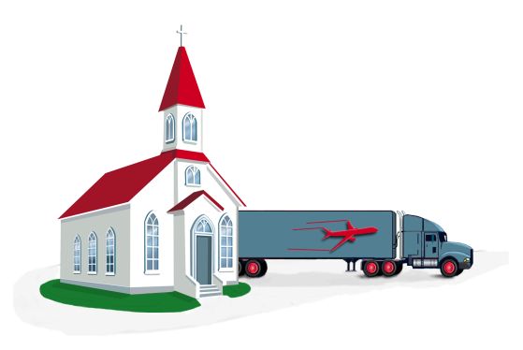
We could admit with the participants that studying history may bring to mind their worst memories from school! So then, why are we going to study the history of world missions? The reason is that a church could be frustrated and paralyzed by thinking about reaching the 30% of the world’s population that is living in 7,000 unreached ethnic groups in the 10/40 Window. [Slide #1 of the PowerPoint] A historical perspective will allow us to appreciate the great momentum that missionary work has seen in recent history.
A metaphor might help us understand this idea. Let us imagine that a local church is asked to do the following task: There is a tractor-trailer outside the church which needs to be pushed, by hand, to the center of the city. Everyone will say, “It is too hard! It is too heavy! That is impossible!” They are looking at the task as if it were a still photograph, and it does look impossible. But what if the situation were presented differently?
It is impossible!
©Depositphotos.com/Viktoria Protsak
©Depositphotos.com/Daria Karaulnik
Let us say the tractor-trailer is being pushed by many people [2] from 1,000 kilometers away, it is already in motion, and has only one kilometer left to go. Now the situation looks completely different! Instead of a still photograph we have a dynamic, moving video. Instead of being an impossible task, we see that the job is almost done. That is what it is like to see the current missionary situation from a historical perspective. Of course, the task is still great, but looking back on how far we have come, we realize how close we are to the finish line.
We can do it!
This chapter gives a panorama of 2,000 years of the advance of the church among the nations. (It is hard to teach the this whole chapter in 40 minutes, so try to summarize as much as possible.)
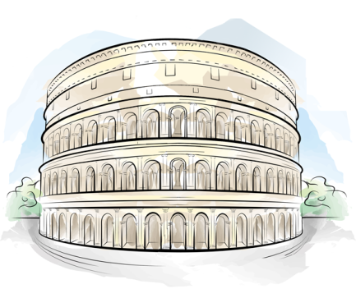
II. From the Apostles to 400 A.D. [3]
As the early church broke with the traditions of Judaism, the Greeks, Romans, and other ethnic groups within the Roman Empire were converted to the faith. The book of Acts describes the first steps in this process and, especially, the role the apostle Paul played in the expansion of the gospel among the Gentiles (ethnic groups).
©Depositphotos.com/Liubov Bunakova
Paul was not the only apostle to cross cultural barriers. In his gospel, John presented Christ in terms that were understandable within the Greek culture. According to tradition, Peter went to Rome until his martyrdom under Nero. The other apostles went to foreign lands and, in Thomas’ case, as far away as India. The book of Romans shows Paul’s intention to go to Spain.
The Four Missionary Mechanisms
- Go voluntarily – Paul and Barnabas are sent out in Acts 13.
- Go involuntarily - The Christians are scattered by persecution in Acts 8.
- Come voluntarily - The Jews come to Pentecost in Acts 2.
- Come involuntarily - Cornelius comes to Palestine as a soldier under orders in Acts10.

We see in the Bible that God moves people and nations to facilitate the spread of the gospel. [4] He sends those who have the gospel to areas where the people do not have the gospel (Go!). He brings those who do not have the gospel to areas where the people do have the gospel (Come!). Sometimes these movements are voluntary, sometimes they are involuntary. To the left you will see these four “missionary mechanisms” with their corre-sponding biblical examples. We will also see these mechanisms working many times throughout the history of missions.
The church grew miraculously [5] in an environment of moral decadence, invasions, political intrigue, and economic chaos, while maintaining a faithful biblical testimony of morality, love, and service. The pure, honest, and courageous lives of sim-
ple Christians and their steadfastness in the face of severe persecution were major factors in this growth. Externally, the church responded to intellectual attacks from paganism, while internally it resisted and condemned a variety of heretical teachings such as Gnosticism (Colossians), Judaizers (Galatians), and false teachings about the person of Christ. The gospel was taken from one village to another by an army of itinerant evangelists, as is mentioned in 3 John 5-8.
By the fourth century the church was starting to change. [6] The customs and beliefs that Paul wrote against centuries earlier began to seep into its doctrines and practice. What would Paul have thought of repetitious prayers, candles, incense and holy water for purifications, the veneration of Mary and the saints, sacramentalism, forced celibacy for the clergy, or the title Pontifex Maximus for the pope? Some of these customs have their origin in the mystery religions of Asia, Persia, and Egypt. Others are due to an overemphasis on practices from the Old Testament. We still see the Catholic church in the New World being too tolerant of the practices of the indigenous cultures.
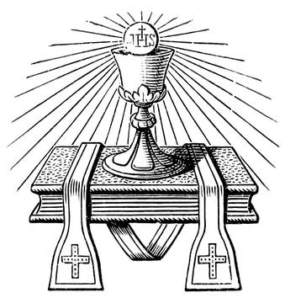
Paul had written forcefully to preserve the simplicity of the faith – trusting only Jesus for salvation and walking in the Holy Spirit. Perhaps the intense persecution caused people to gravitate towards trusting in infant baptism. The difficulty of discipling people who did not speak Greek or Latin made it tempting to trust in a system of physical, outward sacraments. In 312 A.D. the emperor Constantine declared himself Christian and fifty years later Christianity became the official religion of the Roman Empire. The church was flooded by multitudes of people with little Christian conviction, making it even easier to just apply the sacraments.
_{©Depositphotos.}
_{com/S_Kohl}
All these pressures gradually changed the church into a dispenser of salvation through the sacraments and an enslaving religious system. As evangelicals we can still profit from the study of the missionary efforts of the pre-reformation Catholic church, despite our many res-
The church became a dispenser of the sacraments.
ervations about their doctrines and practices.
The church inherited civil authority in an empire that was disintegrating, and the authority of the church and state were mixed. In the process of becoming an institution which governed millions, the church became too tolerant, even to the point of participating in worldly pleasures. The result was a “Christianized” empire but not a converted empire. The church conquered the Roman Empire but, paradoxically, the Roman Empire also conquered the church.
EUROPE
How should we evaluate this era of church history from the perspective of missions? The gospel was taken to many places, including Spain, France, and the British Isles, as seen on the map on the left. [7] If the church had remained in a Jewish environment it would most likely have been wiped out, or at least had very limited growth as a Jewish sect.
AFRICA
ASIA MINOR
Its expansion throughout the Roman Empire was a tremendous advance, and we are indebted to this advance. At the same time, the gospel message was riddled with many serious errors. This demon-strates the dangers of syncretism and the need to keep the Bible as the only foundation for doctrine and practice.
Christianity in the Year 400 A.D.

III. The Barbarians and Islam (400 to 800 A.D.) [8]
The Barbarians invaded the Roman Empire in a series of raids, looting, destroying, and devastating nearly the entire empire. The causes and reasons for these invasions have been widely discussed. Some have blamed the Christians for eliminating the basis of the Roman culture and its religious traditions. Christians have answered that it was God’s judgment upon a corrupt, decadent empire. (This was the thesis of The City of God, written by Augustine in defense of Christians.) The Barbarians were not responsible for the fall of the Roman Empire; rather, the decline of Rome opened the door for the growth of Christianity as well as for invasions from the north and east. The Barbarians were won to the Christian faith, and this is an example of the “come voluntarily” missions mechanism.
If you do not go to the unreached, the unreached may come and invade you, and sometimes…
they are not very friendly!
Ralph Winter, founder of the US Center for World Missions, was of the opinion that the Barbarian defeat of the entire western portion of the empire was Rome’s punishment for not having evangelized them. On the other hand, he recognized that the gospel had reached some tribes outside the limits of the empire, to a minor extent. The great missionary Ulfilas had evangelized the Goths, north of the Danube River, even leaving them a Bible translation. His father was a Christian who had been taken north by Gothic raiding parties (go involuntarily), bringing to mind the young Hebrew girl that was captured by Syrian raiding parties in 2 Kings 5. The Goths’ prior contact with Christianity may be why the raiders did not destroy the churches.
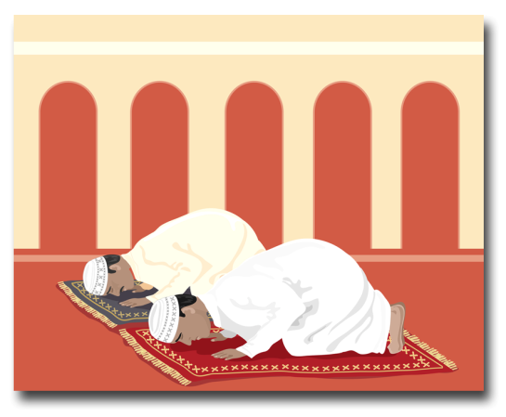
Since the churches were not victims of pillage by the invaders, the remains of the Roman culture and its richness were preserved by the Catholic church. In its defense, we must note that the church maintained order amid the chaos of a civilization in decline.
[9] A significant movement, Islam, had its origins in this period, making nearly unimaginable conquests. This religion was founded by Mohammed (570-632). It began in Mecca, Arabia in 610, when a young Mohammed received his first “revelation.” Over the years he received other revelations which were compiled in the Koran, the book the Muslims consider their holy scriptures. (We should remember what Paul warned in 2 Corinthians 11:14: “Satan himself masquerades as an angel of light.”)
At first, Mohammed was rejected by his countrymen, and he and others were forced to flee to Medina. The Muslim calendar begins in the year 622 with this emigration. Through a series of battles and treaties, the Muslims gained control of Mecca (630) and all of Arabia, and in less than a century after Mohammed’s death, had conquered Persia, Syria, Armenia, Galilee, Egypt, the north of Africa, and Spain. Islam dominated the Persian Empire and a large part of what had previously been the Roman Empire. Finally, the expansion to the west was arrested in Tours, France in 732 A.D. In the east, Constantinople blocked its expansion until the city was taken by the Ottoman Empire in 1453.
_{©Depositphotos.com/Mike Smith}
From a missions perspective, the impact of Islam was extremely significant. It impeded the expansion of Christianity to the south and east. Christian influence was limited to Europe. Christ-ians living in Muslim territory were a persecuted minority, and over time most of them converted to Islam. This put Europe on the defensive against Islam, particularly in Spain, where the struggle to expel the Moors raged for several centuries. In Europe, due to the efforts of monks and mission-aries (Columba, Boniface, and others), many of the tribes converted to Christianity.
ATLANTIC
OCEAN
ASIA MINOR
EUROPE
The emperor Charlemagne (768-814) carried out several campaigns, giving resistant groups two options - baptism or death. Through his role as protector of the church and the close cooperation between secular and ecclesiastic power, Charlemagne became an official of the “Holy Rom-
AFRICA
Christianity in the
Year 800 A.D.
an Empire.” Central Europe was “Christianized” in part by genuine conversions, in part through assimilation, and in part by the sword. This is not an advisable pattern for world missions.

This map [10] shows the advance and decline of Christianity after this turbulent period.
IV. The Crusades and the Vikings (800 to 1200 A.D.) [11]
That the gospel of love became a system imposed by force is a great cause for concern. This warlike posture reached its culmination during the Crusades (1095-1291 A.D.). The at-tempts to take back the Holy Land in the name of Christianity were flawed in two ways. Any gains in territory or Christian control were incomplete and short-lived. Secondly, the violence of the “Christian” attackers created in Muslims a resistance to the gospel that continues to this day. The Jews in Europe also suffered abuses at the hands of Christians. We must admit this gave a very bad testimony to the world and was in complete opposition to the teachings of Christ.
©Depositphotos.com/114655068_s-2015
[12] Nor was the church’s testimony one of unity. For several centuries the churches in the east and in the west were at odds. The competition between the Byzantine Empire and Rome was accentuated during and after the reign of Charlemagne. In 1054 A.D. the split was formalized amid condemnations and quarrels - the Catholic in the west and the Greek Orthodox in the east.
_{©Depositphotos.com/}
_{Tribaliumivanka}
We should pause here to recognize another great Christian missionary tradition, the Nestorian church. Even though they were declared heretics by the western church in the fifth century, their missionary zeal led them from the Middle East all the way to China! They reached their peak in the ninth century, but they were severely persecuted by the Muslims and by the empire of Ganges Khan until they totally disappeared by the fifteenth century. We have not included their growth and decline on these maps.
EUROPE
ATLANTIC
OCEAN
Little by little, the Christian faith expanded north and east. The Vikings invaded Celtic and Barbarian territories. A positive outcome was that the conquering Vikings were themselves conquered by the faith of their captives. Hence, they took Christianity to Scandinavia (see the map on the left). [13] However, this period was known as the Dark Ages, and with good reason. Superstitions and pagan rites were corrupting the church, and society in general had declined.
Christianity in the Year 1200 A.D.
AFRICA
ASIA MINOR
V. The Renaissance and the Reformation (1200 to1600 A.D.) [14]
During this era there was a renewed interest in learning. The Latin Bible was revised and widely circulated. Schools and universities were established. The other half of the planet was discovered and the western Christianized nations were establishing colonies throughout the world. International commerce grew and toward the end of this period the printing press was invented. There was interest in studying the Bible. All this prepared Europe for the Protestant Reformation, marking the beginning of a new era in Christian history.
©Depositphotos.com/Alexandru Romanciuc/arogant
The Reformation was a correction to the abuses in the church and a return to biblical principles:
- Sola Scritura (the Bible as the only authority for Christian life and doctrine),
- Sola gratia (salvation by God’s grace alone),
- Sola Fide (salvation through faith in Jesus Christ alone, not by works),
- Sola Christus (Jesus the only provision for our salvation, not Mary, saints, or works), and
- Soli Deo Gloria (to God only the glory).
This correction was essential for the restoration of the church and served as preparation for a sound basis for evangelical missions. Nevertheless, for several centuries the Protestant churches did little in the way of world missions. Why was there no expansion of the gospel following the beginning of the Reformation? For various reasons:
- The interpretation of the Great Commission - The majority of the reformers believed that the Great Commission was given only to the apostles and therefore it did not apply to them.
- External (the Inquisition) and internal (Protestants against Protestants) conflicts - Unfortunately, after the Reformation, Europe was troubled with many conflicts and the Protestant church was caught up in many theological arguments.
ATLANTIC
OCEAN
- The politics of the time - Portugal and Spain, Catholic countries, dominated the oceans, whereas the Reformation was born in Germany and Switzerland, which were not maritime countries.
EUROPE
- Lack of structures - There were no agencies within the reformed church to facilitate sending missionaries. In contrast, the Catholic church had its orders (Jesuits, Dominicans, Franciscans) which accompanied the conquistadors, filling the world with the Catholic faith. [15]
Christianity in the
Year 1600 A.D.
ASIA MINOR
AFRICA
The map on the left shows the advances at the end of this period.

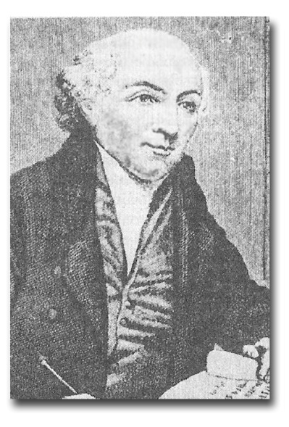
VI. Modern Missions - The First Wave to the Coasts [16]
The eighteenth century saw the beginning of the Protestant missionary effort. The first was from the University of Halle in Denmark which sent missionaries to the coast of India. Even more impressive and long-lasting was the Moravian mission, called “the dawn of Protestant missions.” They sent missionaries to many fields and reached a ratio of one missionary for every 60 members, an accomplishment which has not been repeated to this day!
The groundbreaker of Protestant missions was the Englishman, William Carey, who awakened the church and became known as the “Father of Modern Missions.” His little book, An Inquiry into the Obligation of Christians to Use Means for the Conversion of the Heathens, challenged the evangelical church to establish mission agencies (means) and to send missionaries to the non-Christian continents. The first response to this humble shoemaker was not very encouraging: “When God pleases to convert the heathen, he will do it without your aid or mine.”
William Carey
Through Carey’s insistence, the Baptists of England established a mission agency and sent him to India. [17] Shortly thereafter, there were three mission agencies in England, two in Scotland, one in Holland, and one in the United States. Twenty-five years later there were 25 agencies. Finally, there was a support structure for the evangelical missions movement, based on prayer, economic support, and mission agencies. The European evangelical church dominated this first wave and with great sacrifice established churches in the Pacific Islands, the Caribbean, and on the coasts of Africa and Asia.
©Depositphotos.com/Maxim Kazmin/
_{Michael Bescec}
The majority of missionaries who went to Africa died of malaria within a few years, and some of their replacements arrived with their belongings packed in caskets! Their dedication is an example and a challenge for us today.
This first wave lasted from 1792 to 1910. [18] On this map you can see clearly the expansion of the gospel along the coasts of the great continents. For our purposes as evangelicals, the areas dominated by the Catholic church are now shown in white, while on the previous maps they were shown in red as Christ-ianized areas.
Approximate Extension of the Evangelical Church
at the End of the First Wave - 1910
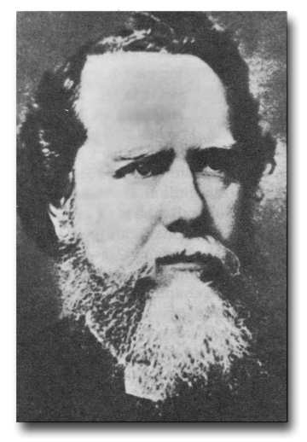
VII. The Second Wave to the Interiors of the Continents [19]
Even as some were saying that the church had now been established in the whole world, a young Englishman named Hudson Taylor was studying statistics and maps of the interior of China. He raised the call to go to the immense populations in the vast inland areas of the major continents. Despite much opposition, he founded a new mission agency, the China Inland Mission, which in its long history has sent more than 6,000 missionaries to China!
[20] It was difficult for the already existing mission agencies to change their focus to the interiors, so 40 new agencies were founded, whose names reflected this new mission frontier. For the most part, these were interdenominational faith missions. The United States dominated this second wave, which began in 1865 and ended in 1980.
Hudson Taylor
At first the new missionaries did not heed the hard lessons learned by the veteran missionaries of the first wave, but with time they made great advances. Taylor was also a pioneer in the area of missionary methods, adapting to Chinese clothing in spite of the resistance and ridicule of his fellow missionaries. In fact, one time he almost blinded himself with chemicals while trying to straighten his hair to appear more Chinese!
There was a special anointing at the universities resulting in 100,000 students giving their lives to missions, with 20,000 of them actually going to the mission field. The popular movie, Chariots of Fire, relates the powerful story of a young Englishman, Eric Liddell, who lived and served as part of this second missionary wave. The tremendous advances of this time can be seen on the map on the left. [21] Once again, some began to say that the Great Commission had been fulfilled, until God raised up two men on opposite ends of the planet.
Approximate Extension of the Evangelical Church at the
End of the Second Wave, plus Recent Advances

VIII. The Third Wave to the Unreached Ethnic Groups [22]
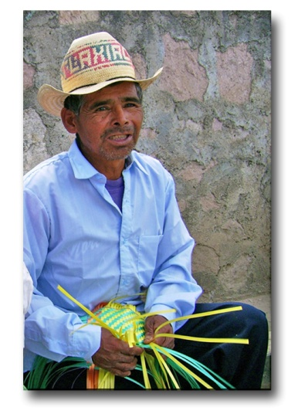
Cameron Townsend, a missionary to Guatemala, was distributing Spanish Bibles when a humble Cakchiquel Indian asked him a simple yet profound question. Townsend realized there were ethnic groups isolated from the gospel, even though the church had been firmly established among the Spanish-speaking Guatemalans.
If your God is so smart, why can He not he speak my language?
Foto por Alejandro Rodríguez
[23] Meanwhile, Donald McGavran lived in India with his parents who were missionaries. He observed how the Hindu caste system separated large populations, preventing the gospel from spreading from one group to another. These two pioneers raised the banner for the “unreached ethnic groups.” From 1940 to the present there has been a third wave - not to the coasts nor to the interiors, but to the unreached ethnic groups.
This new mission frontier gave rise to research into the ethnic groups, yielding statistics and profiles which are used to plan new mission strategies. It was also necessary to create new, specialized mission agencies. Townsend founded Wycliffe Bible Translators, an agency dedicated to the translation of the Bible into all the languages of the world, and which presently has more than 4,000 workers. Other agencies include the Missionary Aviation Fellowship, an aviation service to isolated missionaries; Campus Crusade; Intervarsity; Navigators; Operation Mobilization; Youth With A Mission; and many others.
The twentieth century was a time of surprising growth in the church, particularly in the developing world. A hundred years ago Korea had no evangelical churches; today there are more than 4,000 in the capital, Seoul, and 25% of the Korean population is Christian.

After the conquest of Latin America, Roman Catholicism mixed with paganism became the religion of the majority. In 1900 there were very few evangelicals, but evangelistic efforts have produced miraculous growth. There are now more than 87 million evangelicals in Latin America.
A third example is the growth in Africa. The church has grown dramatically, in part due to the persecution Christians suffer in many parts of Africa to this day. In the last 100 years the Christian community has grown from 9% to about 25%. To see the implications of this phenomenal growth, please turn to the graphs on pages 117 and 118.
These three waves of modern missions during the last 225 years have opened up for us a new dimension of possibilities that some are daring to call “the last age of missions.” [24]

IX. From Receivers to Senders
For many years, the churches in the developing world were receivers of missionaries due to their extreme poverty and small percentage of Christians, causing a localized focus and lack of missionary vision. These evangelicals were used to receiving rather than giving, thereby missing out on a huge blessing. The foreign missionaries themselves share the blame for perpetuating this mentality.
But now this situation is changing. A vision to finish the Great Commission is growing globally, and thousands of mission agencies are springing up in Asia, Africa, Oceania, and Latin America. [25] About 25% of the world’s missionary force presently comes
©Depositphotos.com/Maksym Yemelyanov
from developing countries, or what some are calling the global south. It is exciting to think of the progress we have seen in recent years, but there is still a need to mobilize the millions of churches, both in the global south and in traditional missionary sending areas, towards cross-cultural missions.
The case of Latin America is very exciting. In 1987 the first missionary congress of COMIBAM (Ibero-American Mis-sions Cooperation) was convened in São Paolo, Brazil. Delegates from most Latin countries attended, and a survey counted about 400 Latin missionaries serving cross-culturally. The delegates of each country returned home to mobilize their national churches towards missions. Moisés López returned to Mexico to establish the Missions Cooperation of Mexico (COMIMEX).
When COMIBAM convened a second congress in Acapulco, Mexico in 1997, they counted 4,000 Latin missionaries! At the third COMIBAM congress in 2006 in Granada, Spain, we counted 8,000 Latin missionaries, and now they are saying that there are more than 10,000! At the fourth congress in 2017 in Bogotá, Colombia, we unveiled the Impact 316 Project (see page 120), which is an attempt to divide the 3,000 least reached ethnic groups among the 24 member countries of COMIBAM.
Networks and strategic alliances are forming worldwide so that any church can be involved in fulfilling the Great Commission. God is at work!
X. Applications and Conclusions from History [26]
It is interesting to evaluate the obstacles which for so long impeded the development of missions in the reformed church, and those which confront the evangelical church in Mexico today. Although the circumstances differ, there are some similarities:
- There is still a lack of understanding about the Great Commission. Many still think global missions are exclusively for the rich churches of the first, or industrialized, world. Thus they leave the task to others in the same way the reformers applied the Great Commission exclusively to the apostles of the first century.
- Conflicts within the church distract from the vision. A church divided by quarrels and dissention cannot be completely dedicated to the great vision to which it was called.
- Both politics and regional economic issues in Latin America hinder the sending out of mission-aries. This is used as an excuse to do little for world missions.
- The cultures of the Latin American countries are rapidly becoming humanist and liberal. These cultural wars rob much of the energy and resources from world missions.
- It seems inconceivable, but enthusiasm for the unreached ethnic groups has already started to diminish in many missionary circles. As was the case after the first and second wave of modern missions when some were saying the Great Commission was completed, so now some voices are arguing for other priorities in missions.
There is a great need for establishing mission agencies to facilitate the sending of missionaries, and a need to educate and train the local church to do its part. Although the church has grown considerably in recent years, there is still much to do so that all ethnic groups have the opportunity to hear and understand the message of salvation in Christ. Broadly speaking, 90% of the most spiritually needy live in the 10/40 Window. Due to the domination of Buddhism, Hinduism, and Islam, the enormous population in the region, and the scarcity or absence of devoted Christians, this part of the world constitutes the greatest challenge for Christian missions.
Bibliographic References
This chapter is a compilation of information from these sources:
- Johnstone, Patrick. The Future of the Global Church. Downers Grove: Intervarsity Press, 2011.
- Johnstone, Patrick and Mandryk, Jason. Operation World. Waynesboro: Paternoster Publishing, 2001.
- Keyes, Lawrence E. The Last Age of Missions. Pasadena: William Carey Library, 1983.
- Tucker, Ruth A. From Jerusalem to Irian Jaya. Grand Rapids: Zondervan Publishing House, 1983.
- Winter, Ralph D. “The Kingdom Strikes Back: Ten Epochs of Redemptive History.” in Perspectives on the World Christian Movement (3rd ed.), pp.195-213. Edited by Ralph D. Winter & Steven C. Hawthorne. Pasadena: William Carey Library, 1999.
- Winter, Ralph D. “Four Men, Three Eras, Two Transitions: Modern Missions.” in Perspectives on the World Christian Movement (3rd ed.), pp.253-261. Edited by Ralph D. Winter & Steven C. Hawthorne. Pasadena: William Carey Library, 1999.

