offers this course mainly in events called “Missions Saturdays,” although the curriculum adapts easily to any setting or schedule.

What are the requirements to receive a Missions Saturday in your church?
- A room for 10-50 people, preferably seated at tables,
- lunch and refreshments for the attendees,
- the participation of the pastor and some of the leadership of the church,
- a willingness to complete the Great Commission.

What benefits will your church receive in a Missions Saturday?
- You will be at the center of God’s will for the world.
- Your first steps in world missions will be giant steps.
- God blesses the missionary church.
- You will hasten the return of the Lord!
Read what a pastor has said about Your Church Can Change the World,
“Only a church that is aware of God’s plan, the needs, and the possibilities can be involved effectively in completing the Great Commission. Your Church opened our eyes!”

Pastor Antonio Pavón
Executive Director of COMIMEX Director of Mobilization of COMIBAM
Founder of Inter-alliances and
Mission of Peace

If you want to receive this series of teachings in your church, please contact us at:

Departament of Missions Education
Tel: (55) 59-38-17-80
jimrobh@prodigy.net.mx
James Heimberger

The A B C’s of Cross-Cultural Missions for the Local Church

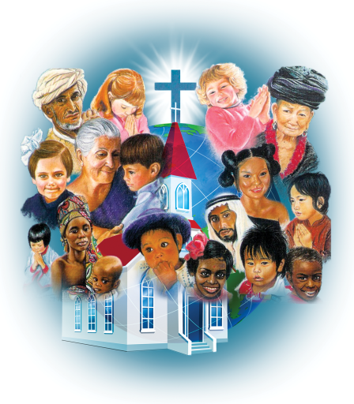

©Depositphotos.com/Viktoria Protsak/
S-E-R-G-O//Collage by Jill Suzanne Hatcher//José Luís Santana

JESUS said,
“AND THIS GOSPEL OF THE KINGDOM WILL BE PREACHED…
TO ALL NATIONS...”
How are we doing with this task?
THERE IS GOOD NEWS!

_{©Depositphotos.com/DIDEM HIZAR}

70% of the world’s population has access to the gospel message! This is a great achievement, for which we should be very grateful! But, on the other hand…

There is bad news!

_{©Depositphotos.com/DIDEM HIZAR}

30% of the world’s population, 2,100,000,000 people, do not have access to the gospel message! They could not hear the gospel even if they wanted to! These people live isolated from the gospel, hidden behind the invisible barriers of language, race, religion, geography, cultures or castes. These people will continue in complete darkness for another thousand years unless new workers invest their lives to cross these invisible barriers to share the gospel with them. But…
THERE IS MORE GOOD NEWS!
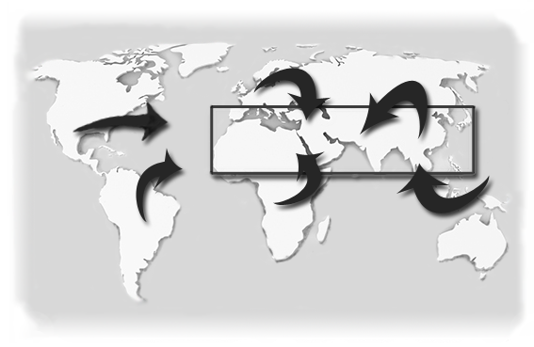
God is raising up a cross-cultural missionary force in these last days like we have never seen before. These missionaries are coming from Africa, Asia, Oceania, Latin America, North America, and Europe, and are advancing on the area of greatest need. This is the famous “10/40 Window” where the majority of the 7,000 ethnic groups live that do not yet have access to the gospel.

The 10/40 Window

DON NOT BE LEFT OUT!

has prepared a series of practical and exciting teachings which will give your church the information, the motivation, and the tools to get involved effectively in completing the Great Commission. This series is called Your Church Can Change the World.

In it you will see:
- God’s missions plan throughout the whole Bible,
- the exciting history of cross-cultural missions,

©Depositphotos.com/Maksym Yemelyanov

- the role of the local church,
- where the greatest need is in Mexico and the world,
- strategies for prayer and finances,
- resources and organizations in Mexico that exist to help your church,
- videos,
- testimonies, and
- fun activities.

