The purpose of this teaching is for the participants to understand:
The Goal
- That to evangelize our world we need cross-cultural missions,
- the ethnic diversity of the world, focusing on the major reli-gious blocks,
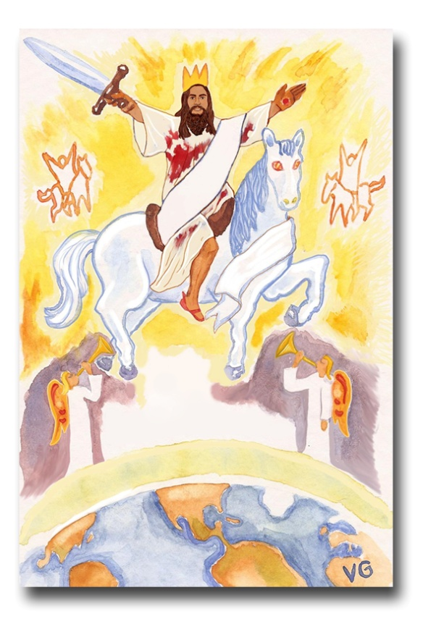
- a numerical model of the world regarding its spiritual needs, population, unreached ethnic groups, and the available mis-sions resources.
©Depositphotos.com/Leonid Dorfman
Who would like to see the Lord Jesus return in all his glory!? [Slide #1 of PowerPoint] Who would like to see the words of the angels fulfilled when they said that Jesus would return in the same way he left? Jesus Christ will return for his bride to celebrate the wedding feast of the Lamb when the signs of the end times have been fulfilled. What are these signs? Matthew 24:14! “And this gospel of the kingdom will be preached in the whole world, as a testimony to all nations, and then the end will come.”
Who is responsible for completing this important task? Each one of us, as children of God, must do our part so that this prophecy will be fulfilled as soon as possible. But how will we do that if we do not understand the spiritual situation of the world?

I. The Spiritual Situation of the World as a Human Graph
The spiritual situation of the world can be dramatically demonstrated by making a “human graph” with volunteers from the audience. (This requires 10 people, so with smaller groups it will not work. Instead, use the PowerPoint slides #2-12.) Start by saying, “If you can count from one to four, you can understand the world’s spiritual situation! I will need 10 volunteers, and each one will represent 10% of the world’s population.” (Make sure they understand the concept of percentages.)
A. Evangelicals [2] - We evangelical Christians are about 10% of the world’s population. To demonstrate this number, ask one of the volunteers to stand a short distance away from the group to form the first part of the graph. At this point it is possible someone will say, “If there is a higher percentage of Christians in the world (10%) than in Mexico (7%), why should we send missionaries there?” That is an important question. You will have to analyze this statistic a little, explaining that in some places like Puerto Rico, the Christian population is over 50%, and in other areas it is lower than .01%, in other words, less than one Christian for every 10,000 people! There are thousands of ethnic groups without even one Christian!
Evangelicals –
We are 10%!
_{©Depositphotos.com/DIDEM HIZAR}

Also, it is necessary to show them a definition of an evangelical Christian, which is found on the left. [3] It is difficult to determine these statistics with precision because often there are people in non-evangelical denominations who demonstrate these characteristics. On the other hand, there are evangelical denominations with some inactive members who might not be Christians.
Evangelical Christians:
- Trust only in the cross of Jesus Christ for their salvation,
- enjoy a personal relationship with God through Jesus,
- exhibit regeneration through the Holy Spirit,
- recognize the Bible as the inspired word of God, the only basis for faith and practice, and
- are committed to biblical preaching, evangelism, and service.
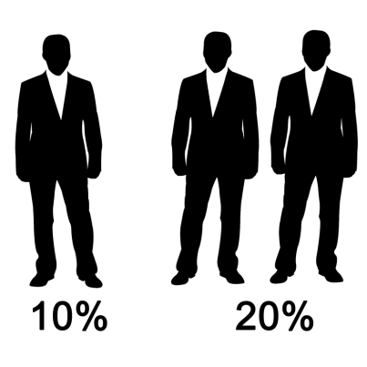
B. Nominal Christians [4] - These are people whose religion mentions the name of Jesus Christ but who do not reflect the characteristics of evangelicals as mentioned above. [5] We sometimes call them cousins, but not brothers! They know about God, the Bible, Jesus, Christmas, and Easter, but either they have not accepted Jesus as their Savior or they do not serve him as their Lord. Many nominal Christians are in groups that have doctrines that evangelicals do not accept. It would be good to mention a few groups that we do not consider Christian so the parti-cipants understand this concept. (Although the Muslim Coran mentions Jesus, we are not including them here.)
Nominal Christians:
- People who name Jesus Christ in their religion,
- but do not exhibit the characteristics mentioned above.
Nominal Christians make up 20% of the world’s population. Ask two volunteers to stand at a distance from the group, leaving a space between these two and the one who represents the evangelicals. Nominal Christians usually live in reached ethnic groups, so most of them have access to the gospel.
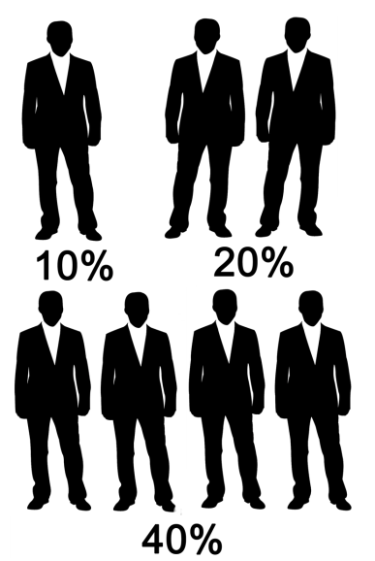
C. Non-Christians living in reached ethnic groups [6] - These are people of some non-Christian religion like Hindus, Muslims, Buddhists, or animists, but who live in ethnic groups that already have a viable church. [7] We can as-sume that within 50 years these people will hear the gospel through the evangelistic work of these growing churches. Ask four more volunteers to form another group. This group makes up 40% of the world´s population.
_{©Depositphotos.com/DIDEM HIZAR}
Pause here to clarify one important concept. There is a tendency to call any non-Christian “unreached,” no matter how saturated with the gospel their ethnic group may be. The trick question in the text box on the following page illustrates this point. [8,9] Even though the context is nominal Christians (Catholics in Mexico), the same dynamic exists in ethnic groups comprised of a majority of Muslims, Hindus, Buddhists, or animists.
_{©Depositphotos.com/DIDEM HIZAR}

In missions, the words reached and unreached refer to ethnic groups, not to individuals! [10] The concept we need to understand is that these people have access to the gospel. There already exists a viable church in their ethnic group (Spanish speakers of Mexico) that they can attend with no barriers to understanding the gospel. For example, someone from that village could go to the city for work and find that his co-worker is a Christian. Or maybe a church from a neighboring village could start a church plant there without encountering barriers of understanding.
A trick question: I drove through a village in the mountains of the state of Puebla. Everyone in the village spoke Spanish fluently, but there is no church in that town. Are these people part of a reached ethnic group, or an unreached ethnic group?
Answer: Reached, because they speak Spanish and therefore, in Mexico, they have access to the gospel.

D. Non-Christians living in unreached ethnic groups [11] - These are people of a non-Christian religion living in ethnic groups that do not have a viable church; they make up 30% of the world’s population. [12] They are the 7,000 unreached ethnic groups. These people have no access to the gospel. You can now complete the human graph by separating the last 3 volunteers from the rest, as shown below.

_{©Depositphotos.com/DIDEM HIZAR}
Non-Christians without
Access to the Gospel
Nominal Christians and Non-Christians
with Access to the Gospel
Evangelical
Christians

They have waited 2,000 years to hear about Jesus, and at this rate they will have to wait another 1,000 years! Notice in the above graph that the other groups (the 20% and the 40%) are surrounded by darkness because they are not born-again believers. But this last 30% is surrounded by a deeper darkness, because in addition to not knowing Jesus, they have no way to ever hear about him.
To dramatize the difference between evangelism and cross-cultural missions, you can take the “evangelical” volunteer by the hand and walk him among the nominal Christians and the non-Christians with access to the gospel, [return to #11], describing what he would have to do to evangelize them. Then take him to the unreached group (the group of 3) and show how an evangelist would get frustrated by the cultural and language barriers.
Finally, he gives up and goes back to the people who understand him. It is important that the participants see that evangelism is not enough to cross these barriers, as can be seen in the diagram on the next page. [13] (Note how the evangelism arrow breaks.) We need cross-cultural missionaries!
This 30% represents the greatest challenge to the Christian church today. It is imperative that Mexican Christians not project the spiritual situation they experience in Mexico onto the rest of the world. Here is a major change of paradigms. The graph on page 55 demonstrates the difference between the world situation and the situation in Mexico. [14] Study this graph carefully so the group understands that the spiritual situation in the world is quite different from the spiritual situation in Mexico.

_{©Depositphotos.com/DIDEM HIZAR}

Cross-Cultural
Missions

In Mexico
In the World

Evangelical Christians 7%
Evangelical Christians 10%

Nominal Christians 20%

Nominal Christians 87%

Non-Christians living in Reached Ethnic Groups WITH Access to the
Gospel 40%

Non-Christians living in Reached Ethnic Groups WITH Access to the
Gospel 4%

Non-Christians living in Unreached Ethnic Groups WITHOUT Access to the Gospel 2%
Non-Christians living in Unreached Ethnic Groups WITHOUT Access to the Gospel 30%

©Depositphotos.com/DIDEM HIZAR}
II. A Study of the 7,000 Unreached Ethnic Groups [15]
Since 10% of the world is evangelical Christian, and 30% of the world lives in the 7,000 unreached ethnic groups, then each Christian need only share Christ with 3 people! We could finish the Great Commission in three hours! Unfor-tunately, it is not that simple.
In the first place, almost all the unreached ethnic groups are found in the 10/40 Window. [16] That is a long way from here! (On the map on the left and in the PowerPoint, you can move the black arrow to your country.) The first barriers to cross are economic and emotional. It is costly to buy an expensive airplane ticket and leave one’s family and country.
The 10/40 Window
©Depositphotos.com/Maksym Yemelyanov

Secondly, almost all the unreached ethnic groups have a religion vastly different from the nominal Christians we are familiar with here in Mexico. [17] The graph below shows the number of unreached ethnic groups in each of the major religious blocks.
The tribal groups mainly practice animism, which is a belief in many nature spirits and an attempt to appease and manipulate them through religious rituals. Hinduism is not so much an organized religion as it is a description of the religious practices of India in the context thousands of gods. The famous Buddha left Hinduism because of the many abuses he saw and established a philosophy of illumination and self-control through meditation, which came to be known as Buddhism. Islam is the religion of the Muslims and is a rigid system of five “pillars” for earning the forgiveness of a demanding god, Allah. A significant number of Muslims believe in imposing their religion by force, which explains so much of what we see in the news.
©Depositphotos.com/Martin Malchev
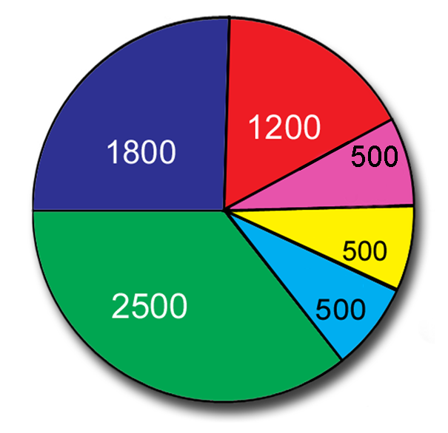
None of these religions created by man, and ultimately by Satan, can achieve salvation, “for there is no other name under heaven given to men by which we must be saved” (Acts 4:12). On the map on the following page [18] we see how these false religions predominate in the 10/40 Window. (The colors on the map are the same as the graph on the left.)
Hindus
Chinese
Tribals
We cannot try to evangelize within these religious systems using only the four spiritual laws. The literature we so often use here works among people who already have a Christian worldview, such as the nominal Christians of Mexico. They understand the words we use and the realities we explain. An experience which may help understand the difficulty of evangelizing among these religions is what happens when we come up against someone who is lost in the New Age movement. We get frustrated because they give a different meaning to every word we use.
Muslims
Others
Buddhists
The Principal Religions of the Unreached Ethnic Groups
The Major Religious Blocks of the 10/40 Window

Countries with a
majority of …

Hindus
Muslims
Buddhists

©Depositphotos.com/Arunas Gabalis

Data

A third factor which makes evangelism in the unreached ethnic groups more difficult is their very different culture. [19] The missionary goes with the best of intentions but may make cultural errors which confuse the people he is trying to reach. He may even seem rude or ignorant in their eyes. For example, in some countries they do not use toilet paper. Instead, the left hand is used for cleaning the body. If the missionary touches someone with his left hand they will think, “This guy does not even know what any four-year-old child knows, and he wants to tell us about God?”

III. The Languages of the World
A fourth factor which makes it challenging to evangelize the world’s 7,000 unreached ethnic groups is the language barrier. [20] There is no easy answer to the question of how many languages there are in the world. If your job is to sell soft drinks, you could cover most of the world with Chinese, English, Spanish and Arabic! If you want to plant viable churches so that everyone can hear and understand the gospel in their own language, the answer is something quite different.
“

Aaa”

John 3:16 in 3,000 languages of the world!
We also need to understand the difference between a language and a dialect. Zapotec, for example, is a language, but it has 53 different dialects, which are regional variations of the language. A translator explained that the differences between the Zapotec dialects can be as pronounced as those of Portuguese to Spanish.
For purposes of world evangelization, the most conservative estimate of the number of languages comes from those who translate the Bible, the Wycliffe Bible Translators. Often a written translation
can be understood in various dialects. The chart on the left [21] shows this need with current data. Wycliffe Bible Translators presently have more than 5,000 workers in the field, hailing from 46 different countries. They are looking for 1,500 more to finish the job within a reasonable time. Wycliffe and COMIBAM have partnered with the vision of recruiting and training 500 Latin translators before the year 2025. There are already several Mexicans working on this project, but we need many more!
As of 2021, the statistics from www.wycliffe.net :
- Languages according to Wycliffe – 7,360
- Languages with some portion of the Bible translated – 3,415
- Whole Bible – 704
- New Testament only– 1,551
- Portions – 1,160
- Translation projects in process - 738
- Languages needing translation – 2,014
For more information contact the Department of Bible Translation of COMIMEX at www.comimex.org
It may be true that to finish the Great Commission, every Christ-ian need only share the gospel with three people, but these three people live in the 10/40 Window, have a different religion, another culture, speak a different language, and probably do not have a Bible translation. The church of Jesus Christ must undertake 7,000 new cross-cultural mission projects to finish the Great Commission!
When teaching missions in a church, always challenge them with the task of Bible translation, especially students who get good grades in languages and grammar. They are our future Bible translators!

IV. The Resources for Finishing the Great Commission
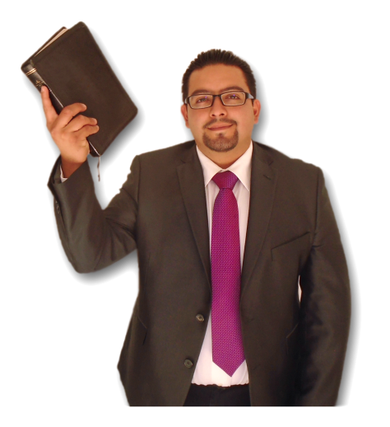
Up to this point we have been analyzing the enormous needs in the world. Now we are going to think about strategies and resources for finishing the job. The first question is, “Where should we send our new missionaries?” Everyone is going to point to the three people in the human graph who represent the unreached ethnic groups. Have them think about this idea for a while before you show them the graph on the next page. [22]
Of the present missionary force only 7% are working in unreached ethnic groups! On the one hand, this is because of the success of the missionaries who are already on the field. On the other hand, many go to the field without thinking strategically, simply following their emotions. Worse yet, some missionaries go where there is already a church because it is so much easier. We must be wise in sending the next generation of missionaries.
Another troubling reality is how the evangelical church in the world spends its offerings. [23] The graph on page 60 shows 100 coins, representing the offerings of evangelicals in the whole world. 95% of the money stays within the ministry of the local church for salaries, maintenance, instruments, evangelism, utilities, etc. 4.5% is sent for missions among reached ethnic groups! Only 0.5% (or 50 cents out of every 100 units of currency!) is used to send missionaries to unreached ethnic groups! We have a great opportunity to focus our resources where there is the most need - the 7,000 unreached ethnic groups. And now… the good news!
Troubling
Statistics!
Only 7% of Missionaries Work among the Unreached Ethnic Groups.

©Depositphotos.com/photography33/Milan Vasicek
How the Evangelical Church Invests Its Offerings

Only 0.5% is spent for missions among unreached ethnic groups.
4.5% is spent for missions
among reached ethnic groups.

©Depositphotos.com/Aaron Amat/Joe Belanger/Vladimir Wangel

The good news is that the church of Jesus Christ is very, very big! We want to finish this chapter on an encouraging note. Explain this graph very carefully to the group. [24] Today there are more than 1,000 evangelical Christian churches for each unreached ethnic group. It is especially amazing to trace the explosive growth of this ratio in the last few decades. (A “ratio” is the comparison of two numbers.) If all these churches get involved in the Great Commission, sacrificially investing their human, spiritual, and financial resources, we can hope to quickly finish the Great Commission that Jesus entrusted to us!
to
The Number of
Christian Congregations
for each Unreached
Ethnic Group

to

to

to

to
to
to
to

Year

©Depositphotos.com/Victoria Protsak/Market Olya
(The hearts represent the unreached ethnic groups.)

On the next page you will find an activity that dramatizes the immensity of the needs of the world, but at the same time, the simplicity of the solution. Now, when we talk about missions, we cannot think only of our town, or another neighborhood, or another Spanish-speaking country. God has opened our eyes and is calling us to the unfinished task. We must rise to the challenge that God has put before us today - to go to those places where Christ has never been named - the unreached ethnic groups. Then, with God’s help, we will hasten Christ’s second coming.
.

When we teach about these statistics, there comes a point when the participants get discouraged because the needs are so great: 7,000 unreached ethnic groups! 30 % of the world’s population! Only 7% of the world’s missionaries working among them! 50 cents out of every 100 dollars! It is a lost cause! It is too hard! On the other hand, some people do not feel the enormity of the task because their minds cannot comprehend such large numbers. This dramatization puts everything into an understandable perspective. Buy a ream of paper with 500 sheets and leave it in the wrapper from the store. (You can use the PowerPoint slides [25-29] if you do not have the package of paper). You could say something like this…
“7,000 unreached ethnic groups! When is the last time you handled 7,000 of something? Do not tell me you paid $7,000 pesos for something, unless you paid with 7,000 coins! We are going to try to grasp the magnitude of these numbers, while at the same time dream about a reasonable strategy to finish the task.”
“First, we are going to represent each one of these unreached ethnic groups with a piece of paper that we call a profile. A profile has the name of the ethnic group, a photograph, a map of their location, a brief description of their culture, some statistics about their population, their spiritual condition, and some prayer concerns.” (You can show them a page from the book, Let Us Reach the Ethnic Groups of Mexico, or print out a page from www.etnopedia.org as an example.) “We are going to imagine we have 7,000 profiles here...” (Start opening the package of paper [25] while you continue talking.) “This is a package of copy paper that I bought at an office supply store. Does anyone know how many sheets of paper it contains?” (Someone will answer: “500.”)
“Even 500 is a really big number. Now we are going to see 500 profiles before our very eyes.” (Hold the sheets of paper firmly in one hand while you slowly flip the sheets with the other, like a fan. [26] Try to do it so that the people can see every piece of paper. It takes a bit of practice.) Continue talking: “To see 1,000 profiles we have to do this two times, right?” (Repeat the action in the other direction. [27]) “Each one of these ethnic groups has its own language and culture and requires a special cross-cultural missions project to reach it. Thousands of missionary teams will be deployed, supported by millions of churches and individuals. There will be much sacrifice and even martyrs. (As you are speaking, study the participants. You will notice that someone is looking at your hands rather than your eyes. Keep flipping the block of paper back and forth, [26,27,26,27, etc.] and ask that person to keep count until you reach 7,000.) “Now you can sense the magnitude of the task required to finish the Great Commission. Does the task seem just too enormous?”
“But do you know what? No one is asking this church to worry about all these unreached ethnic groups.” (When you reach 7,000, stop flipping the pages and look for a single sheet in the middle of the package. Grab it firmly and pull it out with a quick, jerking motion, in such a way that it makes a loud noise. [28]) “We are asking this church to choose just one of these 7,000 ethnic groups and join forces with 1,000 other churches to undertake a well-planned missions project to plant a viable church in this unreached ethnic group.”
“Now how do you feel? Now the task does not seem so overwhelming, does it? If we get organized at a world level, we can finish the Great Commission!” (Lift up the
sheet of paper while you are giving the challenge. [29]) “Clearly the needs of the world are so great that there is a temptation to get discouraged and give up, but if we all get involved, every church doing its part, we can finish the Great Commission. Our generation could live to see a viable church planted in all 7,000 unreached ethnic groups.” (We will study more about this strategy in the “Adopt-A-People” chapter.)

