The purpose of this teaching is for the participants to:
The Goal
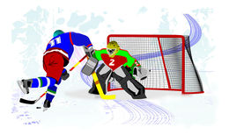
- Appreciate the richness of our country’s ethnic diversity,
- use the available resources to pray for the areas of greatest need in Mexico,
- get involved in serious missions projects among Mexico’s eth-nic groups, being aware of their cultures and the specific needs of their contexts, and
- distinguish between local missions in our Judea and cross-cultural missions in our Samaria.
©Depositphotos.com/Leonid Dorfman
The mission of the Apostle Paul was to preach the gospel where Christ was not known (Romans 15:20). [Slide #1 of the PowerPoint] Strictly speaking, there is no such place in Mexico. The Spanish missionaries finished the task, to the extent that all Mexicans have heard the phrase: “Christ died for our sins.”
A note to our international readers: This chapter is only about Mexico, so the title is high-lighted in yellow instead of all the text. You should substitute this entire chapter with the relevant study of the unreached ethnic groups in your own country. Section V might be directly applicable to your situation. Section VI could serve as an example.
Nonetheless, we would say it was an incomplete knowledge of Christ. It has been said that the Catholic church brought a Christian worldview to Mexico but lacked the ministry of personal salvation through faith in Jesus Christ. Those of us who have evangelized within the Spanish-speaking Mestizo culture are familiar with this, but the situation is more complicated when evangelizing in Mexico’s ethnic groups.
This superficial Catholic worldview, coupled with the practice of sacramentalism (the sacraments being not merely symbols but the conduit of grace), gives rise to a combination of pre-Columbian beliefs and nominal Catholicism in Mexican ethnic groups. This mix is called syncretism, in other words, the combination of two belief systems. Add to this the great variety of languages, the adverse conditions in which they live, their tribal organization, and the tensions with the dominant Mestizo culture and we have a very complex situation. This is why we insist that the work among Mexico’s ethnic groups is truly cross-cultural missions.
_{©Depositphotos.com/zzve}
Jesus did not just send us to preach the gospel among the Mexican ethnic groups, but to make disciples. If we copy the urban, Mestizo, evangelical church model in the indigenous Mexican groups, we will be in danger of creating a new type of syncretism - churches that do not produce true disciples of Christ nor connect with the indigenous soul.
It is not enough to just proclaim the gospel,
we must make disciples in every ethnic group in Mexico.
With humble hearts and our missionary eyes wide open we can effectively help the indigenous church in Mexico to grow. We hope the churches of Mexico and the world will see the spiritual needs of the ethnic groups within our country. We need people who will speak their diverse languages and live among them, as did Jesus, to take them the message in an understandable, significant way that will produce true discipleship.
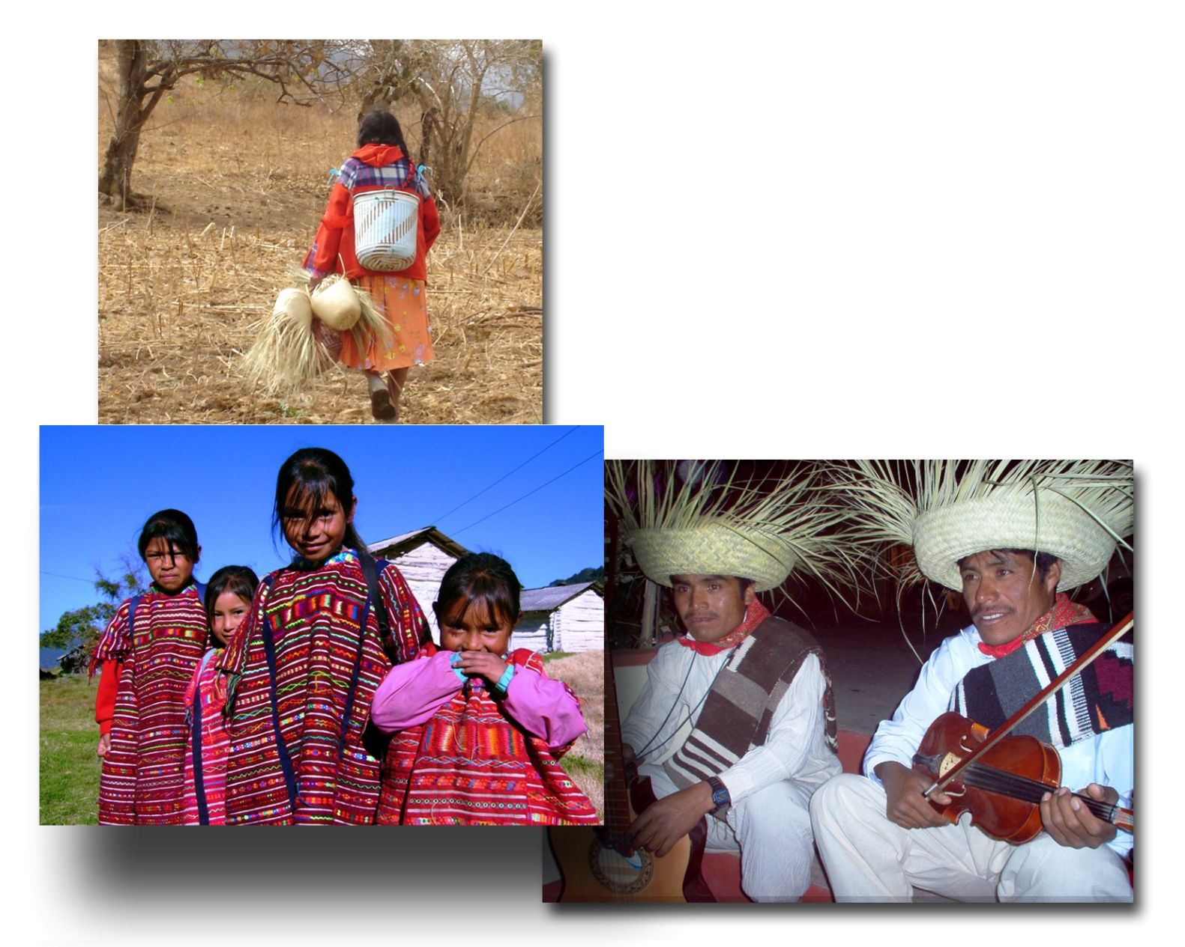
I. The Great Ethnic Diversity of Mexico [2]
There are few countries in the world that surpass us in ethnic richness. India is number one, with 3,000 ethnic groups. A few countries in Africa also have more ethnic groups, but Mexico ranks second in the western hemisphere after Brazil. We often hear about the Zapotecs, thinking they are just one group, but there are 53 variations of Zapotec, each one different from the next. There are 85 Mixtec variations, and so it is with other groups. Even though there are 55 main language groupings whose names we may have heard, there are a total of 335 different ethnic groups, each with its own dialect!

Fotos por Alejandro Rodríguez

II. Research into the Ethnic Groups of Mexico [3]
God has given Mexico the privilege of being one of a growing number of countries in the world that has researched the ethnic groups within its borders. In 1992, various mission agencies met to determine the number of ethnic groups in Mexico and the extent to which the gospel had penetrated each one. The group called itself Operation Samaria. Later, the Research Department of COMIMEX was formed to follow up on this process.
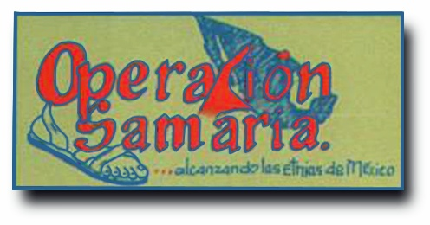
Operation Samaria’s research was based on the linguistic research previously carried out by the Bible translators. The results of Operation Samaria’s work were published in the first two editions of the book Let Us Reach the Ethnic Groups of Mexico (Alcancemos las Etnias de México). [4] For the third edition the decision was made to publish the updated statistics separately. This data can be found on the website www.etnopedia.org, following the link to Mexico. [5]
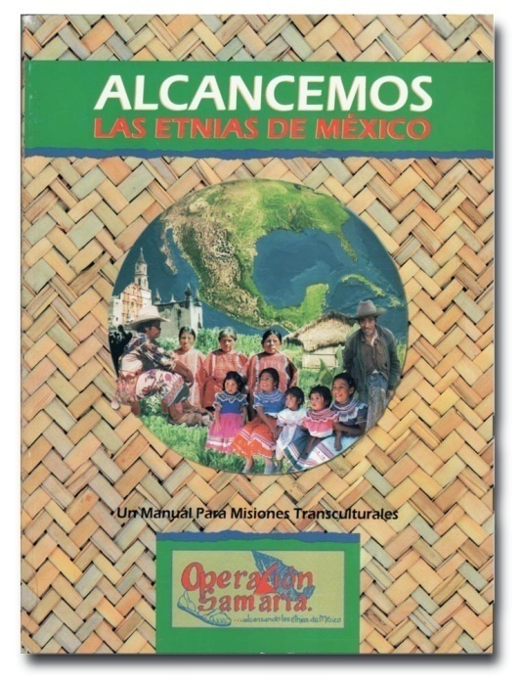
The Let Us Reach book serves as a general introduction to the spiritual condition of Mexico’s ethnic groups. It contains essential articles for the church that wants to pray for its Samaria and begin a serious work in an ethnic group. When presenting this chapter in a church, be sure to have this book on hand to show and explain how the church can use it for new projects in their Samaria.
This research has given us important and surprising information. Although the church of Jesus Christ has existed in our country for more than a century and a half, there are still ethnic groups in Mexico with no church - no viable church that can share the gospel in an understandable, meaningful way.

III. The Morelia Scale [6]
In order to do this research it was necessary to create a scale to measure the degree of gospel penetration in each group. Thus, the Morelia Scale was developed, named after the city of Morelia, Michoacán, where Operation Samaria met for the first time. This has been an important contribution from Mexico to the world mission movement. The Morelia Scale has seven levels which describe an ethnic group from an evangelistic and ecclesiastic point of view. You will find a chart on the following page that describes the scale.
Let Us Reach the Ethnic Groups of Mexico
Available for retail or wholesale. Please call
52 (55) 5938-1780.
[7] We praise God because there are very few Level 1 ethnic groups in Mexico, which we are calling “totally unreached”. Those ranked at levels 2 and 3 are considered unreached by international definitions. At the higher levels it becomes more difficult to say whether or not an ethnic group needs more help from missionaries.
[8] It is not like a light bulb that is either on or off; there are many shades in between. This is further complicated by the fact that an ethnic group can show signs of a viable church, but a few years later it may become stagnant. For this reason, COMIMEX continues to monitor the development of the indigenous churches, insisting that ethnic groups in levels 4, 5 and 6 still need help from the outside, but appropriate to the development and needs of each case. We call these “undiscipled” ethnic groups (although level 6 would probably be considered reached by international standards).
[9] The ethnic groups at level 7 are considered reached using the very high standard described on the next page. These should be challenged to send missionaries to other ethnic groups.
_{©Depositphotos.com/3577543_m} _{Operación Samaria}

The Morelia Scale

1) Without Any Knowledge of the Gospel:
There is no known person with an understanding of the gospel.

2) Sporadic Knowledge of the Gospel:
There has been some Christian testimony, but it has not been permanent.

3) Some Believers:
There are some known believers in the ethnic group, but they do not meet together.

4) The Beginnings of a Church:
There is a small group of believers that meets weekly.

5) A Church in Numerical Growth
The church has grown in number in the last year.

6) A Church in Spiritual Growth:
The church members are growing spiritually. Even though the ethnic group may be considered reached, they may still need outside help for leadership and ministry development.

7) A Self-reproducing Church:
This is a church that fulfills levels 5 and 6 above, but is also self-reproducing, self-sustaining, self-governing, and has the New Testament translation. This is considered a reached ethnic group and they should be challenged to reach out to other groups.

IV. The Present Situation [10]
For more information about the location, strategies, and missiological aspects regarding the work among the ethnic groups of Mexico, please contact…
- www.etnopedia.org ,
- The Department of Investi-gation,
- The Department of Mis- siological Principles,
- The Network of Mission Agencies, and
- The Network of Missionary Training Institutes
- Indigenous Department
at www.comimex.org
As we mentioned, there are a total of 335 ethnic groups, of which 27 are considered reached, 272 are considered undiscipled, and to our surprise, there are 25 unreached ethnic groups in Mexico. These groups do not have a church that can give a Christian testimony, unless we do something so they can hear the gospel and have a church planted among them. This is an important focus of COMIMEX, and should be the focus of Mexican churches: to establish a church in each of these 25 ethnic groups!
The 272 ethnic groups which are undiscipled also require an effort. They need the help of their Mexican or foreign brothers and sisters to prepare leaders, finish the Bible translation, facilitate the multiplication of churches, establish ministries focused on their particular needs, and mobilize their missions force. These ethnic groups, the 272 undis-cipled and the 25 unreached, are the ones your church can prayerfully consider adopting. (See the “Adopt-A-People” chapter.)
A note to our international readers: The colors (green, yellow, red, and black) and their corresponding categories (reached, undiscipled, unreached, and totally unreached) have been modified from the Spanish version of this book to exactly reflect the color codes and data of the website www.etnopedia.org/mexico.
The 27 reached ethnic groups should be challenged to join the world missions movement as full-fledged members, working shoulder to shoulder with the traditional mission agencies. The chart below shows these distinctions.

V. For Effective Missions in the Indigenous Context [11]
Before running off to the mountains, a church should find out if there are already missionaries working in the chosen ethnic group. If so, there are two options: 1) Respect the experience and fruit of these missionaries and work with them, or 2) work in another area far from them so as not to interfere. We do not want to export denominational competition to the indigenous context.
After discerning where God wants us to work, we need to consider the differences between the Mestizo church and the needs of the ethnic group. These differences can be loosely grouped into three categories.
A. Missiological considerations - Wow, what big words! It just means that maybe we should not use the methods we have always used in the sending church. What works in the city does not always work in remote areas, and can even be harmful. When an indigenous person goes into a Christian church for the first time he should feel totally at home, in his own culture. This has many facets:
- The native language should be used as much as possible, both in the Scriptures and in the church. Many of the theological words used in Spanish are not understood by the indigenous people. There are many resources available, both written and recorded. There are also many inexpensive tape, CD or MP3 players that can facilitate the use of the language.
- The style of music should be their own. Often they accept the music the missionary brings only to please him, but this music does not really touch their hearts.
- Experiment with oral methods for discipling and leadership training. Many people cannot read, and even if they do it is not their preferred way of learning. We need to rediscover the art of storytelling.
- There are inoffensive customs within the culture that do not have to be abandoned upon becoming Christian, such as wedding and fellowship traditions.
- On the other hand, there are offensive customs in the culture which should be discarded, but the void this leaves must be filled in the church. For example, if they were accustomed to praying to the rain god to assure a good harvest, upon becoming Christians they must learn that God and the church also care about their crops.
©Depositphotos.com/Klara Viskova

B. Pastoral considerations [12] - The indigenous society and the adverse living conditions present numerous challenges for the pastor and the church. The missionary who arrives from a different context or the visiting pastor often does not understand these situations, causing their ministries to perhaps seem irrelevant to the congregation. It is also possible that the indigenous pastor received his training in a Bible institute in the Mestizo culture and is not trained to recognize these situations. The following are some important considerations.
- The migration of men to distant harvest fields as well as to the United States causes many problems in the families and in the churches.
- Alcoholism devastates the indigenous people.
- The political parties vie strongly for constituents, causing divisions even within a local church.
- The pastor’s salary is often a challenge in a subsistence based agricultural economy.
- Both polygamy and illicit crops complicate and con-fuse the incorporation of new members into the church.
- Persecution is strong in the villages, often revolving around the famous town festival.
_{©Depositphotos.com/agnieszka}
- The lack of medical attention places demands on one’s faith and the pastoral ministry.
- Purchases made on credit with high interest rates leave many with crushing debt.

C. Difficult physical conditions [13] - Droughts, floods, malnutrition, sterile fields, and difficult access to markets, to name just a few. God is concerned with all these problems and mentions them in the Bible.
There must be practical ministries and theological reflection that deal with all these physical struggles so that the indigenous Christians can find the spiritual, emotional, and practical answers they need in the life and teaching of the church. (Of course this must be done in an evangelical context. We do not want to start another round of liberation theology or liberalism.) We propose here several simple technologies and ministries to improve nutrition, health, and the quality of life.
- Nutrition can be improved through integrated projects using microtunnels (small greenhouses), compost, and vegetable gardens.
- More benefit can be derived from fruit and vegetable harvests by using simple techniques for food pre-servation such as canning and drying.
- Where water is scarce projects such as wells, recycling, storage tanks, the regeneration of aquifers, and reforestation are required.
- Drainage and plumbing projects are needed to avoid disease and contamination.
- There can be basic health and first aid projects.
©Depositphotos.com/Evgenia Smirnova

This list of possible projects and ministries does not pretend to be a one-size-fits-all recipe for any missionary work in the indigenous groups of Mexico. Every context is different. Nor does it pretend to put aside the proclamation of the gospel and spiritual discipleship, which are always a priority in a mission work. It is simply an attempt to make the church more relevant in its context. The abundant life in Jesus Christ can speak to the extreme challenges of their lives.
Can you read Acts 1:8 in Portuguese?

VI. The Difference Between Judea and Samaria [14]
“Mas recebereis poder, ao descer sobre vós o Espírito Santo, e ser-me-eis testemunhas,
tanto em Jerusalén como em toda a Judéia e Samaria, e até os confins da terra.”
The vision of COMIMEX has always been to promote cross-cultural missions among the unreached ethnic groups, but since we are studying Mexico in this chapter, it is fitting here to also mention the needs in our “Judea.” Our purpose is to promote local missions (or home missions) in Spanish in this needy area and also to show the difference between local missions and cross-cultural missions.
Our starting point is always the Bible, and in this case we will look at Acts 1:8. Some miss the meaning and force of this verse, saying, “Jesus spoke of a chronological sequence and we are still not finished with our Jerusalem. How then can we send resources to Judea, Samaria, and to the ends of the earth?” This paradigm is flawed in two ways. First, let us look at the Greek.
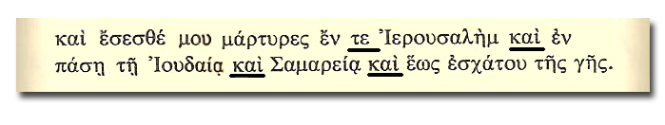

Note the underlined words: Te... kai... kai… kai. According to the Greek-English Lexicon of the New Testament, by Walter Bauer, this construction means: In Jerusalem as in all Judea, as in Samaria, and as in the ends of the earth. Edison Quiroz, the internationally known missions mobilizer from Brazil, tells us that this is precisely how the passage is translated in Portuguese (see the text box above). [15] Jesus was talking about simultaneous actions in the four areas, not a chronological sequence!
To the ends of the earth, friends!
Paul
Luke Barnabas Timothy
The second reason is the historical context of the book of Acts. [16] In the span of the thirty years covered by the book of Acts, Paul was in Rome planning a missionary journey to Spain. For them, Spain was the ends of the earth! He understood that they were simultaneous actions.
Another way to avoid the force of the verse is to equate “the ends of the earth” with the borders of Mexico without looking beyond them. The following chart [17] shows a biblical understanding of Acts 1:8 as well as a more precise interpretation based on our situation today in Mexico.

Acts 1:8 | Chapters in Acts | Characteristics | What it means for us  today in Mexico.
Jerusalem | 1-7 | Implies evangelism in the  place where you live. | The evangelism ministry  of the local church.
All Judea | 8-12 | Implies a short trip to  evangelize in your own  language and culture. | Planting new churches in  Mexico or Latin America,  working in Spanish.
Samaria | 8-12 | Implies a short trip to  evangelize in a different  language and culture. | Planting churches in the  unreached ethnic groups  of Mexico.
To the ends  of the earth | 13-28 | Implies a long trip to  evangelize in a different  language and culture. | Planting churches in the  unreached ethnic groups  of the 10/40 Window.

It is interesting that Jesus said, “in all Judea.” Our Judea is very big indeed! The map on the following page [18] shows the percentage of Christians in each state of Mexico. Obviously, these statistics will include the Christians in the indigenous ethnic groups along with the Spanish-speaking, Mestizo Mexicans, but it does give us a good idea of the general population.
Our Judea is any part of Mexico or Latin America where we might go to plant churches, working in our native language, Spanish. You can argue that the trip was long and the ticket cost a lot of money, but in terms of time, it took you what it might have taken Peter to cross Judea on foot. On the other hand, if we go to the mountains and enter an indigenous village, with another culture and language, we are now in our Samaria! You will experience the difference between evangelism and cross-cultural missions when you cross that line between Judea and Samaria.
On the map the black represents more than 10% evangelical Christian. The shades become progressively lighter until you reach white, representing less than 2% Christian. Note how the darker shades are located around the borders of the country and the white part is in the middle, the area known as the Bajío (plateau). The bull’s-eye is in the middle! [19] On page 74 you will find a parable to help you understand Acts 1:8.
The goal is to hit
the bull’s-eye!

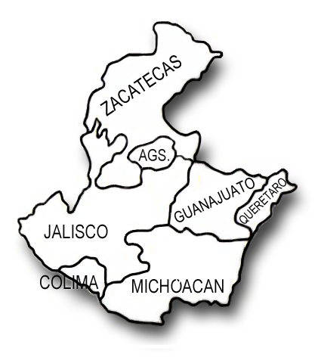
VII. The Bajío and the Circle of Silence [20]
Dr. Gerry Gutierrez, from the Gospel Recordings ministry, has commented on the conditions in the Bajío:
The Bajío is a fertile plateau in the heart of the country, comprised of the states of Guanajuato and Michoacán. It includes the high mountains, plains, and such productive valleys that the region has been called the Mexico’s Granary. The adjacent states of Querétaro, Jalisco, Aguascalientes, Zacatecas, and Colima can also be considered part of the heart of the country, as they share the same characteristics.
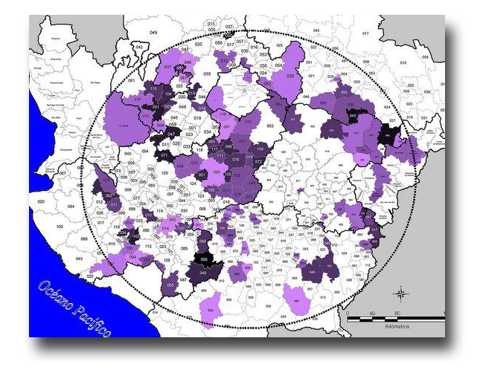
You will notice when looking at a map of the percentage of evangelicals in the states of Mexico that the Bajío region has less than 2% evangelical. If it were not for the scarcity of evangelicals in this region, the percentage in the country would be much greater than 10%.
The Bajío has very strong religious traditions. There are many religious shrines in the area, considered very important by the Catholic church. The seminaries in Zacatecas prepared the priests who imposed the Catholic religion on the indigenous people during the conquest. Even to this day the Catholic church continues to recruit its priests for all of Mexico from the states of Guanajuato and Jalisco.
There are few indigenous peoples in the Bajío, and those there are have been resistant to the gospel. We could mention the Purépechas and a Náhuatl group in Michoacán, and the Coras and Huicholes of Nayarit, although Nayarit has a growing number of evangelicals.
We are mentioning the Bajío for two reasons: To promote prayer so the kingdom of God will extend into this region, and to challenge people to go to this very needy region of our Judea.
Using information from the Mexican census, another ministry, Good News for the Circle of Silence [21], has made a detailed study of all the municipalities in Mexico with less than 1% evangelical Christians. They inform us that 75% of these municipalities are found in the Bajío, specifically in the “Circle of Silence” which can be seen on the map on the left. (The purple indicates less that 1% Christian.)
Please consult www.bnuevas.com/evangelicos
_mexico_2010.pdf
for detailed information about the municipalities with the least number of Christians.
Although any municipality with such a low index of Christians should be targeted for church planting, those in this area have fewer Christian neighbors to evangelize them. For more information about this ministry which is working in the Circle of Silence, contact correo@bnuevas.com .

I was in Aguascalientes at a missions conference. Jorge Lozano, the organizer, invited me to share with the pastors’ alliance, and on the way to the meeting he mentioned, “I think we in COMIMEX have made a big mistake. By emphasizing so strongly the difference between evangelism and cross-cultural missions, the pastors are feeling like they must choose either one or the other. And, for the most part, they are choosing evangelism!”
I was meditating on this as I waited for my turn to speak. I thought to myself, “What am I going to share with them? Another missions verse? Another statistic?” I sat there looking up and praying when I suddenly noticed that the structure of the walls and ceiling of the nave provided the solution! (The word nave is used in traditional churches to refer to the inside of the structure where the congregation gathers.) So I shared the following: [22]
“Let us imagine that the nave of this church represents the entire world population. Study the structure of the walls and the ceiling for a moment.” (It had plastered walls 5 meters high, composite metal beams extending from one wall to the other to support the roof, and C-shaped channels extending between the beams to support the asbestos roof panels.) I continued, “We are going to represent the Great Commission with the command: ‘Paint the whole nave!’
“We will start with the easiest part, the lower part of the walls. It will require water-based paint and rollers. It is easy to apply and not at all dangerous. Everyone can help - children, youth, adults, and the elderly. This represents our Jerusalem, and it is the ministry of evangelism in our local churches.
“While others continue to paint what they can reach from standing on the floor, some bring ladders to paint the upper parts of the walls. Now, we are not going to let the children or the elderly climb the ladders because it is more dangerous, although we will still use the same technique (water-based paint and rollers). This represents our Judea, Spanish-speaking church planting in Mexico and Latin America. We are using the same techniques of evangelism that we used in Jerusalem, but it requires an extra effort to travel and work. We generally send more mature, committed people.
“As we continued with the walls we asked ourselves: What about the metal composite beams? We could reach them by leaning the same ladders up against them. It is not farther or harder to reach than the upper parts of the wall, but it is a lot more dangerous because the ladder could slip and fall. Maybe we should hire some professional painters? The painting technique is very different, too. First you have to sand the metal, clean off the dust, apply an oil-based primer with a brush, and finally a coat of colored, oil-based paint. This represents our Samaria, church planting within the indigenous ethnic groups of Mexico. It is not too far or expensive to get there, but the techniques for evangelism are quite different. It requires devoted and well-trained people.
“And now, the C-shaped channels between the metal composite support beams! How are we going to paint these? With a scaffold. It is very difficult to reach them, but we will use the same painting techniques as we used on the metal support beams. This represents the ends of the earth! It is very far away, expensive, difficult, and dangerous work. It requires well-trained missionaries sent out and supported by the churches of Mexico.
“We should not choose between evangelism and cross-cultural missions. It is only one project: Go and make disciples of all nations! The same love and concern we have for our neighbors and local communities should also extend to the unreached ethnic groups, except that it requires special projects and people specifically trained to go there. Jesus said, ‘Make disciples of all nations.’ It would be absurd to put 20 coats of paint on the lower parts of the walls and leave the metallic parts rusting and ugly. Paint the whole nave!”

©Depositphotos.com/Jaimie Dupla
