When we think of missions in the New Testament, the first, and often the only thing that comes to mind is the Great Commission in Matthew, Mark, and Acts. When it comes to New Testament missionaries we only think of Paul and his companions, or possibly Peter. This represents an inadequate paradigm, and for that reason the goals of this chapter are:
The Goal
- To show that the entire New Testament is a missions document,
- to understand how Jesus was teaching his disciples a mission-ary vision and leading them on mission trips,
_{©Depositphotos.com/patrimonio}
- to understand that the purpose of the power of the Holy Spirit is first and foremost missions,
- to see how difficult it was for the early church to capture this cross-cultural missionary vision, and
- to see in Revelation that the culmination of God’s plan is for the nations.
Before we begin, it would be wise to remember the principles we learned in our study of the Old Testament. [Slide #1 of the PowerPoint] At the end of the Old Testament, the prophet Malachi strongly admonishes God’s people for having failed in their obligation toward the nations. In spite of all this, God sum-marized his missionary vision by saying, “My name will be great among the nations, from the rising to the setting of the sun” (1:11). His plans for missions continue in the opening chapters of the New Testament.
Lessons learned from the Old Testament
- The context of a passage is critical for its correct interpretation.
- The motivation for God’s or the biblical characters’ actions is crucial in the interpretation of a passage.
- The Bible is a unified story with a logical devel-opment from beginning to end.
- God’s missionary purposes were proclaimed at the beginning of each new era of Old Testament history.
- God had a distinct missionary strategy for each of Israel’s situations.
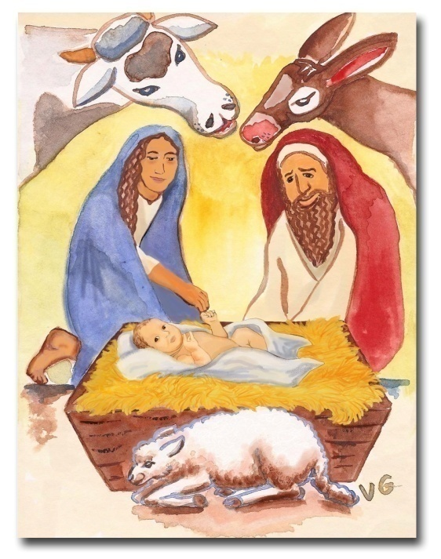
I. The First Christmas [2]
When we think of Christmas we immediately think of being at home with the family, the delicious meals, a warm, hospitable environment, and presents. But the biblical Christmas story was totally different. It is a story of journeys, dangers, inconveniences, the midnight flight to Egypt, and the slaughter of children.
The Savior’s arrival into the world causes both hostile resistance from the devil and a chorus of the heavenly hosts. The New Testament opens with the kingdom of God invading the kingdom of Satan. A popular saying is: “God had only one Son, and he was a missionary.” Christmas is the beginning of the Son of God’s missionary journey from heaven to earth.
There are many ethnic groups involved in the Christmas story: Romans, Israelites, the magi (from Babylon?), Egyptians, and Syrians, with the story itself written in Greek. The nations of the earth arrived to worship Jesus in the persons of the magi.
At the conclusion to the Christmas story, Simeon, full of the Spirit, lifted Jesus up and prophesied saying, “For my eyes have seen your salvation, which you have prepared in the sight of all people, a light for revelation to the Gentiles (ethnic groups) and for glory to your people Israel” (Luke 2:29-32).

II. Jesus’ Ministry [3]
Many think that Jesus was speaking literally when he said, “I was sent only to the lost sheep of Israel,” and that he had no concern for the ethnic groups until he gave the Great Commission in Matthew 28. In reality, the Great Commission was a summary of the mission-ary vision that Jesus had been trying to teach to his disciples all during his time with them on earth.
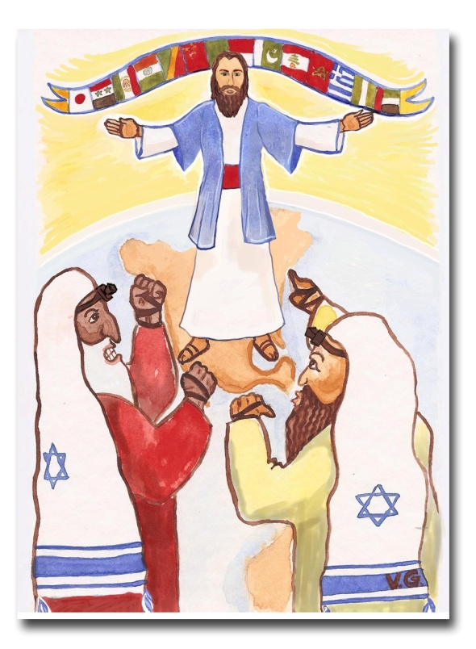
A. Jesus begins his ministry. - In Luke 4:16-30, Jesus ministered in his home town of Nazareth. When they handed him the scroll of the prophet Isaiah, he purposely opened it to the passage where the Messiah speaks in the first person. The Jews had the custom of never reading this passage aloud, yet Jesus reads it out loud and adds: “Today this scripture is fulfilled in your hearing.”
Everyone spoke well of him until he began to oppose them for their lack of a missionary understanding, quoting two examples from the Old Testament, Naaman the Syrian and the widow of Zarephath, where God had healed people from other ethnic groups (see pages 25 and 26). Then they became furious and tried to kill him! Jesus began his ministry with the same admonishment with which Malachi had closed the Old Testament - the lack of vision for reaching the nations on the part of God’s people.
B. Jesus gave the example. [4] - Jesus moved about among the Jews, but he showed that God loved all the ethnic groups. Let us look at the way Jesus so compassionately dealt with the Gentiles and Samaritans in order to get his disciples to think cross-culturally.
- Jesus praised the Roman centurion in Luke 7:1-10 as an example to all saying, “I have not found such great faith even in Israel.”
- In John 4 Jesus revealed to the Samaritan woman that he was the Messiah and she and the whole town were converted. Pointing at those Samaritans, Jesus said to his disciples, “Open your eyes and look at the fields! They are ripe for harvest.”
- Jesus had said four times in John’s gospel, “My time has not yet come.” But when Phillip and Andrew told him in John 12:20-24 that two Greeks were looking for him, he said, “The hour has come...” Like the magi who came to worship him as a baby, now two representatives of the Greek world seek him out, and for Jesus it signaled that his mission was nearing completion.
- In Luke 10:25-37 Jesus rebuked the Pharisee for his lack of love toward the Samaritans.
Jesus took advantage of each of these situations to teach his disciples about the ethnic groups, but the most compelling example is in Matthew 15 where Jesus takes them on a “short-term mission trip” to the pagan region of Tyre and Sidon. Many commentators miss what Jesus was doing in this story because they do not interpret it through missionary eyes. If we take it literally, Jesus ignores the woman (verse 23), declares that he was sent only to the Jews (verse 24), and calls her a dog (verse 26).
Does this sound like the Jesus you know? Some try to soften this insult by saying that the word dogs refers to cute little dogs like Chihuahuas or French poodles! But Jesus was only imitating the disciples’ prejudices and racism, just leading them along to see what they would do. They failed the test when they basically said,
©Depositphotos.com/Basheera Hassanali
“Send her away! She is not a Jew!” At the climax of the scene, when his disciples were convinced that he was thinking just like them, Jesus turned to the woman and said, “Woman, you have great faith!” The disciples were shocked! They learned an important lesson, but as we shall see, it was hard for them to put into practice this love for the nations that Jesus was trying to instill in them.
C. Jesus provided a strategy. [5] - In Acts 1:8, analyzed in detail on pages 70 and 71, Jesus described a missions program which every local church should follow, an outreach to their Jerusalem, Judea, Samaria, and to the ends of the earth. This way we would cover the earth with the gospel.
For the people of this world are more shrewd in dealing with their own kind than are the people of the light!
D. Jesus spoke of funds for missions. [6] - Luke 8:3 shows that Jesus himself received economic support from the women who followed him.
In the parable of the shrewd manager in Luke 16, Jesus exhorts us to look at the “people of this world” because they are wiser (more shrewd) in reaching all the earth with their products than we are with the gospel. Afterwards, he relates the parable directly to missionary giving.
The elements of the parable, the words of verse 9, and the application for us today form a perfect parallelism that can be seen in the chart on the following page. [7] The elements of the parable are in yellow, from left to right. Verse 9 is in green, and the application for us is in blue. Jesus is challenging us to undertake large, daring missionary projects in the same way the multinational companies invest enormous amounts of money to promote products that have no eternal value.
The elements of the parable, Luke 16:1-9 | Use | dishonest business dealings | to gain people indebted to me | so that | when I lose my job here | I | will be welcomed | into their houses.
Verse 9 | “Use | worldly wealth | to gain friends for yourselves | so that | when it is gone | you | will be welcomed | into eternal dwellings.”
The application for us | Use (invest) | money | to gain converts | so that | after the final judgment | you | will be welcomed (by the converts) | into heaven!
Luke 16:9
E. Jesus prophesied about the fulfillment of the Great Commission. [8] - In Matthew 24:14 Jesus linked the end of the world with the fulfillment of the Great Commission. So that no one would misinterpret the phrase “in the whole world,” he clarified it with the additional phrase: “to all nations” (ethnic groups).

III. The Great Commission and the Holy Spirit [9]
You cannot separate the Great Commission from the Holy Spirit. Every time Jesus promised the Holy Spirit he also gave the Great Commission, and every time he gave the Great Commission he also promised the Holy Spirit. What can we conclude from this? The primary purpose of the Holy Spirit is to give power to evangelize the ethnic groups of the world. Fill in the following chart with the participants. Each time Jesus gave the Great Commission, he also emphasized a particular aspect of the Commission (second column) that helps us today with missionary strategies.

Bible Reference | Aspect of the Great Commission | The Great Commission¹ | The promise of the Holy Spirit¹
Mathew 28:18-20 | The Method² – “Make disciples”
Mark 16:15-18 | The Magnitud² – “To every creature”
Luke 24:44-49 | The Message² – “Repentance and forgiveness of sins”
John 20:21,22 | The Model² – “As the Father sent me”
Acts 1:8 | The Ministry – “Jerusalem, all Judea, Samaria, and to the ends of the earth”
¹Edison Queiroz, La Iglesia Local y las Misiones (Miami:Editorial Unilit,1994), p.21.
²Marv Newell, “Biblical Foundation for Making Disciples of Every People,” in Tokyo 2010 Global Mission Consultation and Celebration, ed. Yong J. Cho y David Taylor (Pasadena: Tokyo 2010 Global Mission Consultation Planning Committee, 2010), p.50.
A. The coming of the Holy Spirit [10] - If it is true that the purpose of the Holy Spirit is to empower us to evangelize the ethnic groups, we would expect to see this reflected when the Spirit was given for the first time, and so we do! In verse 5 of Acts 2 we read, “Now there were staying in Jerusalem God-fearing Jews from every nation (ethnic group) under heaven.” They had arrived from all over to celebrate the feast of Pentecost.
Jerusalem
Mesopotamia
Asia
Elamites
Medes
Pamphylia
Cretans
Cyrene
Egypt
Arabs
Parthians
Cappadocia
Pontus
Phrygia
Romans
The Spirit gave the apostles the ability to communicate to 13 ethnic groups at once. Here the historical context and motivation behind God’s actions figure prominently. God wants to reach the ethnic groups! How sad it is that churches today fight and divide over their particular doctrines about the Holy Spirit instead of uniting to complete the Great Commission, as the Holy Spirit desires.
Judea
“From every nation under heaven.” Acts 2:5
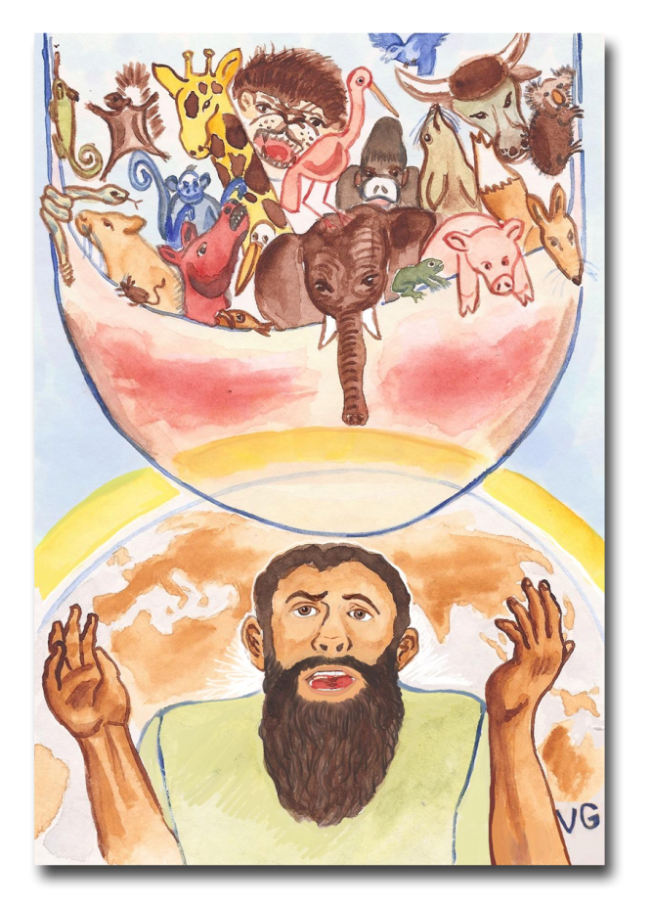
B. The Holy Spirit and new frontiers [11] - Without falling into any particular doctrine of the Holy Spirit, it is interesting to note that the visible manifestations of the Spirit, upon believing in Jesus, occurred many times when the church was crossing some new cultural barrier.
Those who fled to Samaria on account of persecution in Jerusalem (Acts 8:1-5) preached and the Samaritans were converted. The church in Jerusalem sent Peter and John to in-vestigate (verse 14), and it was then that the Holy Spirit was manifested visibly (verse 17).
The same happened with Peter in the home of Cornelius, a Roman centurion (Acts 10). Peter did not even want to enter the house because Cornelius was not a Jew, even after he had received the vision of the sheet. The manifestation of the Spirit was as much for Peter’s sake as it was for the Romans’! Note how timidly Peter asked for the water to baptize them (Acts 10:47). He then ordered his friends from Jerusalem to do the baptism (verse 48) because he knew that the church in Jerusalem would not agree with baptizing Romans (Gentiles). And just as he suspected…
Upon returning to Jerusalem, Peter was criticized for having entered a Gentile’s house, but he defended his actions with the visible evidence of the Holy Spirit. They then exclaimed, “So then God has granted even the Gentiles (ethnic groups) repentance unto life” (Acts 11:18).
C. The first voluntary mission [12] - In the first chapters of Acts we discover that the church had not understood its missionary obligation and that the advances that had been made were a consequence of persecution. In Acts 13 we finally see the church responding voluntarily. Note well: “the Holy Spirit said, ‘Set apart for me Barnabas and Saul for the work...’” (verse 2).
IV. The Response of the Early Church [13]
Samaria
It would be nice to be able to say that the early church obeyed the Great Commission from the very beginning. However, the question the disciples asked Jesus in Acts 1:6 reflects an attitude they would have to overcome: “Lord, are you at this time going to restore the kingdom to Israel?”
Jerusalem
Judea
Up through Acts 7 (a lapse of several years), we see no reference to any ministry outside of Jerusalem. Even though the Spirit had given them the capacity to evangelize all the ethnic groups in their own languages on the day of Pentecost, it seems it had not occurred to them to go to those groups and establish churches. In Acts 8:1 the moment had arrived for God to allow the persecution of the church of Jerusalem, and now we do find Judea and Samaria mentioned for the first time: “and all except the apostles were scattered throughout Judea and Samaria." [14]
If you do not obey Acts 1:8, God applies Acts 8:1!
Acts 8:1
This is interesting. The leaders of the church had also suffered per-secution but they stayed in Jerusalem. We also saw that the word apostle means “the sent one.” We could understand Acts 8:1 this way: “All ex-cept the sent ones were scattered (sent) throughout Judea and Samaria!”
This is a good lesson for us today. If it was difficult for the apostles themselves to understand the missionary vision, having been with Jesus, having seen the miracles, having heard the Great Commission, and hav-
ing lived in the power of the Holy Spirit, how much more difficult is it for us today!? [15] We have already seen how hard it was for Peter to enter Cornelius’ house. We could say the Jews’ racism blinded them to the ethnic groups around them, but what is our excuse? Laziness? Cost? Ignorance? The result is the same: the ethnic groups are still waiting for us!
We can identify with the church in Jerusalem for their initial lack of understanding of the Great Commission and we should ask forgiveness. In the same way we can see the church in Antioch as an example which can spur us into action. [16] From Acts 13 on, we find the church, Paul, and his missionary team responding voluntarily to the Great Commission. It is not necessary to review all the missionary activity in Acts 13-28; anyone can see it is all about missions. This course focuses on those passages where we have always missed the missionary interpretation and application.

V. The Book of Romans [17]
One of the unique characteristics of the book of Romans is the orderly, complete, and systematic presentation of Paul’s theology. We should ask ourselves why? The key is in 15:24 where Paul says, “I plan to do so when I go to Spain. I hope to visit you while passing through and to have you assist me on my journey there.”
What did Paul mean when he said, “Assist me on my journey there”? Paul was not expecting them to carry him or physically accompany him to Spain. He was asking for an offering to finance his missionary journey to Spain, which for them was the “ends of the earth.”
With this in mind, reread the well-known passage of Romans 10:13-15. Note how Paul takes them through a series of logical questions leading up to the last one: “And how can they preach unless they are sent?” (economically, to Spain). Paul needs help getting to Spain to preach the Gospel, so he wrote them a letter. In Bible interpretation this is called the “historical occasion” for the letter.
Paul did not know the Roman congregation personally, so his letter served to introduce himself to them and gain their confidence so they would support him financially. That is why he presents his theology so clearly in chapters 1 through 13. It is a letter from a missionary asking for funds for a missionary project, the same way missionaries write project proposals today.
To make his case for his journey to Spain, Paul turns up the heat in 15:1-22. He uses the word ethne nine times, but in our Bibles it is translated Gentiles. Due to this poor translation, we completely miss
1. Paul
wrote…
3. to reach
Spain.
2. to the
church in
Rome…
$$$$$
the point, because the common understanding of Gentile is “non-Jew.” The first six times he uses Gentiles to prove, through a study of the Old Testament, that this had always been God’s purpose for the ethnic groups. Then he uses the word three more times to talk about his own calling and passion for the nations. Instead of seeing Paul as an example that we should emulate, most Christians misunderstand him in this way: “Paul wanted to reach the non-Jews; I am not a Jew, therefore Paul’s ministry was for me! Thank you, Paul! End of subject.” Substitute the words ethnic groups or nations for Gentiles in this passage and see how your perception changes.
Note how Paul opens the book of Romans in 1:1-7. The emphasis of the passage falls on verse 5 where he says, “to call people from among all the Gentiles (ethnic groups).” He also closes in 16:25-27 saying, “so that all nations (ethnic groups) might believe and obey him.” The book of Romans is a fundraising letter for a missionary project.

VI. The Epistles [18]
Although the missionary vision is not found explicitly on every page of the epistles, there are several concepts and references that deserve noting.
- The historical context of the epistles is completely missions oriented. Paul, the missionary, wrote these letters to the young churches he had planted to correct doctrinal or practical errors, while he continued to new mission fields. The fact that the epistles carry the names of people from different cities reflects the constant movement and journeys behind them.
- Paul anticipated support from the Corinthians (1 Cor. 16:5, 6).
- In Galatians, Paul resists the Judaizing tendencies in the context of defending his call to the nations and God´s plan for the nations (1:15,16; 2:1-10; 3:6-14).
- In Ephesians 2:11 - 3:13, Paul shows that God’s plan (the mystery) always included the world’s ethnic groups along with Israel. Our misunderstanding of the word Gentiles to mean only “non-Jews” causes us to interpret this passage from a theological or spiritual
viewpoint, while missing Paul’s calling and passion for the ethnic groups.
- Paul wrote to the Philippians to thank them for having sent him a missionary offering, and it was not the first time. He tells them in 4:16, “for even when I was in Thessalonica, you sent me aid again and again.” Any missionary today who writes letters to thank his or her supporters can identify with this letter.
- In Colossians [19], Paul speaks of the proclamation of the gospel “all over the world” (1:6) and “to every creature under heaven” (1:23).
- The church at Thessalonica had an exemplary missions program (1 Thessalonians 1:2-10).
- John urges his readers to support traveling missionaries in 3 John 5-8.
VII. The Pastoral Epistles [20]
1 and 2 Timothy and Titus are called the pastoral epistles because they contain instructions pertaining to church organization, but again we need to see the historical context. Paul, the veteran missionary, is sending instructions to the younger missionaries. He is urging them, “Hurry up and finish organizing the churches. We have new fields to reach. Bring my Bible and my jacket that I left in Carpus’ house. I already sent Tychicus to Ephesus.” It is like reading the e-mails of a first century mission agency!

VIII. Revelation [21]
The premise of this Old and New Testament study is that the Bible is a logical, orderly story from Genesis through Revelation:
The Bible tells the story of a missionary God and his strategy to take the gospel of salvation to all the ethnic groups of the world.

We ought to find an impressive ending to this story in the last book, and so we do! In Revelation 5:9 we find Jesus being worshiped by the heavenly host: “You are worthy to take the scroll and to open its seals, because you were slain, and with your blood you purchased men for God from every tribe and language and people and nation...” The great multitude in 7:9 is from “every nation, tribe, people, and language.” What Jesus prophesied in Matthew 24:14 is finally fulfilled.
©Depositphotos.com/Halina_photo
We began the study of the Old Testament showing that the Bible is a story in which the protagonists are introduced, the antagonist sets the stage for the drama, and just when the situation looks hopeless, God begins his strategy for salvation in Genesis 11 and 12. The rest of the Bible shows the advance of the kingdom of God over the kingdom of Satan.
The Tree of Life
The story reaches its climax in Revelation 19 and 20 with the final battle which Jesus wins by his great power and authority. After the climax of any story comes what is called the epilogue, where we see the protagonists returning to a place of peace and blessing. The Bible is no exception.
On each side of the river stood the tree of life, bearing twelve crops of fruit, yielding its fruit every month. And the leaves of the tree are for the
healing …
of the nations!
The last two chapters show God and mankind living together in communion and perfect intimacy in paradise, the New Jerusalem. But note on the left just how humanity is described in this new paradise (22:2). The access to the tree of life that Adam and Eve lost in Genesis 3 is restored in Revelation 22 to “the nations” (ethnic groups)! The tree of life shows how the missionary story is unified in the Bible. The story began in a garden and ends in a city; it began with death and ends with eternal life; it began with a single couple and ends with all the nations!
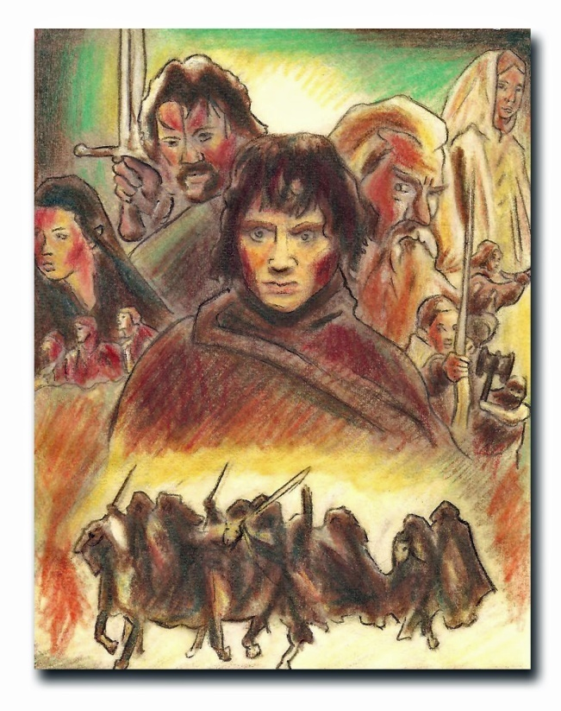
IX. The Truth or Fantasies [22]
The Bible is the most important and the most exciting story ever written. It is the original story that many have copied. Lately there have been a series of movies such as Star Wars, The Lord of the Rings and The Chronicles of Narnia, which have captured the imagination of a whole generation of young people. These pale in comparison with the Bible and the drama that goes on to this day wherever the kingdom of God is invading the kingdom of Satan. (Although Rings and Narnia were written by Christian authors, most moviegoers do not realize that these films are metaphors of the Bible story.)
What a shame that these movies are so exciting for young people while church may seem like a chore or an obligation. The following article shows how they have copied our story. Hopefully it will be useful to you in your ministry of missions mobilization, especially among young people.
[23] The Star Wars and The Lord of the Rings series are imitations of a true story. The true story is the Bible and the advance of the church of Jesus Christ among the ethnic groups of the world. What a shame that fantasies attract the young peoples’ attention more than reality! How exciting to go to the movies and watch science fiction, while church can seem like a dry routine or tradition. If something in these movies arouses interest, captures the imagination, and evokes the desires of the heart, how much more exciting must the true story be? Let us analyze the various elements of these movies to show how they come from the Bible.
The struggle between good and evil - The Bible begins with creation, then the enemy, the devil, immediately appears. The struggle between the kingdom of darkness and the kingdom of God unfolds throughout its pages and ends in a final war, where Christ and his heavenly hosts defeat the devil. Which is the original story? The Bible, of course!
Ancient prophesies and writings - In this type of science fiction there are often ancient writings, forgotten for thousands of years, which are discovered and then contain the knowledge to unleash special powers. That is what Gandolf did in The Lord of the Rings, and also the protagonist in The Mummy. Something inside us longs for that connection with deep, ancient wisdom. But where does this tradition come from? The Bible, of course! It contains the most faithful writings of antiquity. It narrates the creation of the universe, the earth, and mankind. It contains the most precise descriptions of ancient civilizations. In it is the story of God himself visiting the earth. There are prophecies yet to be fulfilled, and when you read it, you find the Holy Spirit breathing life into its words and into your life.
Wise prophets - When the wise Jedi leader Yoda speaks, all listen. Gandolf embodies that same essence of wisdom and knowledge. In a time of corrupt politicians who fall into disgrace and humiliation, we long to be able to trust someone who is clean, pure, and incorruptible. Hollywood knows this, so they offer it to us in the movies. But do we not find these people we are looking for among the great Bible characters? What about Abraham, Moses, Isaiah, Miriam, and Jeremiah? Again, we find that the kingdom of God is the real story!
Strong, valiant warriors - The movie stars are the Jedi knights, whose strength, courage, and honesty are the admiration of every young person. We find in The Lord of the Rings the same dynamic in those who comprise the fellowship of the ring. There is a certain mystique about valiant

soldiers who give their lives for just causes. Do we not feel that same nostalgia for the heroes of the Mexican Revolution? Consider David and his mighty men who established Israel. Let us not forget Deborah and Gideon, who risked their lives to rescue God’s people. In the New Testament the war is spiritual, but the warriors are just as valiant: Paul, Peter, James, Stephen, and Lydia, among many others. Once more we find that we have the truth.
Journeys - There is always an adventure that requires a mission or a journey. Something in our hearts wants to travel and conquer new horizons. God’s first word to Abram was: “Leave.” Israel followed the cloud by day and the pillar of fire by night. Jesus said, “Go and make disciples of all nations.” We are not even sure where Paul ended up! The Bible is a story of journeys.
Ethnic groups - One of the most interesting scenes in Star Wars is in a bar where there are beings from different planets, each with their own language. The same occurs in The Lord of the Rings, where we see the interaction between humans, elves, magicians, dwarves, and orcs. There is something fascinating in this diversity. God is calling us to go to India, the Middle East, Indonesia, or to the Zapotecs. These movies pale in comparison to the great human diversity that God created. There are 7,000 ethnic groups that still do not have the gospel!
Spiritual power - Are you seeing a pattern here? The Force - false; the Holy Spirit - true. The Dark Lord - false; the devil - true. Darth Vador - false; the beast in Revelation 13 - true. Hobbits - false; you and I - true. Aragorn - false; Jesus Christ - true.
Brothers and sisters, in order to produce these movies the actors act in front of a green screen, and afterwards the technicians add all the fascinating backgrounds with computers. In other words, everything is a fantasy! In the Bible, everything is true. In the church, everything is real! In the street every time the gospel is proclaimed, it is real! On the mission field, where the missionary breaks into enemy strongholds, it is all real! The many ethnic groups in the 10/40 Window, waiting for a messenger of the gospel, are in real darkness! How is it possible to be complacent towards the kingdom of God while enjoying fantasies at the movies?
It has been said that in the theaters, each time the movie Avatar ended, the people would experience a kind of collective depression. They woke up and realized that it was all a fantasy! We have the opportunity to jump onto the screen and live the true adventure! Let us read the ancient prophecies, hear the voice of the prophets, follow in the footsteps of the King, go as valiant warriors on missions to the unreached ethnic groups, all in the power of the Holy Spirit…
“... and may the fellowship of the Holy Spirit be with you all.”

[24] The great Christian author, C.S. Lewis, captured the Bible’s sense of the wonder and adventure in the advance of God’s kingdom in his books, The Chronicles of Narnia. Jesus’ character, portrayed by the mighty lion, Aslan, chose a few ordinary children, Peter and his brother and sisters, to demolish the strongholds of evil and establish his kingdom.
Before they met Aslan, they listened intently to Mr. Beaver telling them about the great lion. Sister Lucy asked him if Aslan was safe. Mr. Beaver exclaimed, “Of course he is not safe, he is a lion! But he is good!” God is still looking for valiant men and women who will respond to his wonderous call to the nations.

