Prayer is the power source behind any ministry. How much more when the task is as difficult as completing the Great Commis-sion? Therefore, the goals of this teaching are:
The Goal
- To motivate the churches to pray for cross-cultural missions,
- to encourage some members of the missions committee to research current information for missions prayer in the church,
- to present a variety of urgent missions needs and petitions,
- to provide resources for missions prayer, and
- to analyze the church’s activities in order to saturate them with missions prayer.
Prayer is the motor for cross-cultural missions. [Slide #1 of the PowerPoint] God is doing mighty works among the unreached ethnic groups in response to the pleas of his people. So many have been praying for the Muslims in recent years that Jesus himself has been pleased to visit them in visions and dreams! One in four Muslims who convert to Christ testifies to these supernatural visits.
When men work,
men work;
When men pray,
God works.
Hans Von Staden
©Depositphotos.com/Pavel Losevsky
There are three ways we can participate in the Great Commission: going to the field, giving so others can go, and praying! All our mission plans and projects are nothing more than human activity if they are not covered in constant, fervent prayer.

I. The Call for Missions Prayer [2]
The apostle John tells us, “This is the confidence we have in approaching God: that if we ask anything according to his will, he hears us” (1 John 5:14). We know God’s will is for none to be lost (2 Peter 3:9). We already learned that the basis of the whole Bible is God’s missionary plan. How much more then should we pray for the fulfillment of the Great Commission, since it is the will of God revealed in the whole Bible?
We saw that God had established all of Israel as a kingdom of priests in relation to the nations of the earth (page 23, Exodus 19:5,6). Peter also refers to the church as a royal priesthood in 1 Peter 2:9, “that you may declare the praises of him.” What is our priestly role in relation to the nations? Interceding for the unreached ethnic groups before God’s throne! Praying for world missions!
©Depositphotos.com/Bobby Wijaya
The Bible calls us to missionary prayer. Jesus teaches us to pray in the Lord’s Prayer, “Thy kingdom come.” When Jesus saw the multitudes he said, “Ask the Lord of the harvest, therefore, to send out workers into his harvest field” (Matthew 9:38). Missions were born through prayer and fasting (Acts 13:1-4). Paul pleads with the church in Rome to pray for him, a missionary, “I urge you, brothers, by our Lord Jesus Christ and by the love of the Spirit, to join me in my struggle by praying to God for me” (Romans 15:30). God continues to look for those who would stand in the gap (Ezekiel 22:30) between the present reality (7,000 unreached ethnic groups) and the future promise, “After this I looked and there before me was a great multitude that no one could count, from every nation, tribe, people and language” (Revelation 7:9).
The success of missionary work greatly depends on both personal prayer and the church’s prayer. For this reason, everyone - children, youth, adults, and the elderly - should be involved in this great privilege. “The prayer of a righteous man is powerful and effective” (James 5:16). Are you willing to reach the unreached through a true commitment of love, mercy, and perseverance, kneeling and pouring out your heart for them in prayer?

II. The Search for Information for Prayer [3]
Oh God,
Bless the world;
Bless the missionaries.
Bless the world;
Bless the missionaries.
Bless the world;
Bless the missionaries…

The lack of current information sometimes causes us to falter in our discipline of intercession for missions because our prayers become repetitive. Our brother on the left will get bored very quickly with these monotonous prayers, and he might be tempted to give up praying for missions. This shows the importance of asking someone on the church’s missions committee to be in charge of finding current information.
They should look for information pertinent to their own church’s missionary projects. This could include:
- Prayer letters from the missionaries they are supporting,
- maps and information from the country or area where their missionaries are working,
- profiles of the ethnic groups they are reaching,
- pictures of the missionaries and their families,
- information from the mission agencies they work with, and
- an orientation to the spiritual and religious context they are working in.
Later in this chapter we will present other sources of information for missionary prayer.

III. Petitions for Missions Prayer [4]
We have already learned that the missionary process is long and difficult: The missionary receives their calling, gets prepared, is sent out, adapts to the field, starts to see fruit, and finally sees a church established in the ethnic group. This whole process must be covered in prayer.
©Depositphotos.com/Oscar Williams
We are going to group the many possible petitions into three categories: the mission fields, the missionaries, and the newly planted church within the ethnic group. Remember that in the Bible we can find many promises on which to base our prayer for the unreached and for the missionaries. Each recommended petition is supported biblically. This way we will be sure we are praying for missions as the Lord desires.
A. Prayer for the mission fields - God told Jesus, the great intercessor, in Psalms 2:8, “Ask of me, and I will make the nations your inheritance, the ends of the earth your possession.” If Jesus had to ask, how much more must we? Upon seeing the needs in the mission fields, Jesus “had compassion on them, because they were harassed and helpless, like sheep without a shepherd. Then he said to his disciples, ‘The harvest is plentiful but the workers are few. Ask the Lord of the harvest, therefore, to send out workers into his harvest field’” Matthew 9:36-38). Abram interceded for Sodom in Genesis 18.
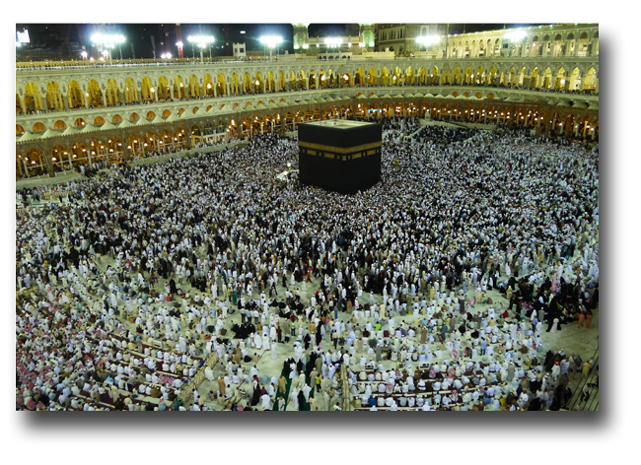
Prayer for the mission fields is like the hard work of plowing the earth to receive the seed of the gospel. Christians are not even allowed to enter the country where the picture on the left was taken, but we can go to that enormous concentration of Muslims through the power of the Holy Spirit! Imagine what Jesus could do in the minds and hearts of all those misguided pilgrims if an army of prayer warriors were interceding from all around the world! The following are some suggestions for prayer for the mission field: [5,6]
©Depositphotos.com/Mohamad Shahreen Amri

Prayer for the Mission Fields
- The great need for workers for the harvest (Mt. 9:35-38).
- The different ethnic groups within and outside of Mexico, particularly those where the gospel has not yet penetrated (Mt. 24:14, Mr. 11:15-17, Rev. 5:9).
- The preparation of the people’s hearts so that when the seed of the gospel is sown it will not be snatched away (Lk. 1:17).
- The opening of closed and semi-closed countries, and for their governments (1 Tm. 2:1-4).
- Open doors to present the gospel (Acts 16:9, Col. 4:2-4).
- Against the principalities of darkness over the country, region, or city (Dn. 10:11-14, Mr. 3:26, 27).
- For the gospel to spread through the ethnic group (2 Ths. 3:1; 1 Ths. 1:4-10).
- To halt the advance of false religions such as Islam and Hinduism (Lk. 21:8).
- The healing of the land (2 Chr. 7:14).
- The specific needs of each place.

B. Prayer for the missionaries - Even Paul asked the Ephesians to pray for him. He states in 6:18,19, “And pray in the Spirit on all occasions... Pray also for me, that whenever I open my mouth, words may be given me so that I will fearlessly make known the mystery of the gospel.” Perhaps Paul’s great courage was due to the Ephesians praying for him! If the apostle Paul asked for prayer for his ministry, how much more should we pray for our missionaries today? The following are some suggestions to enrich your missionary prayer and bless your missionaries. [7,8]

Prayer for Missionaries
- The missionary’s relationship with God (Mt. 22:37, Gal. 5:16; 2 Pet. 3:18).
- The missionary’s good testimony (Heb. 13:18).
- The missionary’s health, energy, and recreation (James 5:15,16; 1 Cor. 15:58, Rom. 15:32b).
- The missionary’s family (1 Cor. 9:5, Eph. 4:32; 5:21-6:4).
- The missionary’s ability to learn a new language and adapt to a new culture (Acts 2:4; 14:8-20).
- Wisdom for the missionary and success in his/her ministry (2 Ths. 3:1; 2 Tm. 2:2: 4:2).
- That the fruit would endure in the new believers (Jn. 15:4-8).
- Against the opposition or persecution he/she encounters (2 Ths. 3:2).
- Against the spiritual oppression to which he/she is often subjected (Eph. 6:10-12).
- Wisdom to speak and make decisions (Acts 6:10).
- Grace to relate to other team members (Jn. 17:20,21; 1 Cor. 1:10).
- A clear vision for the ministry (Acts 16:7-10).
- That there be no lack of economic, moral, or prayer support (Phil. 4:10-20).
- Against the natural tendency to impose the missionary’s own culture together with the gospel (1 Cor. 9:20-23).
- The missionary’s travels (Rom. 15:32a).
- Liberation from dangers (2 Cor. 1:9-11).
- The specific needs of each missionary.

C. Prayer for the new church - Paul always prayed for the churches he had planted, as he tells the Ephesians: “I have not stopped giving thanks for you, remembering you in my prayers” (1:16). A new church is like a tender new plant, needing to be showered in prayer. Satan does not like when the gospel penetrates an unreached ethnic group and will attack the new church with all his fury. You could pray like this: [9,10]
Prayer for the New Church
- Maturity and good testimony among the believers (1 Ths. 3:12,13, Acts 2:47).
- Good understanding between the missionary and the church (Jn. 13:35).
- For lasting fruit (Jn. 15:16).
- The participation of all the believers in the ministry (Eph. 4:11-16).
- Against misunderstanding the gospel and the danger of syncretism (Mk. 12:24).
- Against legalism and traditionalism into which it is easy to fall (Gal. 3:1-5, Mk. 7:6-8).
- Fellowship, as in the early church in Jerusalem (Acts 2:41-47).
- Protection from the enemy (1 Pet. 5:8).

IV. Resources for Missions Prayer [11]
In addition to the search for information that we mentioned in section II, there are many other resources to motivate and enrich your prayer for missions. The following are resources that you can obtain from COMIMEX, a Christian bookstore, the internet, or by phone.
- Etnopedia – The www.etnopedia.org website has, in English, more than 2,800 profiles of the world’s least reached ethnic groups. Thousands of these are translated into 10 other languages. Etnopedia is constantly looking for translators so that this vital information can be used by more emerging mission movements.
The international readers of Your Church may be interested in seeing the coordinated, continental missionary deployment strategy that the COMIBAM movement is attempting. On the main Etnopedia page in Spanish, scroll down to the bottom and follow the link that says Catálogo de Etnias No Alcanzadas para la Iglesia Iberoamericana. Each country listed has a unique catalogue of unreached groups recommended by COMIBAM for adoption and reaching.
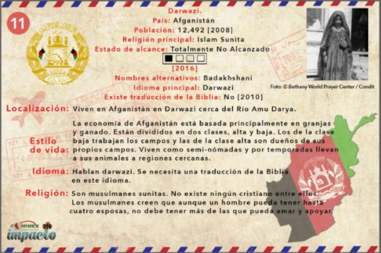
- In Mexico, the COMIBAM catalogues program goes by the name Impact 316. To promote prayer and participation in Impact 316, COMIMEX printed packages of 52 Prayer Cards. Each card focuses on one of the most needy ethnic groups of our catalogue. You can purchase the packages from the secretary of COMIMEX at (55) 1081-8372 or at
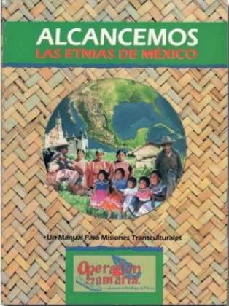
secretario@comimex.org . (See page 120 to learn more about the Impact 316 program.) Spanish only.
- Let Us Reach the Ethnic Groups of Mexico - [12] This book was presented in detail on pages 64 and 65 and contains information and prayer requests for each language family of Mexico. Contact the Missions Education Department of COMIMEX at (52) 55-5938-1780 or find it at COMIMEX events. Spanish only.
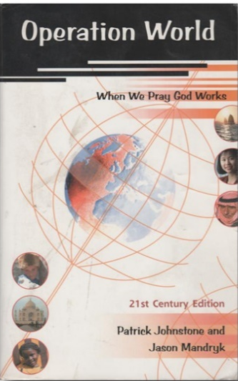
- Operation World – This book has detailed and interesting articles on every country in the world. You will learn about
their population, geography, economy, and politics, but most importantly about the spiritual condition of the people, the advances of the evangelical church, and the specific challenges facing the Kingdom of God. Available in Christian bookstores or at www.operationworld.com .

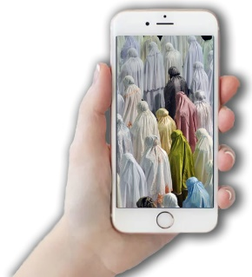
- The Joshua Project - [13] This internationally known data base has an app for mobile devices which highlights a specific ethnic group each day. You will be part of a worldwide network of global Christians interceding for that group on that day. The app is available in various languages. The website also offers many other resources for teaching missions and mobilizing in your church. Find out more at their website, www.joshuaproject.net .
- Sea Parte del Millón - (Be Part of the Million) is a movement of intercession for the Muslim world of the Assembly of God churches of Iberoamerica. They are seeking to raise up one million intercessors who will commit to praying one hour each week. You can sign up at their website, www.seapartedelmillon.org , to receive notifications and prayer requests. This is open to Christians from all denom-inations. Be part of the million! This resource is only available in Spanish.

_{islam44.blogspot.com}
V. Prayer in the Church [14]
Prayer is an integral part of the life of the church. Before starting a new meeting, make a list of all the ways the church is already praying to see how you could include prayer for missions in these existing activities, using relevant materials.
- Personal and family devotions,
- pastoral prayer from the pulpit,
- cell groups, Bible study groups, and Sunday school,
- prayer vigils,
- a “missions minute” during the worship service,
- youth groups, women’s groups, men’s groups, and of course
- new activities in the local church or with other churches exclusively for missionary prayer.
[15] What would it be like if every Christian in Mexico prayed for 5 minutes a day for world missions? If 7% of the Mexican population of 100,000,000 is Christian, that would be 5 minutes x 7,000,000, in other words, over half a million hours of prayer for missions every day! What would God do in response to so many prayers?
Jesus taught us about prayer in the parable of the widow and the unjust judge. She was finally granted her request due to her persistence (Luke 18:1-8). Jesus asks us, “When the Son of Man comes, will he find faith on the earth?” Today we need to show the same persistence as the widow by obeying Jesus’ command, “The harvest is plentiful, but the workers are few. Ask…!”

