The goal of this chapter is for churches to become effectively involved in missions. We could cross land and sea and spend lots of time and money, only to duplicate the efforts of other missionaries. That is why it is necessary:
The Goal
- For the churches to direct their missionary efforts towards unreached ethnic groups,
- to adopt an unreached ethnic group, becoming an integral part of a worldwide strategy, Adopt-A-People (AAP), and
- to persevere until there is a viable church planting movement in their adopted ethnic group.
What factory would be successful if it allowed all its workers to do whatever they pleased? What army would be victorious if all the soldiers attacked however they thought best? What sports team would win if the players did not practice the plays and use them in the game?
©Depositphotos.com/Haizul Adri Abd Manaf
We all agree that planning and coordination are necessary for important activities. But when it comes to the church and the Great Commission, it seems like our strategy is, “Every man for himself! Mind your own business! Pick yourself up by your own bootstraps!” Many mission ministries work with no particular goal in mind, and in isolation from all the others. It is like we are shooting arrows into the air and afterwards painting the target on the ground around the arrow wherever it falls! [Slide #1 of the PowerPoint] It may look like we hit a target, but in reality, we are not being as effective as we could.
Nehemiah faced the enormous task of rebuilding the ruined walls of Jerusalem. [2] He assigned specific sections of the wall to different people and families, and together they finished the task in 52 days! Each small group of people was responsible for a small part of the wall and they all worked in coordination. We need to recapture the essence of Nehemiah’s plan and apply it to the job of completing the Great Commission. 2,000 years have passed since Jesus gave us the Great Commission. We can do better.
Are we just shooting arrows into the air?

I. What is Adopt-A-People? [3]
AAP is a worldwide program with the purpose of evangelizing the 7,000 unreached ethnic groups in coordination with the global body of Christ. AAP exists in different forms. In some places AAP is a formal ministry with an office and employees. Sometimes it is a program within a mission organ-ization. In the least formal cases, it is a working philosophy but not a program as such.
The essence of Adopt-A-People has three elements.
- The missionary task is focused on specific unreached ethnic groups, rather than a particular missionary or ministry. For example, if a church focuses on supporting a particular missionary and for some reason, he or she leaves the field, the church often forgets about the ethnic group where the missionary was working. Another example could be a specialized ministry, such as a medical mission. Perhaps they go wherever a door of opportunity opens for medical work, without the goal of planting churches in specific unreached ethnic groups.
In Adopt-A-People the unreached ethnic group is the focus, and all the other considerations, such as personnel and strategies, are secondary. Missionaries may come and go, and strategies can change, but with the AAP strategy, the unreached ethnic group is not forgotten.
- Adopt-A-People is a long-term commitment with the ethnic group until a viable church with a church planting movement has been established. It is not satisfied with a few converts meeting in the missionary’s house, although at some point this could represent a great breakthrough. The church should reflect the characteristics mentioned on page 34.
©Depositphotos.com/Felix Pergande
- Adopt-A-People works in communication and coordination
with the rest of the body of Christ on a global level. An ethnic group is chosen after consulting the data bases of unreached ethnic groups, under the guidance of the Holy Spirit. Priority must be given to those groups that have no church, Christians, Bible, or missionaries. If one chooses a larger ethnic group where another Christian ministry is already working, there should be communication and coordination between the two ministries so that duplication or competition are avoided. Finally, there should be feedback to the data bases of unreached ethnic groups.
As we send our missionaries to the field, we can no longer just say, “I am going to India,” or “I am going to China,” or “I am going to Indonesia.” Each one of these countries already has churches in their dominant cultures. We could cross land and sea, spend years learning a difficult language, and spend a million dollars, only to realize thirty years later that there were already churches there when we started! No more shooting arrows into the air. We must aim at specific targets, the 7,000 unreached ethnic groups.
Below is the depiction of small battle [4] that helps us understand the philosophy of Adopt-A-People. Which side will win? All the soldiers with the blue hats are aiming at an easy target, the big guy! The soldiers with the red hats have a strategy. Each one has been assigned a different target and is aiming at it. When the order is given to shoot, the red side will win (although it will not go well for the big guy with the red hat!). (These are Mexican style hats!)
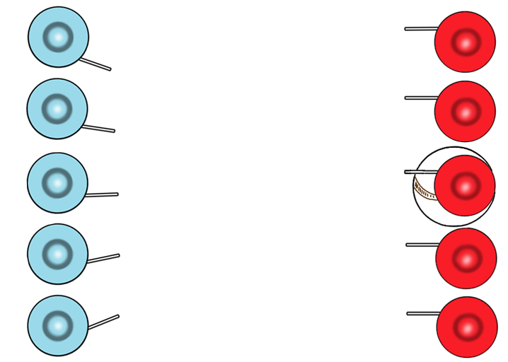

II. The Basis for our Optimism [5]
There are several reasons why many people think the fulfillment of the Great Commission is right around the corner. In the last few decades, many ethnic groups have received the gospel and their churches have grown. The following two graphs analyze the remaining task from two perspectives.
The first shows the number of people (living in unreached ethnic groups) that each born-again believer needed to reach at different points in history. We see that in the year 2,000, every believer had to share the gospel with only three people who live in unreached ethnic groups (taking into account, of course, the difficulties mentioned on pages 56-58). Compare that to the believer in the year 1900 who had to reach 27 people!
The graph on the following page shows the number of Christian churches for every unreached ethnic group. We see that in the year 2000, for every unreached ethnic group, there are more than 1,000 churches that can cooperate to reach it. [6] It is tempting to draw conclusions from these numbers: Just organize groups of 1,000 churches, assign each group an unreached ethnic group, and we are done! We could finish the Great Commission in a question of decades. This is the logic that has inspired the Adopt-A-People program. At first glance it sounds easy, but reality has forced us to analyze and re-evaluate the Adopt-A-People program.
Number of
People living in Unreached Ethnic Groups per Christian

Year
©Depositphotos.com/Khoon Lay Gan

to

The Number of
Christian Congregations
for each Unreached
Ethnic Group

to

to

to

to
to
to
to

Year

©Depositphotos.com/Victoria ProtsakMarket Olya

III. A Realistic Analysis of Adopt-A-People [7]
(This text box is probably not appropriate for a church that is just beginning to understand missions. It is meant for missions mobilizers who will be facilitating Adopt-A-People projects.)
The Adopt-A-People program began in the late 1980’s. There were worldwide AAP conferences during the ‘90’s and it seemed like it would be the paradigm for organizing missions to complete the task. In 1992, as a COMIBAM project, each country of Ibero-merica was assigned a certain number of ethnic groups to reach. Thus was formed the Adopt-A-People Department in COMIMEX. The name was later changed, in Spanish, to Reach-A-People to reflect the commitment of a long-term project.
By the year 2000 the program was having some problems. There are different ways to implement an Adopt-A-People project, and these differing visions and strategies caused the program to begin to splinter on a worldwide level. The AAP Department in COMIMEX experienced three changes of leadership in a short time. A missiologist from the United States, in a conversation with the author in 2005, commented that Adopt-A-People was put “on the back burner”. (That is an expression in the United States that means that it is on hold. It is still in the kitchen, but it is not being cooked!)
The author was convinced that there must be some missionary organism that was organizing missionary deployment on a global level. He has invested more than 15 years searching for it, but it does not exist! We must analyze why Adopt-A-People did not reach its expectations and look to the future having made the necessary corrections.

A lot of emphasis was placed on the local church for initiating an ethnic group adoption but, since it is a long-term commitment, the church often failed at this very point. Pastors change, churches divide, members change churches, and the adoption can easily be forgotten in the life of the church. There are several cases where an adoption has worked from the local church, and any Adopt-A-People program should be open to including this possibility, even if it is not the most successful option.
Another difficulty with Adopt-A-People was the long lists of ethnic groups. It is one thing to be moved by the reality of 7,000 unreached ethnic groups; it is quite another thing to sit down with a list of 7,000 unpronounceable names, choose one, and make a 25-year commitment! Some would argue that you need to answer a series of questions, guided by the Holy Spirit, which serve as a filter to reduce the options from 7,000 to a few hundred. This may be true, but this has not worked for the ethnic groups in the 10/40 Window on the scale necessary to have the needed impact. This situation paralyzes the church’s actions and decisions. The result is they leave the question of deployment in the hands of the missionary candidates.
The Adopt-A-People program depends on a flow of information among the data bases, receiving mission agencies, and the churches, and it was assumed that with the internet this would be easy. But that has not been the case. Many consulted the data bases only to obtain what they needed to start a work, but never sent any feedback to the data bases. The mission agencies are also reluctant to share information about missionaries who are working in dangerous places.
These factors added up in different ways in different situations, and the result has been that Adopt-A-People has not had the lasting impact that was expected. What can be done based on this analysis? It is possible to recapture the original dynamic of Adopt-A-People (and of Nehemiah) if we do three things:
- Recognize that adopting and reaching an ethnic group can be done in various ways and that we should not force the Adopt-A-People philosophy into a single model or ministry.
- In the case of adoptions that start from the sending countries, we should work in cooperation with the receiving mission agencies and the regional research and strategy networks, also on the field. These regional research and strategy networks are relatively new and were not very well known when Adopt-A-People was growing in the ‘80s and ‘90s. These new organizations will be presented in the following section.
- Each national missionary movement should focus on its own list of recommended ethnic groups, in other words, the global church should divide up the remaining task.

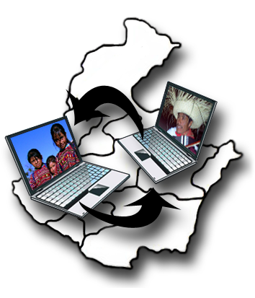
IV. The Crucial Link [8]
God has raised up a new kind of mission organization that every Adopt-A-People project should consult, the regional research and strategy networks. We will define each part of this very-long name.
©Depositphotos.com/Aleksei Elkin/Photos by Alejandro Rodríguez
- A network [9] implies cooperation among many mission or-ganizations that share information and resources to achieve something larger than any one organization could achieve alone.
- Being a regional network means that together they have focused their attention on a geographic area where there are many unreached ethnic groups, and each of the organizations is working in this region either directly or in a supporting role.
- Its research function means they are always looking for more precise information about the ethnic groups in their region, such as their location, population, characteristics, and how far the gospel has advanced among them. They are the ones who provide much of the information in the data bases of the unreached ethnic groups.
- Having the best information possible and knowing about the many ministries working in the region, they are the most suited to suggest strategies to reach these ethnic groups.
Some examples of these networks are the Research Department of COMIMEX, which represents the ethnic groups of Mexico; the Indonesian People Group Network; the Evangelical Network of North Africa; or the Bihar Outreach Network (BORN) of India. These networks are physically present in the region, have done the research, and have strategies to reach their ethnic groups. They can help us with our adoption and outreach projects.
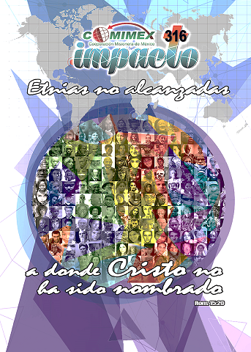
The chart [10] on pages 122 and 123 shows how a regional research and strategy network works in cooperation with the mission agencies, serving as a connection between the resources from the sending country and the needs on the field. An adoption project can originate from the body of Christ (page 122 on the left), taking advantage of sending agencies to help with logistics, and land on the field to work with a field agency which is well informed by the regional network (page 123 on the right).
In 2015, COMIMEX took up the AAP philosophy again as the primary focus of its work with a new project called “Impact 316.” [11] The body of Christ in Mexico accepted the challenge of adopting and reaching a recommended list (catalogue) of 316 of the remotest unreached ethnic groups in the world. The exciting part of the project is that the other countries of COMIBAM will be working on different cata-logues. This represents a historic cooperation in missions. Visit our website www.comimex.org under the “recursos” tab to obtain the manual for this project or get a unique catalogue for your country at www.etnopedia.org/contactus .

VI. Who Adopts an Ethnic Group? [12]
Although this teaching is probably directed to the local church, you will find in your missions mobilization ministry that there are many different models for adopting and reaching an unreached ethnic group. This is the thesis of the Impact 316 project. Here are some possibilities:
- An individual can dedicate his/her life to reaching an ethnic group. This person could be the missionary who goes to the ethnic group, or in some cases this person is the “people group advocate” or “non-resident missionary” for this group. This person recruits other people and resources for the vision and spearheads the project for decades.
- A local church can initiate the whole adoption process and look for the help it needs from other organizations in the missions community.
- A denomination, large or small, can gather resources more easily than one local church and can undertake an adoption project.
- A pastoral alliance could adopt an ethnic group near its city, or even in the 10/40 Window.
- A sending mission agency’s name or vision statement might reflect the ethnic groups it wants to adopt and reach.
- A receiving mission agency is often closer to the ethnic groups on the field and is more likely to adopt some ethnic groups. It looks for resources and cooperation from us to carry out its work.

VII. Steps towards Adopting an Ethnic Group [13]
The adoption process does not happen overnight, but here are some suggestions, or questions, that might get you moving in the right direction. Please see the list on page 124.
- First, form a missions committee. The adoption process is part of the work of the missions committee of the church. Elect someone on the committee to coordinate the adoption process.
- Organize prayer to ask for God’s guidance in the process. Try to seek prayer from all those you are going to cooperate with.
- Who will you be cooperating with? If there are 1,000 churches for every unreached ethnic group, which ones are already in some sort of working relationship with yours? With your denomination? With your region within the denomination? With the other pastors in your city?
Resources for Adopting and Reaching an Ethnic Group
- www.alcanceunaetnia.org
- www.etnopedia.org
- The book, Alcancemos las Etnias de México (see page 65)
- Contacts with sending and receiving mission agencies
- www.comimex.org and follow the links to Impacto 316 or call 52 (55) 5938-1780
- aue@comibam.org
- www.linkingglobalvoices.com
- Do you want to choose a group in your Samaria (the ethnic groups of Mexico) or do you feel led to adopt in the 10/40 Window? Maybe you can (or should) do both at the same time. Visit the website www.etnopedia.org to see profiles of the unreached ethnic groups of the world and the catalogue of the 316 unreached groups recommended for Mexico.
- Once you have decided who you are going to cooperate with, you should decide whether you want to choose an ethnic group where no one else is working (a totally pioneer situation) or if you want to partner with some other effort already working in the group.
- Pray about the level of difficulty or risk you are willing to take.
- Ask yourselves if you want to work with an ethnic group which already has a New Testament translation or a portion of Scripture.
- Investigate the resources available to aide in the selection of a group. (See text box on the left.) The regional research and strategy networks can help at this step.
- Choose the unreached ethnic group.
The World’s
Meeting Place for
Ethnic Group Profiles

- Visit the page.
- Join the network.
- Adopt an ethnic group.
- Find information.

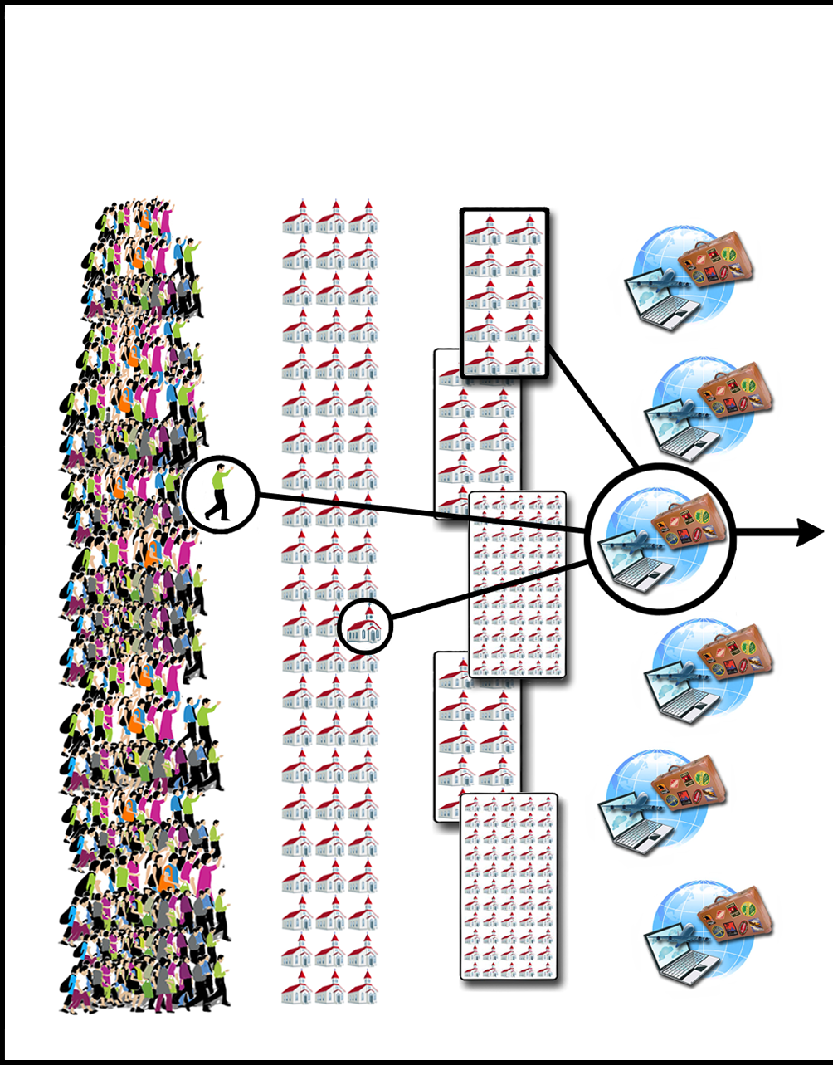
The Resources for Sending Missionaries

Thousands
of Sending
Mission Agencies
Small and
Large
Denominations
7,000,000
Christian Churches
700,000,000
Christians

©Depositphotos.com/Victoria Protsak/Aleksei Elkin/Alexander Aisenstadt/S-E-R-G-O

Resources on the Field for
Reaching Ethnic Groups

2,200,000,000
People living
in Unreached
Ethnic Groups
7,000
Unreached
Ethnic Groups
Receiving
Mission
Agencies
Regional Research and Strategy
Networks

©Depositphotos.com/Aleksei Elkin/Alejandro Rodríguez/Christos Georghiou/Alexander Aisenstadt/S-E-R-G-O/Mohamad shahreen Amri //Collage by Jill Suzanne Hatcher//Alejandro Rodríguez.
9 Steps:
1. Form the committee.
2. Prayer
3. Who will we cooperate with?
4. Samaria, the 10/40
Window, or both?
5. ¿Pioneers or in partnership?
6. Level of difficulty?
7. New Testament?
8. Investigate resources and networks.
9. Choose the ethnic group.

