©Depositphotos.com/Viktoria Protsak/S-E-R-G-O//
Collage by Jill Suzanne Hatcher//José Luís Santana

A simple course for learning the ABC’s of cross-cultural
missions in the local church.

Department of Missions Education

Department of Missions Education, (52)-55-5938-1780, jimrobh@prodigy.net.mx
©2017 by James Edward Heimberger

Proposal for a series of three Missions Saturdays to educate and involve your church in cross-cultural missions to the unreached ethnic groups of the world.

First Saturday
9:00 – 9:45 Paradigm Changes
9:45 – 11:00 Missions in the Old Testament (I)
11:00 – 11:30 Coffee break
11:30 – 12:00 Missionary Testimony
12:00 – 1:00 Definitions
1:00 – 2:00 The History of Missions
2:00 – 3:30 Lunch (Mexicans eat late!)
3:30 – 4:30 World Needs
4:30 – 4:50 Video: The Unreached – Touching God’s Heart in the 10/40
Window
4:50 – 5:00 Close with prayer.

Second Saturday (about a month after the first)
9:00 – 10:00 Missions in the Old Testament (II)
10:00 – 11:00 The Needs in Mexico
11:00 – 11:30 Coffee break
11:30 – 12:40 Missions in the New Testament
12:40 – 1:30 The Local Church and Missions
1:30 – 2:00 (Any theme not covered from the first Saturday)
2:00 – 3:00 Lunch
3:00 – 3:40 Praying for the World
3:40 – 4:30 Financing Missions
4:30 – 4:50 Video (of your choice)
4:50 – 5:00 Close with prayer.

Third Saturday (as soon as feasible)
The third Missions Saturday is designed to work with a reduced number of people who are ready and willing to work the new missions committee.
10:00 – 12:00 The Missions Committee in the Local Church
12:00 – 12:30 Coffee break
12:30 – 2:00 Work session with the prospects for the new committee
2:00 – 3:00 Lunch
3:00 – 4:00 Adopt-A-People
4:00 – 5:00 The Ministry of Missions Mobilization (Optional)

PARADIGM CHANGES

I. What is a paradigm? To show what a paradigm is and how our paradigms can limit us, try to solve the following riddle.

Rules: Connect the nine dots with four
straight lines, without lifting your
pencil off the paper.

A paradigm is __________________________________

______________________________________________

______________________________________________.

II. How our paradigms can limit us

“Then ___________ came to them and said, “...Therefore
_______ and make ______________ of ________ ___________.”

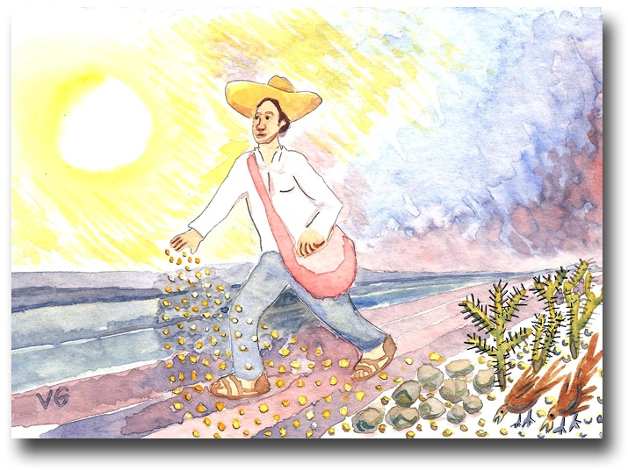
III. Paradigms that will change with Your Church

IV. From worldly Christians to global Christians
The parable of the sower teaches us about the different types of Christians.

- Worldly Christians
John 3:16 – For God so loved me…

- Fruitful Christians

- Global Christians

A global Christian is a fruitful Christian (one who produces fruit thirty, sixty, and one

hundred to one) who has extended his/her ____________, __________, ___________,

and _____________ to advance daily the Kingdom of God among the _______________

____________ ____________ of the world.

V. How to be a global Christian
- Have intimate communion with the Lord.
- Take on the Great Commission personally as your life’s purpose.
- Cultivate the missions vision.
- Impact the world every day.
- Spread the vision.
MISSIONS IN THE OLD TESTAMENT

I. World missions - the basis of the Bible
The Bible tells the story of a_____________ God and his __________ to take the gospel of salvation to ________ the _________ ________ of the world.
- It is time to play…Biblical Basis!

II. Good methods of Bible interpretation
- The context
- The motivation – so that…!
- See the Bible as a wonderfully unified story.

III. Genesis 1-11: The biblical drama unfolds.
- Protagonists (God, Adam and Eve), antagonist (the serpent), the fall, the tree of life, Cain and Abel, Gen. 6:5, the flood, Noah, and the tower of Babel
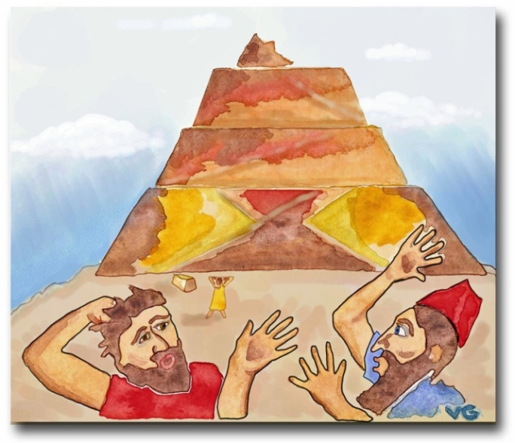
IV. God’s solution (Gen. 11 and 12:1-3)
- The problem with humanity - only one language (11:1)
- Man’s technological advances in v. 3
- Humanity uses its unity to rebel against God in v.4.
- Humanity was provoking God to judgment (v.6).
- God’s solution (first half) - confuse their language (v.7)
- God’s solution (second half) - the call of Abram
(Gen.12:1-3)
- God’s double purpose – pastoral and missions
- God gave Abram the Great Commission (Gen. 12:3).
- God’s missionary plan forms the structure of the Bible,
within which the plan of salvation and all other spiritual
teachings are developed.

V. The period of the Patriarchs (Gen. 18:18; 22:15-18; 26:4, and 28:14)
- Peoples = ethnic groups
- Nations = ethnic groups

VI. God explained why he carried out the Exodus with great signs and wonders (Exodus 9:13-16).
- The Egyptians learned about God (7:5 and 14:18).
- The Midianite ethnic group (Exodus 18)

VII. Mount Sinai and Israel’s missions purpose (Exodus 19:5,6)
- Remember the function of a priest.
- Israel’s priestly role between God and the nations
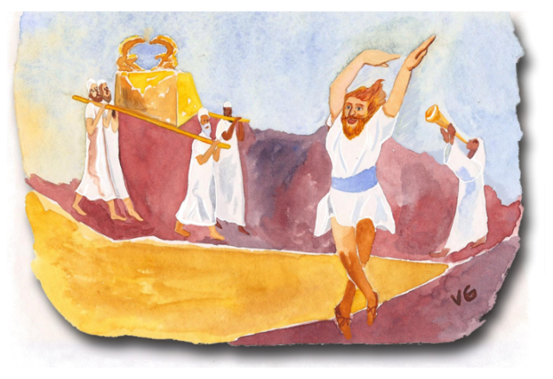
VIII. The conquest (Joshua 4:19-24)
- God could have taught them how to build a bridge!
- Note the pastoral and missions purposes in v.24.

IX. The ark of the covenant enters Jerusalem in
1 Chronicles 16.
- Count all the times David mentions God’s
global missions vision as he dances before the ark.
X. Israel - “in the center of the nations”
- This strategic location of Israel in the ancient world had a missions purpose.
- This resolves the enigma of God’s apparent cruelty in the Old Testament.

XI. The dedication of Solomon’s temple
- 1 Kings 8:41-43
- The queen of Sheba (1 Kings 10:1-9)
- The whole earth sought audience with Solomon (1 Kings 10:23, 24). This is the climax of the Old Testament, but…
- This missions strategy fell apart with Solomon’s downfall (1 Kings 11).
XII. God was still at work in the Divided Kingdom.
- The widow of Zarephath (1 Kings 17)
- Naaman the Syrian (2 Kings 5:1-27).
- Hezekiah and the Assyrians (2 Kings 19)
- Psalms 2, 67, and 96, among many others
- The prophets, especially Isaiah
- Jonah is sent to Nineveh.
- Habakkuk 2:14
“The Great Fish”
A new travel agency
for rebellious missionaries!
XIII. During the Exile God evangelized all the nations through the mouths of pagan kings.
- Nebuchadnezzar´s first dream (Dan. 2)
- Shadrach, Meshach, and Abednego (Daniel 3)
- Nebuchadnezzar´s second dream (Dan 4)
©Depositphotos.com/Matthew Cole/Daniel Cole
- Daniel in the lions’ den (Daniel 6)
- Daniel’s vision in the night (Dan. 7:13,14)

XIV. The restoration
- Ezekiel prophesied that the nations would see how God would restore Israel to its land -
“then the nations will know that I am the Lord.” (Ez. 36:23).
- God said in Malachi 1:11, “my name will be great among the nations…”
XV. The 400 years between Malachi and Matthew
- God prepared the ancient world to receive the seed of the gospel.
- The Jewish Diaspora
- The Greek language and the translation of the Old Testament into Greek
- The Roman Empire – highways, ships, and passports

DEFINITIONS
I. Activity - technical vocabulary for different vocations
- Without good definitions we cannot do specific jobs.

II. The most important word - nation
- It does not mean country!
- Nation in the Bible = ethne in Greek; ethnic group in English
- The example of India
- Characteristics of a nation or ethnic group:
History Religion Language
Caste Race Culture
Geography Social class Migrations
©Depositphotos.com/corneliap/Emir Semik/Khoon Lay Gan

- Words that express this concept: People, nation,
Gentiles, languages, families, tribes, races, lineage,group, ethnic group, ethno-linguistic group.
- Let us play Country or Ethnic Group?
- Number of ethnic groups in the world: ____________
Viable Church
III. The importance of thinking in ethnic groups, and not in countries

IV. Reached and unreached ethnic groups
The church that is strong enough to finish evangel-
izing its own ethnic group without more missionary help from the outside.
- The existence, or not, of a viable church
- Reached ethnic groups: __________Unreached __________
- 30% of the world population lives in unreached ethnic groups.
- The 10/40 Window (see following page)
- Access or no access to the gospel
_{©Deposithotos.com/_13450650_s}
V. The difference between evangelism and missions
- Evangelism – crossing a social barrier between the believer and the unbeliever
- Evangelistic activities
- Cross-cultural missions- crossing language, cultural, and social barriers
- Cross-cultural missions activities
A _________ (or apostle) is the person God calls and the church sends to the _______ _______ ________, crossing social, language, and cultural barriers, to plant a _________ church.

VI. Apostles and missionaries
- Let us play Who Should we Call?
- Definition of a missionary
- “Not all Christians are missionaries, but all Christians are called to participate in God’s global mission.”
VII. Mission organizations
- Sending mission agencies
- Receiving mission agencies
- Missionary training institutes

VIII. Other important definitions
- Culture
- Castes
©Depositphotos.com/Milan Vasicek
- Worldview
- Geography
- Tribe
- Indigenous

The 10/40 Window

The largest concentration of unreached ethnic
groups is found in a rectangular window!
The 10/40 Window is the region between the Atlantic and Pacific Oceans, between 10 and 40 degrees north latitude. It encompasses North Africa, the Middle East, a large part of Asia, and southern Europe.
The 10/40 Window contains:
- 60% of the world’s population;
- the majority of the least evangelized countries;
- the three major religious blocks: Muslims (1,300 million); Hindus (800 million), and Buddhists (400 million);
- 80% of the world’s poorest people; and
- only 7% of the world’s missionary force!

THE HISTORY OF MISSIONS
©Depositphotos.com/Maksym Yemelyanov

I. Activity - two ways to look at the tractor-trailer
- A still photo – It is impossible!
- A dynamic video – We can do it!

II. From the apostles to 400 A.D.
- The church broke with the traditions of Judaism.
©Depositphotos.com/Daria Karaulnik
- The apostles went out as missionaries.
- The four missions mechanisms in the Bible
- The miraculous growth of the church
- Non-Christian practices and beliefs influence the church.
- Constantine converts in 312 A.D. and 50 years later Christianity became the official religion of the Roman Empire, with positive and negative consequences.

III. The Barbarians and Islam (400 to 800 A.D.)
- With the Roman Empire in decline, the Barbarians invaded from the north.
- Lesson – “If you do not go to the unreached, the unreached may come and invade you, and sometimes… they are not very friendly!” The Barbarians were won to the faith.
- Islam began in 610 A.D. and quickly conquered the Middle East, the north of Africa, and Spain.
- Charlemagne, the Holy Roman Empire, and its inadvisable evangelistic techniques

IV. The Crusades and the Vikings (800 to 1200 A.D.)
_{©Depositphotos.com/}
_{Alexandru Romanciuc/arogant}
- The Crusades did not achieve their objectives and
created prejudices against Christians even to this day.
- The church split between the Catholic and the Greek Orthodox in 1054 A.D.
- The Nestorian church grew all the way to China, but later was extinguished.
- The Vikings invaded and were eventually won to the faith.

V. The Renaissance and the Reformation (1200 to 1600 A.D.)
- There was a renewed interest in learning; universities were established;
the printing press was invented.
- The Reformation corrected the abuses of the Catholic church.
- For 250 years the Protestants did not form mission agencies.
- The Catholics were sending many missionaries!

VI. Modern missions – the first wave to the coasts (1792 to 1910)
- The “awakening of Protestant missions” during the 18th century – the Moravians sent out one missionary for every 60 church members!
- Pioneer of the first wave - William Carey
- His booklet - An Inquiry into the Obligation of Christians to Use Means (mission agencies) for the Conversion of the Heathens
- The response: “When God pleases to convert the heathen, he will do it without your aid or mine.”
- Carey went to India.
- His example spawned 3 mission agencies in England, 2 in Scotland, 1 in Holland, and 1 in the United States. 25 years later 12 agencies had been formed in Europe and the United States..
- Europe dominated in the sending of missionaries.
- Achievements - the coasts of Africa and Asia

- In Africa, few missionaries survived more than a few years because they had no defenses against malaria. Their replacements packed their belong-ings in caskets!

VII. The second wave to the interiors of the continents (1865 to1980)
_{©Depositphotos.com/Maxim}
_{Kazmin/Michael Bescec}
- The pioneer, Hudson Taylor, studied the statistics of the population of China.
- He founded the China Inland Mission which has sent 6,000 missionaries since its founding.
- 40 new mission agencies were formed.
- Achievements - the interiors of the great continents
- The United States dominated.
- At first they paid no attention to the lessons learned by the missionaries of the first wave.
- There was a historic missionary movement from the universities.

VIII. The third wave to the unreached ethnic groups (1940 to the present)
- Pioneer - Cameron Townsend in Guatemala
- A humble Indian asked Townsend:
If your God is so smart, why doesn’t he speak my language?
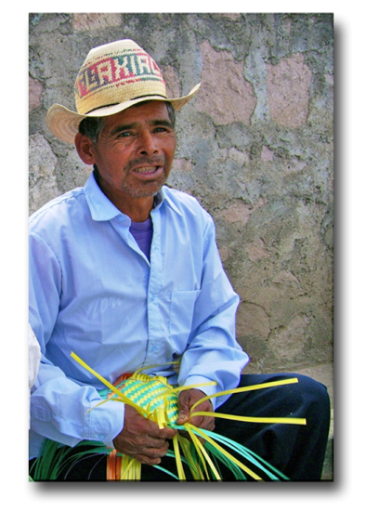

Thus was formed Wycliffe Bible Translators!
- In India, Donald McGavran observed the caste system. They both independently discovered the biblical concept of ethnic groups.
- Achievements - identifying and reaching the unreached ethnic groups
- Many new specialized mission agencies were formed.
- The miraculous growth of the church in the developing world.

IX. From receivers to senders
Foto por Alejandro Rodríguez
- Mission agencies sprang up in Asia, the Pacific Islands,
Africa, and Latin America.
- The COMIBAM movement
- The COMIMEX movement
- The growth of the Latin missions movement
- Cooperative networks and strategic alliances

X. Applications and conclusions from the history of missions
WORLD NEEDS

I. The spiritual condition of the world can be shown as a human graph.

% of the world population compared to Mexico
- Evangelical Christians 10% 7%
- Nominal Christians 20% 87%
- Non-Christians with access to the gospel 40% 4%
_{©Depositphotos.com/DIDEM HIZAR}
- Non-Christians without access to gospel 30% 2%

Non-Christians without
Access to the Gospel
Nominal Christians and Non-Christians
with Access to the Gospel
Evangelical
Christians

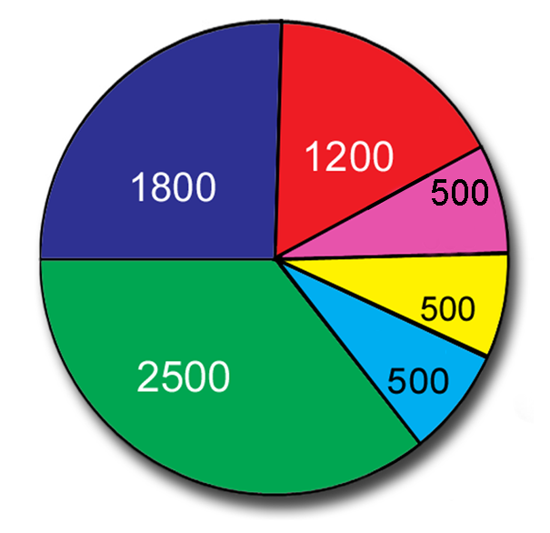
- This last 30% needs cross-cultural missionaries to go to them!
- The world situation is very different from the situation in Mexico.

II. A study of the 7,000 unreached ethnic groups
Hindus
Tribals
- We could finish the Great Commission in three hours!
- They live mainly in the 10/40 Window.
- Their religions are very different - Islam,
Chinese
- Buddhism, Hinduism, and animism.
Buddhists
- Their cultures are very different.
Others
Muslims
III. The languages of the world
- Spoken languages according to Wycliffe – 6,918
- Languages with some portion of the Bible translated – 2,932
- Whole Bible – 554
- New Testament only – 1333
The Principal Religions of the Unreached Ethnic Groups
- At least one book – 1045
- Languages needing translation – 1,800

IV. The resources for finishing the Great Commission
- 7% of the present missionary force is working among unreached ethnic groups.
- Of the offerings in the Christian church, 95% stays in local church, 4.5% goes for missions among reached ethnic groups, and only 0.5% is for missions among the unreached ethnic groups!
- There are more than 1,000 churches for every unreached ethnic group.
- It is possible!

V. A dramatization of the statistics
- Your church does not have to reach all 7,000 unreached ethnic groups, but it does have to help reach one!
THE NEEDS IN MEXICO

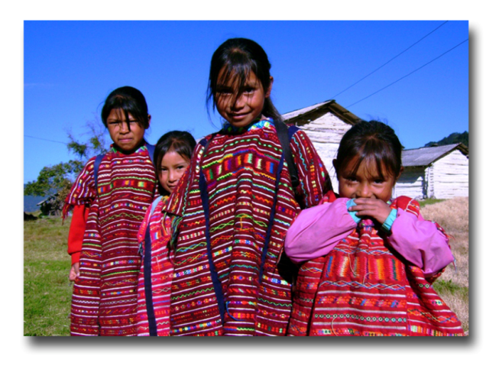
In addition to announcing the gospel, we have to make disciples in every ethnic group in Mexico.
- A very complex situation
- The danger of a new syncretism
- It is truly a cross-cultural missionary task.

I. The great ethnic diversity in Mexico

II. Research into the ethnic groups of Mexico
- Operation Samaria
- Let Us Reach the Ethnic Groups of Mexico
- Etnopedia – www.etnopedia.org

III. The Morelia scale
- 1-3 are considered unreached.
Foto por Alejandro Rodríguez
- 4-5 still need missionary help and are
called undiscipled ethnic groups.
Reached Ethnic Groups 93
- With a viable church
- 29 groups at level 7
- 64 groups at level 6
Undiscipled Ethnic Groups 179
- Ethnic groups in the process of being reached, but still needing outside help
- 81 ethnic groups at level 5
- 98 ethnic groups at level 4
Unreached Ethnic Groups 23
- Levels 1 through 3
Total of Mexican Ethnic Groups 295
- 6-7 is a mature church which should be
sending missionaries.

IV. The present situation

V. For effective missions in the indigenous context
- Missiological considerations
- Pastoral considerations
- Difficult physical conditions

VI. The difference between Judea and Samaria.
- Acts 1:8 speaks of four simuteneous fields of action.

Acts 1:8 | Chapters in Acts | Characteristics | What it means for us  today in Mexico
Jerusalem | 1-7 | Implies evangelism in the  place where you live. | The evangelism ministry  of the local church
All Judea | 8-12 | Implies a short trip to  evangelize in your own  language and culture. | Plant new churches in  Mexico or Latin America,  working in Spanish
Samaria | 8-12 | Implies a short trip to  evangelize in a different  language and culture. | Planting churches in the  unreached ethnic groups  of Mexico
To the ends  of the earth | 13-28 | Implies a long trip to  evangelize in a different  language and culture. | Planting churches in the  unreached ethnic groups  of the 10/40 Window

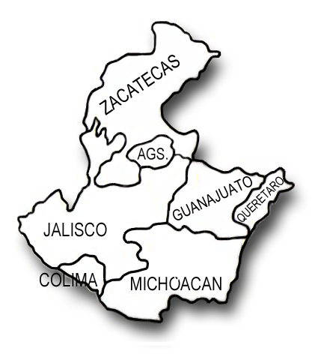
VII. The Bajío and the Circle of Silence
Dr. Gerry Gutierrez, from Gospel Recordings has commented on the conditions in the Bajío.
The Bajío is a fertile plateau in the heart of the country, comprised of the states of Guanajuato and Michoacán. It includes the high mountains, plains, and such productive valleys that the region has been called Mexico’s Granary. The adjacent states of Querétaro, Jalisco, Aguascalientes, Zacatecas, and Colima can also be considered part of the heart of the country, as they share the same characteristics.
You will notice when looking at a map of the percentage of evangelicals in Mexico that the Bajío region has less than 2% evangelicals. If it were not for the scarcity of evangelicals in this region, the percentage in the country would be much greater than 10%.

The Bajío has very strong religious traditions. There are many religious shrines in the area, considered very important by the Catholic church. The seminaries in Zacatecas prepared the priests who imposed the Catholic religion on the indigenous people during the conquest. Even to this day the Catholic church continues to recruit its priests for all of Mexico from the states of Guanajuato and Jalisco.

There are few indigenous people in the Bajío, and those there are have been resistant to the gospel. We could mention the Purépechas and a Náhuatl group in Michoacán, and the Coras and Huicholes of Nayarit, although Nayarit has a growing number of evangelicals.
We are mentioning the Bajío for two reasons: To promote prayer so the kingdom of God will extend into this region, and to challenge people to go to this very needy region of our Judea.

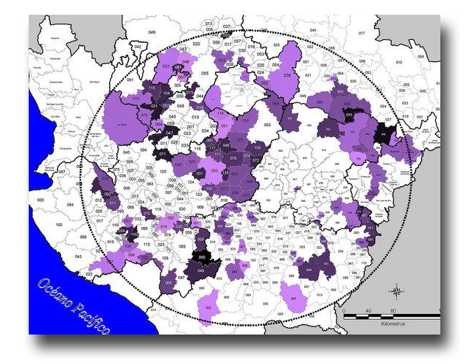
Using information from the Mexican census, another ministry, Good News for the Circle of Silence, has made a detailed study of the municipalities in Mexico with less than 1% evangelical Christians. They inform us that 75% of these municipalities are found in the Bajío, specifically in the “Circle of Silence,” which can be seen on the map. (The purple indicates less than 1% Christian.)

Although any municipality with such a low index of Christians should be targeted for church planting, those in this area have fewer Christian neighbors to evangelize them. For more information about this ministry which is working in the Circle of Silence, contact correo@bnuevas.com .

VIII. The parable of Paint the Whole Nave.

MISSIONS IN THE NEW TESTAMENT

Introduction – The New Testament is a missions document.
- Let us remember the lessons learned from the Old Testament.

I. The first Christmas
- Journeys, dangers, and inconveniences
- Many ethnic groups are mentioned.
- The magi came from a faraway land.
For the people of this world are more shrewd in dealing with their own kind than are the people of the light!
- Simeon prophesied about the baby Jesus (Luke 2:21-33).

II. Jesus’ ministry showed his purpose for the nations.
- The beginning (Luke 4:16-30)
- Jesus gave the example:
- The Roman centurion (Luke 7:1-10)
- The Samaritan woman (John 4)
- Two Greeks (John 12:20-24)
- The good Samaritan (Luke 10:25-37)
- The Canaanite woman (Matthew 15:21-28)
- Jesus provided a strategy (Acts 1:8).
- Jesus spoke of missions funding in Luke 16:1-9.
- Jesus prophesied about the fulfillment of the Great Commission (Matthew 24:14).

III. The Great Commission and the Holy Spirit

Bible Reference | Aspect of the Great Commission | The Great Commission¹ | The promise of the Holy Spirit¹
Matthew 28:18-20 | The Method² – “Make disciples”
Mark 16:15-18 | The Magnitud² – “To every creature”
Luke 24:44-49 | The Message² – “Repentance and forgiveness of sins”
John 20:21,22 | The Model² – “As the Father sent me”
Acts 1:8 | The Ministry – “Jerusalem, all Judea, Samaria, and to the ends of the earth”
¹Edison Queiroz, La Iglesia Local y las Misiones (Miami:Editorial Unilit,1994), p.21.
²Marv Newell, “Biblical Foundation for Making Disciples of Every People,” in Tokyo 2010 Global Mission Consultation and Celebration, ed. Yong J. Cho y David Taylor (Pasadena: Tokyo 2010 Global Mission Consultation Planning Committee, 2010), p.50.

- The coming of the Holy Spirit (Acts 2)
- The Holy Spirit and new frontiers (Acts 10-11:18)
- The first voluntary mission (Acts 13)
If you do not obey Acts 1:8, God applies Acts 8:1!
IV. The response of the early church
- In Acts 1-7, everyone stayed in Jerusalem.
- After the persecution in Acts 8:1, Judea and Samaria are
mentioned for the first time.
- Acts 8:1 says that all were scattered except the apostles!
- Maybe they did not understand their missions obligation at first, but what is our excuse?
- Acts 13 and following shows the mission “unto the ends of the earth.”

V. The book of Romans
- Why is the book of Romans different from Paul’s other epistles?
- “Assist me on my journey [to Spain]” (15:23,24)
- The key question – “And how can anyone preach unless they are sent?” (10:13-15)
- Romans is a fund-raising letter for a missionary project.
- Paul’s passion for the ethnic groups (15:7-22)
- Note the use of the word ethne in 1:5 and 16:26.

VI. The epistles
- The missionary context of the epistles
- Paul anticipated missionary support from the Corinthians (1 Cor.16:5,6).
- His call to the nations (Galatians 1:15,16; 2:1-10, and 3:6-14)
- The “mystery” of God – the ethne (Ephesians 2:11-3:13)
- Philippians is a thank-you letter for a missionary offering.
- Colossians 1:6 and 23
- The missions ministry of the Thessalonian church (1Tes. 1:2-10)
- 3 Juan 5-8

VII. The pastoral epistles
- 1 and 2 Timothy, and Titus are instructions from the veteran missionary to the young missionaries.
- It is like reading the e-mails of a first century mission agency.

VIII. Revelation - a vision of the completed task (5:9,10; 7:9 and 22:1,2)

IX. The truth or fantasies - the movies Star Wars, The Lord of the Rings, and The Chronicles of Narnia are copies of the true missionary story that we have in the Bible.
- The struggle between good and evil
- Ancient prophecies and writings
- Wise prophets
- Strong, valiant warriors
- Long, dangerous journeys
- Ethnic groups
- Spiritual power
THE LOCAL CHURCH AND MISSIONS
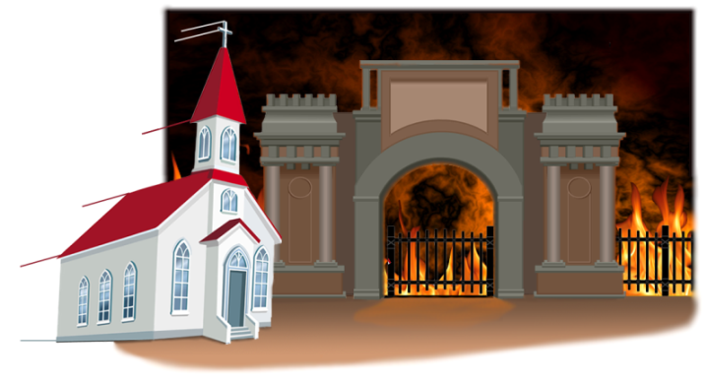
Introduction – The church is God’s instrument for completing
the Great Commission.
Hades
- The church touches on all the themes of Your Church.

I. The biblical nature of the church
- In Matthew 16:18 Jesus used the word church
for the first time.
- The church should be attacking the gates of hell.
- Missions and pastoral purposes of the church
©Depositphotos.com/Victoria Protsak/Andriy Myahkov/Khoon Lay Gan/Kristy Pargayer/Margaret Grissom

- Let us play All Aboard the Plane!
II. The church as the goal of missions
- The goal in the field - a viable church
- The eternal goal in heaven (Rev. 22:2)

III. The church as the base for missions
- Biblical examples
- A new ministry in the local church -
the cross-cultural missions committee

IV. The church and the missionary community
- The church does not have to do it alone!
Frustration!
- See the model for cooperation on the following page.

V. A new orientation for the church
- From frustration to vision!

VI. A survey for measuring the missions
participation of the local church
©Depositphotos.com/mike smith/mike smith/
Martin Malchev/dayzeren/Daria Karaulnik

Vision!
Missionary
Training

Sending
Mission
Agency
Short–term
Mission
Experience

Theological
Studies

Receiving
MIssion
Agency

Missionary
Candidate

The missionary
joins a team on
the field.

Pastor

Members
Missions
Committee

The Goal – To Establish
a Viable Church in an
Unreached Ethnic Group

The Base for Missions -
The Local Church

©Depositphotos.com/Aleksei Elkin/Alexander Aisenstadt/S-E-R-G-O/Christos Georghiou/Alexander Aisenstadt/S-E-R-G-O/Aleksei Elkin/Patrick Bombaert/Mohamad Shahreen Amri/Oleksandr Lupol/Patrick Guénette/Vladimir Galantsev/Vladimir Galantsev/Alexander Aisenstadt/Viltoria Protsak/Milan Vasicek/Nadejda Tchijova/photography33/Alexey Dubovsky/LoopAll/Daria Karaulnik/Denis Cristo/Arunas Gabalis//Collage by Jill Suzanne Hatcher.

PRAYING FOR THE WORLD

Introduction - Prayer is the power source for cross-cultural missions.
When men work,
men work;
When men pray,
God works.
Hans Von Staden

I. The call for missions prayer

II. The search for information
for missions prayer

©Depositphotos.com/Bobby Wijaya

III. Petitions for missions prayer

When praying for the mission fields we should pray for:
- The great need for workers for the harvest (Mt. 9:35-38).
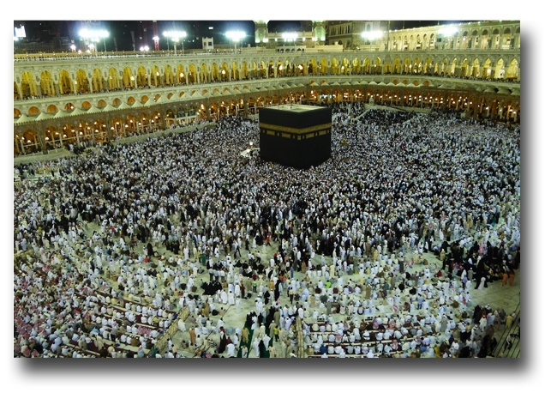
- The different ethnic groups within and outside of Mexico, particularly those where the gospel has not yet penetrated (Mt. 24:14).
- The preparation in the people’s hearts for when the seed of the gospel is sown (Luke 1:17).
- The opening of closed countries, and for their governments (1 Tm. 2:1-4).
- Open doors to present the gospel (Acts 16:9).
- Against the principalities of darkness over the country, region, or city (Dn. 10:11-14, Mark 3:26, 27).
- For the gospel to spread through the ethnic group (2 Ths. 3:1)
- To halt the advance of false religions such as Islam and Hinduism (Luke 21:8).
- The healing of the land (2 Chr. 7:14).
- The specific needs of each place.
©Depositphotos.com/Mohamad Shahreen Amri

When praying for the missionaries we could pray for:
- The missionary’s relationship with God (Mt. 22:37).
- The missionary’s good testimony (Heb. 13:18).
- The missionary’s health, energy, and recreation (James 5:16).
- The missionary’s family (1 Cor. 9:5).
- The missionary’s ability to learn a new language and culture (Acts 2:4).
- Wisdom for the missionary and success in his/her ministry (2 Tim. 2:2).
- That the fruit would endure in the new believers (John 15:4-8).
- Against the opposition or persecution he/she may encounter (2 Ths. 3:1,2).
- Against the spiritual oppression to which he/she is subjected (Eph. 6:10-20).
- Wisdom to speak and make decisions (Acts 6:10).
- Grace to relate to other team members (John 17:20,21).
- A clear vision for the ministry (Acts 16:7-10).
- That there be no lack of economic, moral, or prayer support (Phil. 4:10-20).
- Against the natural tendency to impose the missionary’s own culture together with the gospel
(1 Cor. 9:20-23).

- The missionary’s travels (Romans 15:32a).
- Liberation from dangers (2 Cor. 1:9-11).
- The specific needs of each missionary.

Concerning the new church on the mission field, let us pray for:
- Maturity and good testimony among the believers (1 Ths. 3:12).
- Good understanding between the missionary and the church (John 13:35).
- Lasting fruit (John 15:16).
- The participation of all the believers in the ministry (Eph. 4:11-16).
- Against misunderstanding the gospel and the danger of syncretism (Mark 12:24).
- Against legalism and traditionalism into which it is easy to fall (Gal. 3:1-5 and Mark 7:6-8).
- Fellowship, as in the early church in Jerusalem (Acts 2:41-47).
- Protection from the enemy (1 Peter 5:8).

IV. Resources for missions prayer
- www.etnopedia.org , Catalogues of Unreached Ethnic Groups for the Iberoamerican Church.
- Packages of prayer cards for Impact 316, (55) 1081-8372 or secretario@comimex.org .
- Let Us Reach the Ethnic Groups of Mexico, at (52) 55-1538-1780.
- Operation World, found in Christian bookstores or www.operationworld.com .
- The application for mobile devices from www.joshuaproject.net .
- Be Part of the Million, found at www.seapartedelmillon.org .

V. Opportunities for prayer in the church
- Personal and family devotions,
- pastoral prayer from the pulpit,
- cell groups, Bible study groups, and Sunday school,
- a “missions minute” during the worship service,
- youth groups, women’s groups, men’s groups,
- special events for missions prayer

What would it be like if every Christian in Mexico prayed for 5 minutes a day for world missions? If 7% of the Mexican population of 100,000,000 is Christian, that would be 5 minutes x 7,000,000, in other words,
over half a million hours of prayer for missions every day!
What would God do in response to so many prayers?
“The harvest is plentiful but the workers are few.”
Ask!

FINANCING MISSIONS

Introduction – How are we going to finance all these missionaries we have to send?

I. God’s plan for provision
- 12 tribes (Genesis 49:28)
- The tribe of Levi was set apart (Deuteronomy 10:8).
- The tribe of Levi had no inheritance (Numbers 18:20,21).
- Levi received the tithe from the other tribes (Num. 18:12).

II. Elijah and the widow of Zarephath (1 Kings 17:3-14)
- Some Christians think that God always provides for his
servants by sending the ravens!
- A principle of God’s economy is this: If we provide first for his
servants, he will provide for us.

III. Where the tithes go
- Old Testament (Malachi 3:8-12)
©Depositphotos.com/neyro2008/Vladimir Gorban

- New Testament
- Jesus affirmed the tithe (Matthew 23:23).
- The first Christians gave more than the tithe (Acts 2:44,45).

IV. The apostles in first place, in sequence and urgency
- Ephesians 4:11
- 1 Corinthians 12:28
- But wasn’t Paul a tentmaker? (Philippians 4)
- Paul received support from various churches (2 Corinthians 11:7-9 and 12:13).
- Jesus received financial support (Luke 8:1-13).
- Jesus spoke of the use of money in light of the imminent final judgment (Luke 16:1-15).
- Paul asked the church in Rome for financial support (Romans 15:23).

V. An analysis of our spending
We asked one hundred Mexican Christians the following question: How much does a Christian in Mexico spend on junk food every week?
- Let us play “One Hundred Christians Said!”
with our host Johnny Mobilizer.
- We came up with the sum of US$70,000,000.
a month! Say it aloud: “Seventy million dollars a month!”
- “Is this the kind of fast I have chosen?” ( Isaiah 58:5)
- Each one making a small, daily sacrifice!
- We have seen how the Christian church spends its offerings. Of every 100 dollars of offering, 50 cents goes to missions among the unreached ethnic groups.

VI. Models for financing missions
- Models to determine where the offerings go
- Models for collecting the offerings
- What did Paul promise the Philippians after
receiving their missions offering? (Philippians 4:19)
- God blesses the church that blesses his missions cause!

THE MISSIONS COMMITTEE IN THE LOCAL CHURCH
Introduction – The vision of the missions committee:
For the local church to have an effective missions program, resulting in the sending out of mis-sionaries who can count on the sustained spiritual, moral, and economic support necessary to reach the unreached ethnic groups of the world.

I. The identity of the missions committee
- What is a missions committee?
- What is the goal of the missions committee?
- Why is this committee so important?
©Depositphotos.com/Denis Cristo/Arunas Gabalis

- What does the missions committee do?

II. The activities of the missions committee
Learn and be informed. - The committee is constantly studying the Bible, statistics, and missions books and publications to learn what God has done, is doing, and what still needs to be done.
Network. - The committee stays in contact with COMIMEX and other mission institutions to learn about needs, opportunities, missions events, and materials.
Seek a vision from God. - Together with the pastor and the congregation, the committee tries to discern the unique role this church has in the fulfillment of the Great Commission. An example of a vision could be: “God has called us to plant churches in the 10/40 Window.” Another could be: “God has called us to support Bible translators among the indigenous people of Mexico.” A vision can be broad or focused, but the church needs to know where it is headed.
Recommend a missions policy for the church. - This will answer many questions like the following: “Whom should we support? Which theological tendencies do we support? How will we raise funds? What requirements will we look for in the missionaries we support?”
Determine God’s will in choosing an ethnic group to adopt. - This is the logical consequence of following the previous four steps. The church’s missions vision will be continually fine-tuned until God says, “I want your church to reach this particular ethnic group.” Even before receiving such a clear vision a church can advance in missions, but a specific ethnic group should always be the goal.
Investigate. - One church leader wrote, “Do your homework!” In other words, start researching your ethnic group. Contact various mission agencies to determine who is working or willing to work among them. Write to other organizations that can tell you where to find more information about your ethnic group. Check the internet for more information. Ask a computer expert in your congregation to investigate for you. COMIMEX, Adopt-A-People, and Etnopedia (www.etnopedia.org) have materials that can help your church find more information and a profile of your ethnic group.
Promote prayer. - Using the available materials, the committee looks for a way to saturate the church with prayer for missions during the worship service, prayer meetings, cell groups, Sunday school, special meetings, and the members’ personal devotional times. See “Praying for the World” (pages 91-96).
Educate and raise awareness. - The committee keeps the church informed about the basic concepts of cross-cultural missions, testimonies about the advance of the gospel on the field, their adopted ethnic group, and prayer requests from the missionaries the church supports. To do this, the committee could organize an annual missions conference, decorate the church with maps and flags, or make a bulletin board with updated information. It could also write up missions news for the church bulletin, have a missions moment during the worship service, place missions books on a table near the exit, organize a missions service, or plan a missions prayer meeting.
Collect missions offerings. - The missions finances must always be managed according to the financial policies of the church. Some congregations include an account for their ethnic group in the church budget. Others make it part of their Faith Promises. Some take up a regular collection to finance ministries to the unreached. Many use a combination of these. You can also have special campaigns for specific projects. For example, one church asked for contributions to translate the Jesus film into the language of an unreached ethnic group. The idea here is that the more you involve your church, the more they will participate economically in the missions program.
Organize an annual missions conference. – This is an event to dedicate an entire weekend to missions. You can invite special speakers, missionaries from the field, mission agencies, etc. The members of the committee can prepare themes from Your Church to share during the conference. Decorate the church with flags from different countries and pictures of ethnic groups. Prepare special foods from other cultures. Choose worship songs that talk about missions. All this creates a great sense of victory! Some churches close this event by asking the members to register their Faith Promises for the coming year.
Morally support the missionaries. - Missionary life entails many struggles and pressures that are not felt in one’s home country. With letters, calls, and, if possible, some small gifts from Mexico, the Mexican church can minister to its missionaries on the field. They should also minister to the missionaries when they are home on furlough.
Plan short-term mission trips. – They say the younger generations need to experience things before contributing to a cause. You can plan short-term trips to your unreached ethnic group as part of your mobilization strategy in the church. Those who go will return and influence others with what they saw. You can also plan short-term trips within Mexico to confirm the missionary call of prospective candidates. Look for more information from mission agencies and with the Department of Youth Mobilization of COMIMEX.
Organize activities for children. – Give a missions emphasis in Sunday School or Vacation Bible School. Recently, the “Children’s Missionary Adventure” of COMIMEX have been quite fruitful. For mor information see www.aventuramisionera.com.
Look for missionary candidates. - The greatest honor a church can have is for one of its own members to become a missionary. The missions committee must pay special attention to following up these disciples and helping them in the long process of preparation for going to the field.

III. Goals and a working plan

IV. Some important considerations
- The missions champion
- Long-term commitment
- Safety
Establish short,
medium, and
long-term goals.

V. Models of cooperation with the missions community
- The players
- The plays
©Depositphotos.com/Felix Pergande
ADOPT-A-PEOPLE
Introduction – Everyone doing their part in coordination

I. What is Adopt-A-People?
- A missions project directed towards a specific unreached people group
- A long-term commitment
- In communication and coordination with the body of Christ

II. The basis for our optimism
- The task is more feasible every day.
©Depositphotos.com/Felix Pergande
- 1 Christian for every 3 non-Christians without access to the gospel
- More than 1,000 evangelical churches for every unreached ethnic group

III. An analysis of Adopt-A-People (optional)
- Churches change often and it’s difficult to honor long-term commitments.
- The lists of ethnic groups are so long they can paralyze us.
- Lack of communication
- Recapture the dynamic of Adopt-A-People.

IV. The crucial link
- Regional research and strategy networks
- What is a network?
- Regional – focused on a very needy geographical area.
- Research – Those who provide information about the unreached ethnic groups.
- Strategies – Those most suited to make a plan. (Impact 316)

VI. Who can adopt and reach an ethnic group?
- An individual!
- A local church
The World’s
Meeting Place for
Ethnic Group Profiles
- A denomination
- A pastoral alliance
- Sending or receiving mission agencies

VII. Steps towards adoption
- Visit the page.
- Join the network.
- Adopt an ethnic group.
- Find information.
- Form a missions committee.
- Prayer
- Who will you cooperate with?
- Samaria or the 10/40 Window?
- Pioneers or partners?
- Level of difficulty
- New Testament?
- Research
- Choose the ethnic group.

THE MINISTRY OF MISSIONS MOBILIZATION (Optional)

Introduction
- Definition of the ministry of missions mobilization
- Only 10% of the churches in Mexico are involved in cross-cultural missions.

I. The three stages of missions mobilization
- Approach pastors and leaders to promote events.
- Share the missions vision in events.
- Facilitate changes and projects.

II. The great variety of missions events

III. Approaching pastors and leaders
- Have contact with them.
- A humble attitude
- Be positive.
- Be an example.
- Practical ideas
- The challenge

The Challenge!
©Depositphotos.com/Mike Smith/dayzeren/Martin Malchev

The pastor responds to the missions mobilizer:
“You are asking me to invest money, time, and personnel…
Which I do not have,
To evangelize ethnic groups…
Which I did not know existed,
Using structures and strategies…
That I do not know about,
For reasons and motives…
I do not understand…
To save souls…
That will never attend my church?!”

IV. Sharing the missions vision

V. Conclusion and challenge – The only escape now is by going to the mission field yourself!
“Missions teaching without a plan will end up in the _________ _______;
A project without vision will shortly lack _______________.”

