The Great Commission
An Introduction to Cross-Cultural Missions
for Youth

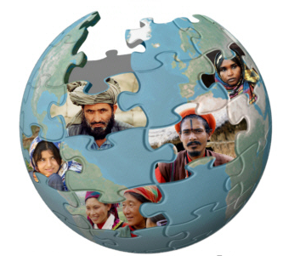

Robin Heimberger
Logo from www.etnopedia.org used with permission
Based on the course Your Church Can Change the World

