***INTRODUCTION***

This study is an introduction to cross-cultural missions, originally prepared for use in Sunday school with youth. It is based on the material presented in *Your Church Can Change the World,* but with certain adaptations. Although it presumes to be self-teaching and has an answer key for all the questions and puzzles at the end, we recommend that the teacher familiarize him/herself with the material in *Your Church* in order to complement this teaching. The following are references in *Your Church* corresponding to each chapter (or question) in this study.

THE GREAT COMMISSION

1. See *Your Church*, “Missions in the New Testament” chapter.

2. See *Your Church*, “Paradigm Changes” chapter.

3, 4, 5. See *Your Church*, “Definitions” chapter.

PENTECOST AND THE GREAT COMMISSION

See *Your Church*, “Missions in the New Testament” chapter.

MISSIONS IN THE OLD TESTAMENT I, II

See *Your Church,* “Missions in the Old Testament” chapter.

MISSIONS IN THE NEW TESTAMENT I, II

See *Your Church*, “Missions in the New Testament” chapter.

WORLD NEEDS I

2, 3. See *Your Church*, “Definitions” chapter.

4, 5, 6. See *Your Church*, “World Needs” chapter.

WORLD NEEDS II

See *Your Church*, “World Needs” chapter.

YOUR PART IN THE GREAT COMMISSION

1, 2, 3, 4. See *Your Church*, “Praying for the World” chapter.

5. See *Your Church,* “Financing Missions” chapter.

Our hope is that this material will awaken in the hearts of youth the desire to participate in the great task Jesus entrusted to us to reach all the nations with the good news of salvation. May the Lord raise up more laborers for the harvest!

Robin Heimberger

©2013 by Robin Joy Heimberger

***THE GREAT COMMISSION***

1. Read Matthew 28:18-20. These verses contain what we call “The Great Commission”

which Jesus gave to the disciples after his resurrection and before ascending into

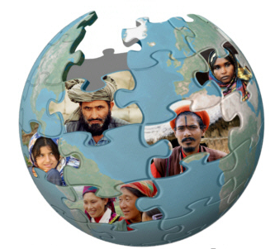heaven. What did he command them (us) to do?

_________ and _______________ disciples

of __________ _________________.

2. Connect the nine dots using only four

straight lines, without lifting your pencil

from the page.

3. In the Bible the word *ethne* (in Greek) is translated as *people, nation, or Gentiles.* The

best translation would be *ethnic group* or *people group.* Identify from the following list

which are countries (**C**) and which are ethnic groups (**E**).

Mexico _____ Nahuatl _____ Mali _____

India _____ Afghanistan _____ Mixtec _____

Kurds _____ Berber _____ Bedouin _____

4. An ethnic group is a group of people with their own identity due to their common

history, religion, language, caste, race, culture, geography, social level, or migrations, or

a combination of these. How many ethnic groups do you think there are in Mexico?

a) 3 c) 295

b) 57 d) 431

5. A “reached” ethnic group is one that has a viable church. There may still be much work

to do until every person in that group hears the gospel, but it will not depend on

missionaries coming in from the outside.

There are still 7,000 *unreached* ethnic groups in the world.

What can *you* do to help fulfill the Great Commission?

________________ __________________ ________________

**WORD FIND**

Find and circle the following ethnic groups.

(You can find out more about them on [www.etnopedia.com](http://www.etnopedia.com))

|  |  |  |  |  |  |  |  |  |  |  |  |
| --- | --- | --- | --- | --- | --- | --- | --- | --- | --- | --- | --- |
| R | J | E | H | A | L | Q | W | T | A | N | O |
| C | H | A | M | P | A | U | P | N | T | M | I |
| A | M | S | J | F | M | R | A | K | E | J | M |
| E | R | S | U | M | H | R | L | P | N | W | B |
| O | S | A | M | G | A | K | I | V | I | C | X |
| K | X | J | G | K | N | A | A | M | A | H | M |
| U | C | A | A | R | N | I | U | O | D | E | B |
| E | Z | T | B | D | U | K | Y | N | L | A | U |
| L | N | R | D | V | N | E | A | I | U | D | G |
| A | R | O | C | E | K | M | M | L | I | K | I |
| H | W | S | D | G | L | I | W | A | R | E | S |
| G | Z | O | R | A | M | A | S | A | M | E | N |

BUGIS

BEDOUIN

INGUSH

SERAWI

ANTAKARANA

CHAMPA

ERSU

HMU

GHALE

JAT

DAINET

CORA

KAIKE

MIMI

SAMA

***PENTECOST AND THE GREAT COMMISSION***

1. Do you remember the Great Commission? Write it here:

_______ and ___________ ________________ of all ________________.

(If you don’t remember, look for it in Matthew 28:18-20.)

2. Jesus gave the Great Commission several times. And each time he also gave us the

power to fulfill it1. Read the following passages and fill in the answers.

MATTHEW 28:18-20.

MC900036552[1] COMMAND PROMISE

All authority in heaven and on

earth has been given to me.

And surely I am with you always…

Go and make disciples of all nations,

baptizing them… and teaching them…

MARK 16:15-18

COMMAND PROMISE

LUKE 24:44-49

COMMAND PROMISE

JOHN 20:21-22

COMMAND PROMISE

ACTS 1:8

COMMAND PROMISE

3. Read Acts 2:1-13. Note 3 things that happened when the Holy Spirit was given at

Pentecost. (Note: The feast of Pentecost was a Jewish celebration of the harvest,

which also commemorated God giving Moses the 10 Commandments, 50 days after the

exodus.) 1.

2.

3.

1Edison Queiroz, La Iglesia Local y las Misiones (Miami:Editorial Unilit,1994), p.21.

4. Acts 2:5 says, “Now there were staying in Jerusalem God-fearing Jews **from every**

**nation under heaven**.” How many nations (ethnic groups) are specifically mentioned?

a) 2 c) 13

b) 15 d) 7

Try to locate them on a map of the world in New Testament times.

5. What was the purpose of the tongues the Holy Spirit gave to the disciples?

a) to prove that they were Christians

b) to make them feel more spiritual

c) to help them get a better grade on language tests

d) to declare the wonders of God to the nations

6. The Holy Spirit gives us the power to evangelize the ethnic groups!

Read Luke 11:13. Would you like to be filled with the Holy Spirit? Would you like to

have the power to be a witness for God and to obey the Great Commission? ASK!

ANSWER THE FOLLOWING QUESTIONS

TO FIND THE HIDDEN WORD.

1. What the disciples would receive when the Holy Spirit came upon them (Acts 1:8).

2. Another meaning for *nation.*

3. These were given to the disciples at Pentecost (Acts 2:3).

4. Those who have seen and testify.

5. One of the nations represented at Pentecost (Acts 2:10).

6. What Jesus told us to make when he gave the Great Commission (Mt. 28:19).

7. What should be preached in Jesus’ name (Lk. 24:47).

8. One area where the disciples would be witnesses (Acts 1:8).

9. What filled the disciples at Pentecost (Acts 2:4).

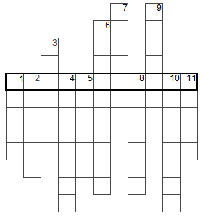

***MISSIONS IN THE***

***OLD TESTAMENT I***

1. Read Genesis 11:1-9. Which drawing represents humanity before, and which represents

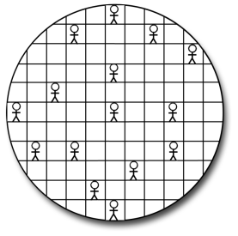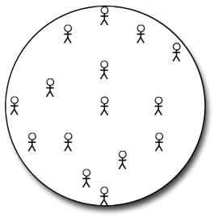humanity after the tower of Babel?

________________ _______________

2. How were the ethnic groups formed?

a) God assigned a different language to each baby that was born.

b) Languages evolved depending on where people lived.

c) When the tower of Babel was destroyed, the Holy Spirit gave out other tongues

d) God confused the language to scatter them over the earth

3. Read Genesis 12:1-3. What was the purpose in blessing Abraham? What responsibility

did he have?

a) to make him rich c) to bless all the peoples on earth

b) to give him many descendants d) to take him on trips all over the world

4. God divided humanity into multiple ethnic groups then chose *one* ethnic group (Israel –

the descendants of Abram/Abraham) to reach them. Israel’s purpose is to bless all the

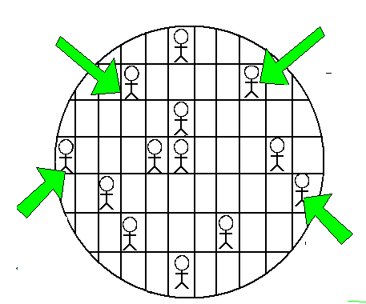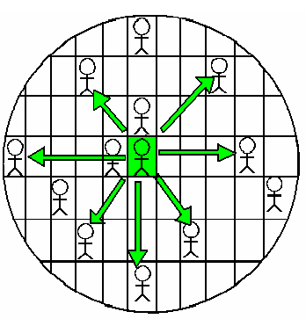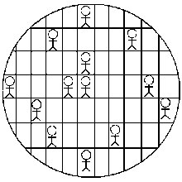ethnic groups of the world. Which drawing represents Israel’s purpose?





5. Look up the following verses (and a few earlier ones) to determine who God promised to

bless, and for what purpose.

**Who? For what purpose?**

Gen. 22:18

Gen. 26:3,4

Gen. 28:14

6. Read Exodus 9:13-16. What was God’s purpose in raising up Pharoah and sending the

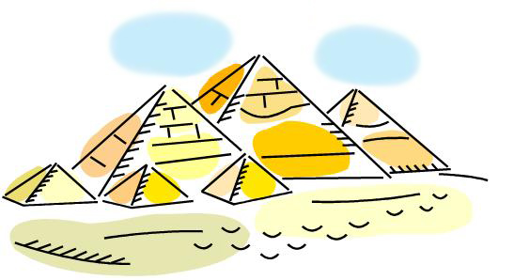plagues? a) to show Egypt’s strength c) to make the Egyptians serve Moses

MC900412992[1]MC900412992[1]MC900412992[1]MC900412992[1]MC900412992[1]MC900412992[1]MC900412992[1]MC900412992[1]MC900412992[1]MC900412992[1]MC900412992[1]MC900412992[1]MC900412992[1] b) to make himself known in all the earth d) to destroy Egypt

7. Read Exodus 19:5,6. A priest represents God to the people, and the people before God.

If all Israel was to function as priests, before whom were they to represent God?

_A_ ___ ___ ___ ___ ___ _N_ ___ ___ ___ ___ ___ ___

8. Read Psalm 67. What is the purpose of God’s blessing?

_________________________________________________________

9. Read Galatians 3:7-9, 14. Who are the true children of Abraham? Decipher and separate the words:



_____________________________________________________



A B C D E F G H I J K L M N O P Q R S T U V WX Y Z

10. Read 1 Peter 2:9,10. Now Christians are children of Abraham!

Now Christians are the royal priesthood!

What is God’s purpose in blessing us now? What is your responsibility??

Move horizontally or vertically from one letter to the next to determine our responsibility.

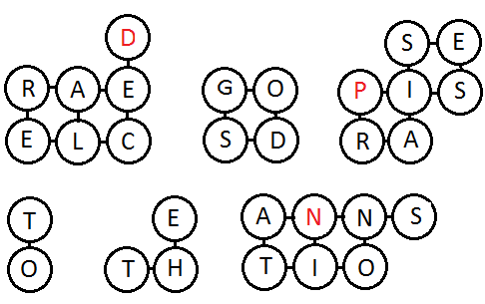

______________ ________ ______________

____ ______ ______________

***MISSIONS IN THE***

***OLD TESTAMENT II***

Every time the Israelites began a new era in their history, it was celebrated with a solemn ceremony. And each time God’s missions purpose was restated!

1. Read Joshua 4:19-24. Moses had died. His successor, Joshua, led the people of Israel

MC900354172[1]to the Promised Land, and ceremoniously set up 12 stones.

How did they cross the Jordan River, and why did he set up the stones?

a) they built a bridge/to demonstrate their skill

b) in boats/ to keep them together

c) swimming/ to dry their clothes on

d) on dry land/ so that all the peoples of the earth would know God’s power

2. Once established in the Promised Land, King David had the ark of the covenant brought

to Jerusalem in another ceremony. Read 1 Chronicles 16:7-36 and count the number of

times David refers to the nations, all peoples, or all the earth and their relationship

with God.

1 2 3 4 5 6 7 8 9 10

3. Read 1 Kings 4:29-34. King Solomon was wiser than any other man. Why did God give

him such wisdom? (Particularly verse 34.)

______________________________________________________

What gifts and talents has God given you? Why do you think he gave them to you?

_______________________________ ______________________________

MC900194122[1]

4. When Solomon dedicated the temple, he prayed for the foreigners who would come (1 Kings 8:41-43, 59-60). Who came and heard about the Lord? (See 1 Kings 10:1-9 and Luke 11:31).

MC900194122[1]MC900194122[1]MC900194122[1]MC900194122[1] __________________________________

5. In Luke 4:25-27 Jesus gives 2 examples of God sending his prophets to minister to non-

Jews. Read 1 Kings 17:8-24 and 2 Kings 5:1-17 and answer:

PROPHET WHERE? TO WHOM? MIRACLE

______________ ____________ _____________ ______________

______________ ____________ _____________ ______________

MC900353632[1]6.

The book of Jonah is clearly a missionary book. Read Jonah 1:1-3. Where did God send Jonah as a missionary?

a) to Amittai c) to Tarshish

b) to Nineveh d) to Joppa

Find the cities mentioned on a map.

How would you respond if God called you to preach to a distant, non-Christian people?

_________________________________

7. Because they fell into idolatry, God punished the Israelites by sending them into exile in

Babylon. The book of Daniel contains various examples of how, even from there, God used his servants to reach the other peoples of the earth. Look up the references and fill in the crossword puzzle with the answers.

ACROSS

1. Name of the king of Babylon (Daniel 3)

2. King who threw Daniel into the lions’ den (Dan. 6:1)

3. One of the Jews who didn’t worship the statue (Dan. 3:12)

4. Who the king writes to, praising God (Dan. 4:1,2)

5.Those who Daniel saw serving Jesus (Dan. 7:13, 14): from every ____

6. Who the king praised (Dan. 4:34)

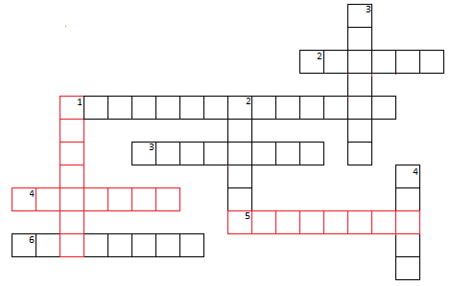DOWN

1. Who the king writes to, praising God (Dan. 4:1,2)

2. He was thrown into the lions’ den (Dan. 6:16)

3. Punishment for not worshipping the statue (Dan. 3:6)

4. God spoke to the king of Babylon through this (Dan. 2:3, 47)

8. There are MANY MORE references to all the peoples, nations, and languages in the Old

Testament that God wants to reach. As an exercise, read Psalms 2, 67, and

96 in particular, and also 18, 22, 33, 46, 47, 49, 57, 65, 66, 72, 82… and note the missionary vision in them. God has a missionary heart.

Do you have God’s heart?

***MISSIONS IN THE***

***NEW TESTAMENT I***

1. The New Testament opens with an emphasis on the *nations*. Read Matthew 2:1-4, 13.

Four different nations/ethnic groups witness the birth of Jesus. What are they?

a) Indians, Germans, Romans, Jews c) Orientals, Jews, Romans, Egyptians

b) Romans, Jews, Indians, Egyptians d) Romans, Mexicans, Germans, Jews

2. According to Simeon’s prophecy in Luke 2:29-32, what was to be Jesus’ mission?

Salvation in the sight of __________ ________________

Revelation to the ________________

3. In Luke 4:16-30 Jesus read from the book of Isaiah, teaching that he was the

fulfillment of the prophecy. How did his listeners respond? Mark with an X the

MC900423153[1]MC900434407[1]face that shows their reaction.

MC900434379[1]MC900434409[1]

When he then gave 2 examples of prophets who performed miracles among people of

*other nations,* how did his listeners respond? Put a check mark on the face that shows

their reaction.

4. Jesus gave the example. He moved about among the Jews but showed that God loves

all the nations. Connect the passages with the non-Jews Jesus ministered to.

Matthew 15:21-28 The Samaritan woman

Luke 7:1-10 The Roman centurion

John 4 The Canaanite woman

Which of these 3 did Jesus say had much faith? Circle them.

5. Even though Jesus had given the Great Commission at least 5 times (see ***Pentecost and***

***the Great Commission***), the church didn’t obey until it was persecuted and scattered!

Read Acts 8:1-5. What did those who were scattered do?

a) they went from house to house c) the persecuted Saul

b) they preached in Jerusalem d) they preached everywhere

Who did NOT leave Jerusalem to preach? _______________________!

6. We have already seen the relationship between the Great Commission and the coming of

MC900110880[1]MC900020595[1]the Holy Spirit. Read Acts 11:1-18. What was Peter accused of?

a) associating with non-Jews c) eating reptiles

b) traveling d) lying

7. How did God demonstrate his desire to also save the Gentiles (non-Jewish nations)?

Add vowels and separate the words.

G_D_LS_G_V_TH_MTH_H_LYSP_R_T

8. Read Acts 8:26-40 and find the answers in the WORD FIND.

Who the angel sent south Where Philip was going

Where Philip left from The queen of Ethiopia

Why the eunuch had gone to Jerusalem What Philip announced

What the eunuch was reading The eunuch’s nationality

What the eunuch did when he believed Who the prophecy was about

Where the Spirit took Philip Animal compared with Jesus

|  |  |  |  |  |  |  |  |  |  |  |  |  |  |  |  |  |  |  |  |  |  |  |  |  |  |  |  |  |  |  |  |  |  |  |  |  |  |  |  |  |  |  |  |  |  |  |  |  |  |  |  |  |  |  |  |  |  |  |  |  |  |  |  |  |  |  |  |  |  |  |  |  |  |  |  |  |  |  |  |  |  |  |  |  |  |  |  |  |  |  |  |  |  |  |  |  |  |  |  |  |  |  |  |  |  |  |  |  |  |  |  |  |  |  |  |  |  |  |  |  |  |  |  |  |  |  |  |  |  |  |  |  |  |  |  |  |  |  |  |  |  |  |  |  |  |  |  |  |  |  |  |  |  |  |  |  |  |  |  |  |  |  |  |  |  |  |  |  |  |  |  |  |  |  |  |  |  |  |  |  |
| --- | --- | --- | --- | --- | --- | --- | --- | --- | --- | --- | --- | --- | --- | --- | --- | --- | --- | --- | --- | --- | --- | --- | --- | --- | --- | --- | --- | --- | --- | --- | --- | --- | --- | --- | --- | --- | --- | --- | --- | --- | --- | --- | --- | --- | --- | --- | --- | --- | --- | --- | --- | --- | --- | --- | --- | --- | --- | --- | --- | --- | --- | --- | --- | --- | --- | --- | --- | --- | --- | --- | --- | --- | --- | --- | --- | --- | --- | --- | --- | --- | --- | --- | --- | --- | --- | --- | --- | --- | --- | --- | --- | --- | --- | --- | --- | --- | --- | --- | --- | --- | --- | --- | --- | --- | --- | --- | --- | --- | --- | --- | --- | --- | --- | --- | --- | --- | --- | --- | --- | --- | --- | --- | --- | --- | --- | --- | --- | --- | --- | --- | --- | --- | --- | --- | --- | --- | --- | --- | --- | --- | --- | --- | --- | --- | --- | --- | --- | --- | --- | --- | --- | --- | --- | --- | --- | --- | --- | --- | --- | --- | --- | --- | --- | --- | --- | --- | --- | --- | --- | --- | --- | --- | --- | --- | --- | --- | --- | --- | --- | --- |
| |  |  |  |  |  |  |  |  |  |  |  |  |  |  |  | | --- | --- | --- | --- | --- | --- | --- | --- | --- | --- | --- | --- | --- | --- | --- | | G | D | L | K | W | I | H | R | O | M | L | P | D | I | N | | H | E | S | U | S | E | J | I | T | W | A | E | Q | D | X | | T | W | I | B | V | L | E | Z | A | G | Z | U | U | O | M | | E | O | O | M | N | P | R | U | E | I | O | E | L | B | I | | J | R | E | A | I | Z | U | A | T | M | T | C | Y | J | E | | F | P | R | L | E | Y | S | P | H | D | U | A | V | I | H | | M | I | I | A | R | K | A | O | I | N | S | D | R | O | T | | J | H | S | E | S | B | L | G | O | O | D | N | E | W | S | | P | S | U | A | C | H | E | R | P | I | S | A | T | A | L | | M | R | I | G | I | H | M | T | I | Y | L | C | O | R | D | | H | O | L | Y | G | A | Z | A | A | F | D | P | B | N | U | | I | W | E | Y | B | X | H | G | N | R | A | D | A | M | E | |

9. In Acts 9 we see the miraculous conversion of Saul (Paul), persecutor of the church.

Why did God save him? (v. 15)

TO CARRY JESUS’ NAME BEFORE _____ __________________.

10. We see in Acts 13:1-4 the church finally responding to the Great Commission,

encouraged again by the Holy Spirit. Who was sent to preach?

a) Barnabas and Saul c) Barnabas and Simeon

j0297749j0297749j0297749 b) Niger and Lucius d) Manaen and Herod

j0297749

11. The book of Acts is clearly a missionary book.

If you don’t obey Acts 1:8, God may apply Acts 8:1!

Find the verses and comment on how you can begin to fulfill the Great Commission now!

***MISSIONS IN THE***

***NEW TESTAMENT II***

1. Read Romans 10:13-15. What steps are necessary for someone to be able to believe in

the Lord Jesus for salvation? The figures represent the steps; order them from 1 to 4

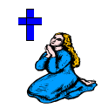and note what they represent.

MC900281285[1]MC900047962[1]

# _____ # _____ # _____ # _____

REPRESENTS:___________ ___________ ____________ ___________

2. What is needed to send preachers to the nations? Discuss in the group some things

missionaries need and note them here.

3. Read Romans 15:7-18. How many times does Paul mention the *Gentiles, peoples,* or

*nations?* Paul uses the word εθνη (*ethne,* ethnic group) but it’s translated *Gentiles*,

*peoples* or *nations* in our Bibles. Substitute *ethnic groups* for *Gentiles* in this passage and feel the difference. Paul’s mission was to reach the ethnic groups of the world.

a) 5 c) 8

b) 7 d) 10

4. How had the church in Philippi been involved in missions? Read Philippians 4:13-20.

a) they were persecuted with Paul c) they sent perfumes to Paul

b) they helped Paul economically d) they accompanied Paul on his trips

5.

The Bible tells the story of a missionary God and his strategy to take the gospel of salvation to all.

Compare Matthew 24:14 with Revelation 5:9. Note how the prophecy is fulfilled.

Now read Rev. 7:9-12. Who are present in heaven, worshiping the Lamb (Jesus) and God?

A GREAT ______________ THAT NO ONE COULD COUNT,

FROM EVERY _____________,

_____________,

______________, AND _________________.

6. In Genesis 3:24, as a consequence of Adam and Eve’s sin, God obstructed the way

to the tree of life. This tree isn’t mentioned again in the whole Bible until Rev. 22:2.

MC900391406[1] In heaven, who will have access to the tree of life?

a) Adam and Eve c) the 144,000 of the 12 tribes of Israel

b) a lamb d) the nations

7.

*For God so loved the* ***world*** *that he gave his one and only Son, that whoever believes in him shall not perish but have eternal*

*life. (John 3:16, NIV)*

But how will they believe if they haven’t heard? And how can they hear without someone

preaching to them? And how will they preach if they aren’t sent? There are 7,000

ethnic groups in the world that haven’t heard. Will you go for them? Will you give your

offerings to send others for them? Will you pray for them?

Find out and note here what missionaries your church supports and where they serve.

Pray for them.

MISSIONARY COUNTRY OR ETHNIC GROUP SERVED

*

*

*

8. Each line contains two words that have something in common and are found in this study.

Add vowels and separate the words.

HRBLV __ __ __ __ __ __ __ __ __ __ __

PRCHSND __ __ __ __ __ __ __ __ __ __

NTNTNG __ __ __ __ __ __ __ __ __ __ __ __

GNTLSTHNCGRP __ __ __ __ __ __ __ __

__ __ __ __ __ __ __ __ __ __ __

PRYGV __ __ __ __ __ __ __ __

***WORLD NEEDS I***

1. Read Matthew 24:3-28. Jesus is teaching his disciples about his return. This passage

refers in part to the destruction of Jerusalem (which occurred in 70 A.D.) and in part

to his return. Of all these signs, which one hasn’t been fulfilled?

a) wars, earthquakes, famines c) false prophets who deceive

b) the gospel preached in the whole world d) increase of wickedness

2. In *evangelism* the believer must face social barriers to share the gospel. What are

some of the difficulties you have in sharing Christ with your friends, neighbors, and

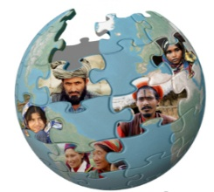family?

_____________________________________________

_____________________________________________

3. In *cross-cultural missions*, besides the social barriers, one must also cross linguistic and

cultural barriers. Mark with an **E** the **evangelism** activities and with an **M** the **cross-**

**cultural missions** activities.

___ find supporters ___ learn another language ___ appreciate another culture

___ share with friends ___ leave your family ___ youth group

___ visitation ___ Christian concerts ___ eat new things

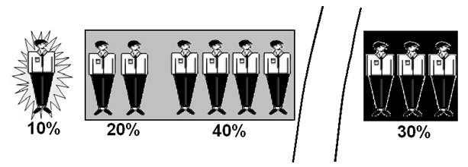

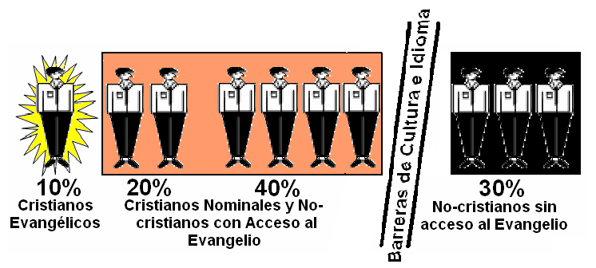4. The world situation is currently represented like this:

**Non-Christians without**

**Access to the Gospel**

**Nominal Christians and Non-Christians**

**with Access to the Gospel**

**Evangelical**

**Christians**

An evangelical Christian…

* trusts only in the cross of Jesus Christ for salvation,
* enjoys a personal relationship with God through Jesus,
* exhibits regeneration through the Holy Spirit,
* recognizes the Bible as the inspired word of God, the only basis for faith and practice, and
* is committed to biblical preaching, evangelism, and service.

Nominal Christians are people who name Jesus Christ in their religion, but do not exhibit the characteristics mentioned on the left.

Which group are you in?

10% 20% 30% 40%

5. Which of these groups need to be *evangelized*? 10% 20% 30% 40%

Which of these groups need *cross-cultural missions*? 10% 20% 30% 40%

6. Remember that a reached ethnic group is one that has a viable church, able to

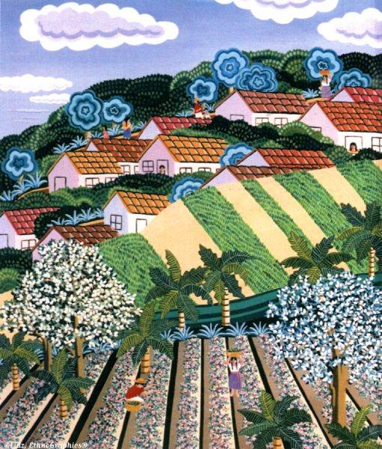evangelize its own ethnic group without outside help.

*I walked through a town in the mountains of Puebla.*

*Everyone there spoke Spanish, but there was not a*

*single Christian church in the town.*

Do these people belong to a reached or an unreached

ethnic group?

__________________________

Why?

____________________________________________

How many words can you make using only the letters in

**UNREACHED**?

SCORING:

1 point for each 3-letter word

2 points for each 4-letter word

3 points for each 5-letter word

5 points for each word of 6 or more letters

Example:

arc = 1

head = 2

crane = 3

***WORLD NEEDS II***

1. We’ve seen that 10% of the world is Christian and that 30% live in unreached ethnic

groups. Then if each believer shared Christ with 3 people we’d finish the Great

Commission in a matter of hours!

Write the names of 3 people in unreached ethnic groups with whom you will share the

gospel this week.

___________________ _____________________ ________________

2. What keeps you from evangelizing these 3 people? The first barrier is ECONOMIC.

Most of the unreached ethnic groups live in the **10/40 Window**. The 10/40 Window is the region between the Atlantic and Pacific Oceans, from 10° to 40° north. The 10/40 Window has:

* 60% of the world’s population
* the majority of the least evangelized countries
* three great religions – Islam, Hinduism, and Buddhism
* 80% of the poorest people in the world.

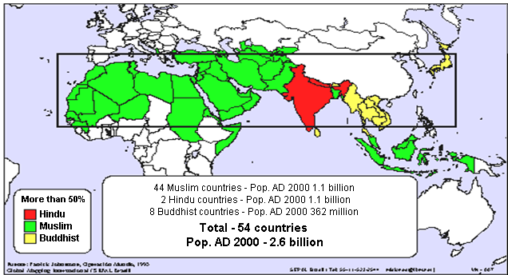

Calculate the cost of a round-trip ticket to Morrocco, the closest destination from Mexico, assuming it costs US$3,200 at 11 Mexican pesos per dollar.

3,200

x 11

Mexican pesos

3. In many countries foreigners are not allowed to work for wages. You will need to raise

your support before you go. You will have to rent an apartment, furnish it, buy your

food, pay for daily transportation, medical costs, etc. Let’s suppose you need US$2,000

a month (plus plane fare). Where will you get it?

Note 4 places you could look for support.

________________ ________________ _________________ ______________

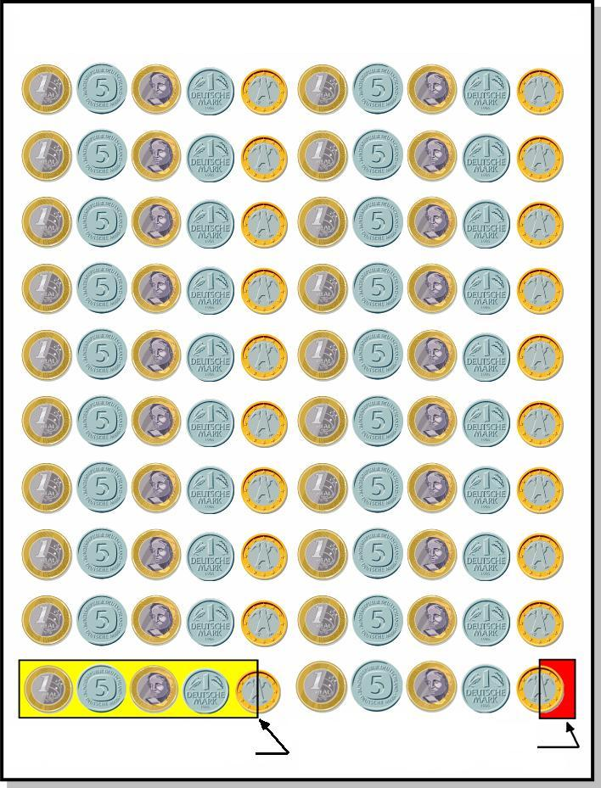4.

How the Evangelical Church Spends its Offerings

Ask your pastor what percentage of your

church’s offerings are designated to reach

the unreached ethnic groups of the world.

A. Average monthly offerings:

$_________

B. Offerings for missions to unreached ethnic

groups:

$_________

C. Percent of offerings for the unreached:

B/A = _________ x 100 = ______%

How does your church compare with this graph?

0.5% for missions among

the unreached

4.5% for missions among

the reached

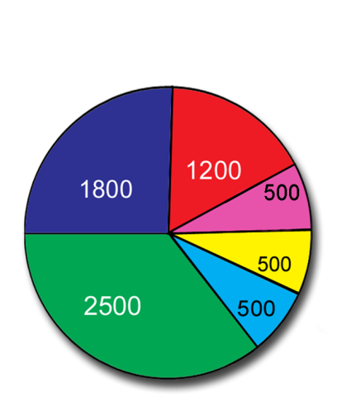5. Another barrier is the CULTURAL and RELIGIOUS barrier.

In general, the tribes

practice **animism**,

believing in many spirits

in nature that need to

be appeased.

This graph shows the

Hindus

Tribals

**The Principal**

**Religions of**

**the Unreached**

**Ethnic Groups**

number of unreached

ethnic groups in the

Buddhists

Chinese

major religious blocks.

Others

Muslims

The **Hindus** believe in thousands of gods and in a social caste system. Buddha left Hinduism upon seeing the abuses and established a philosophy of illumination and self-control through discipline and meditation, which is **Buddhism**. The Muslims practice **Islam**, a rigid system to win the forgiveness of their demanding god, Allah.

Read Acts 4:10-12. Which of these religions can save?

a) Animism c) Buddhism e) all, because all paths lead to God

b) Hinduism d) Islam f) none of the above

6. The LINGUISTIC barrier also causes difficulties in preaching to all the nations.

**The Languages of the World**

**Languages according to Wycliffe – 6,918**

**Languages with some portion of the Bible translated – 2,932**

* **Whole Bible – 554**
* **New Testament only – 1333**
* **At least one book – 1045**

**Translation projects in process - 2267 Languages needing translation - 1800**

For example, Zapotec is a **language** (the words, pronunciation, and combinations are used and understood by a large community). But Zapotec also has 53 **dialects** (regional variations).

In Mexico there are 295 dialects within 53

languages. How many do you know?

____________

What are some things that make fulfilling the Great Commission difficult? Note

general barriers as well as personal barriers.

__________________ ___________________

___________________ ____________________

____________________ _______________________

**UNSCRAMBLE THESE WORDS.**

**THEN UNSCRAMBLE THE LETTERS IN RED TO FIND THE ANSWER.**

TEROPOS __ __ __ __ __ __ __

STALE DEGALVENEIZ __ __ __ __ __

__ __ __ __ __ __ __ __ __ __ __

SOTM DOTPPULAE __ __ __ __ __ __ __ __ __ __ __ __ __

SOTM MUMSLIS __ __ __ __ __ __ __ __ __ __ __

SOTM NIDESHU __ __ __ __ __ __ __ __ __ __ __

SOTM SBITDUDHS __ __ __ __ __ __ __ __ __ __ __ __ __

__ __ __ F__ __ __ Y W__ N __ __ W

***YOUR PART IN THE GREAT COMMISSION***

MC900097247[1]

1. It seems like an insurmountable task. However, there are things

**you** can be doing **now** to fulfill Jesus’ command.

What is first?

_________________________

2. Read Matthew 9:36-38. In this passage, what does Jesus tell us to pray for?

a) the conversion of our friends c) a good harvest

b) more missionaries d) that the sheep don’t get lost

**Careful!** Sometimes God uses US as an answer to our prayers!

3. We can also pray for missionaries who are already on the field. Read Ephesians 6:18-20.

What did Paul, the missionary, request?

a) courage to preach c) to be in the Spirit

b) to be freed from prison d) perseverance

4. Among other things, we can also pray for:

* the missionary’s relationship with God (Matthew 22:37)
* the missionary’s testimony (Hebrews 13:18)
* a clear vision for ministry (Acts 16:9,10)

Look up the following passages and note 3 more things we should pray for missionaries.

2 Thessalonians 3:1,2 _____________________________________________

Philippians 4:15 __________________________________________________

2 Timothy 4:2 ___________________________________________________

MC900230638[1]

5. How can you support missions if you barely have enough for your

own expenses? Calculate how much you spend each week on

junk foods, etc. (chips, candy, sodas, coffee).

$ ______________ x 4 =

Multiply by 4 (weeks/month) $ ____________ x 12 = $ ____________

Now multiply this by 12 (months/year).

If you just gave up the extra expenses for *one week a month*, how much could you save

for missions in a year?

$ _____________ x 12 = $ _____________

MC900331636[1] 6. **You don’t need to hear a voice telling you to “GO!”**

**when you already have a verse telling you to.** (Mark 16:15)

Write the verse here: ________________________________________

______________________________________________________________

WHAT WILL YOU DO?

CROSSWORD PUZZLE

ACROSS DOWN

1. The first thing needed for cross-cultural missions 1. A great missionary in the New Testament

2. There are about 7,000 of these in the world 2. First word of the Great Commission

3. Jesus’ mandate to go and preach 3. Religion tribal people practice

4. There are 295 of these in Mexico 4. “Missions” translation of εθνη

5. Money donated to missions 5. The neediest people live in the 10/40 __

6. Religion which worships Allah 6. Structure associated with languages

7. % non-Christians with gospel access 7. Religion which split from Hinduism

8. Jewish festival associated with tongues 8. One barrier to missions



***CONTEST***

***MC900065210[1]***

This game serves as a final review. Using a deck of cards, the players take turns taking one card each. They should answer the question which corresponds to the card taken. For example, if someone chooses the 10 of clubs, he or she should answer the question: *Name a missionary your church supports*. You can keep track of the number of correctly answered questions and give a prize to the winner. This can also be played in teams. It should be played until all the cards have been drawn.

HEARTS

Ace. What is the Great Commission?

2. Who gave the Great Commission?

3. Where is the Great Commission found in the Bible?

4. What promise accompanies the Great Commission?

5. What was the purpose of the tongues given to the disciples by the Holy Spirit on Pentecost?

6. How is the Greek word *ethne* (εθνη) translated in the Bible?

7. What is an ethnic group?

8. What is the difference between a nation and a country?

9. Name 3 ethnic groups.

10. What is a reached ethnic group?

Jack. How many unreached ethnic groups are there in the world?

Queen. Where did languages originate?

King. What responsibility did God give Abram?

DIAMONDS

Ace. What was the name of the ethnic group God chose to bless all the nations?

2. Name a miracle God did in the Old Testament to demonstrate his power to the non-Jewish nations.

3. Who fled because he didn’t want to be a missionary? (Old Testament)

4. What was the name of the king of Babylon?

5. Who learned about Jehovah by listening to Solomon’s wisdom?

6. What city did Jonah preach in?

7. Who are the Gentiles?

8. What (Who) did Jesus send us so we would have the power to evangelize?

9. In Acts 1:8, where did Jesus send his disciples to preach? Name 2.

10. Who received the Gentiles after a vision of many animals?

Jack. What did the Gentiles receive upon believing in Jesus (just as the Jews did at Pentecost)?

Queen. Name one non-Jew who Jesus healed.

King. Who is the most famous missionary in the New Testament?

CLUBS

Ace. Why did the Christians (but not the apostles) leave Jerusalem?

2. What was Paul’s name originally?

3. In which 2 books of the Bible is the tree of life mentioned?

4. What is the difference between evangelism and cross-cultural missions?

5. What percentage of the world’s population has no access to the gospel?

6. What is the 10/40 Window?

7. Where do the majority of the unreached ethnic groups live?

8. What religion is practiced in India?

9. Name one barrier to cross-cultural missions.

10. Name a missionary your church supports.

Jack. What religion is practiced by the Muslims?

Queen. How many languages are there in the world?

King. Name one thing a missionary needs before leaving for the field.

SPADES

Ace. What is the first thing you can do to fulfill the Great Commission?

2. Name one thing missionaries need prayer for.

3. How can you support missions with your offerings if you don’t have much money?

4. What is the first word of the Great Commission?

5. Where do missionaries get their support?

6. Why does Jesus tell us to ask for more workers?

7. What does Jesus mean by the harvest field?

8. Name a chorus or hymn that talks about cross-cultural missions.

9. How many languages are spoken in Mexico?

10. Name one thing you can do to promote a cross-cultural missions vision in your church.

Jack. Give your testimony in 1 minute.

Queen. Why do some missionaries need to change their names?

King. What is a closed country?

***ANSWER KEY***

***THE GREAT COMMISSION WORD FIND***

|  |  |  |  |  |  |  |  |  |  |  |  |
| --- | --- | --- | --- | --- | --- | --- | --- | --- | --- | --- | --- |
|  |  |  |  |  |  |  |  |  | A |  |  |
| C | H | A | M | P | A |  |  | N | T |  |  |
|  |  | S |  |  |  |  | A |  | E |  |  |
| E | R | S | U | M | H | R |  |  | N |  |  |
|  |  |  |  | G | A | K |  |  | I |  |  |
|  |  | J |  | K | N | A |  |  | A |  |  |
|  |  | A | A |  | N | I | U | O | D | E | B |
| E |  | T |  |  |  | K |  |  |  |  | U |
| L | N |  |  |  |  | E |  | I |  |  | G |
| A | R | O | C |  |  |  | M |  |  |  | I |
| H |  |  |  |  |  | I | W | A | R | E | S |
| G |  |  |  | A | M | A | S |  |  |  |  |

1. Go, make, all nations

2.

3. Countries: Mexico, India, Afghanistan, Mali

Ethnic groups: Kurds, Nahuatl, Berber, Mixtec, Bedouin

4. c

5. pray, give, go, promote cross-cultural missions, etc.

***PENTECOST AND THE GREAT COMMISSION***

1. Go, make disciples, all nations

2. MARK 16:15-18

COMMAND: Go into all the world and preach the good news to all creation

PROMISE: And these signs will accompany those who believe…

LUKE 24:44-49

COMMAND: Repentance and forgiveness of sins will be preached in his name to all nations

PROMISE: I am going to send you what my Father has promised

JOHN 20:21-22

COMMAND: As the Father has sent me, I am sending you.

PROMISE: He breathed on them and said, “Receive the Holy Spirit.”

ACTS 1:8

COMMAND: You will be my witnesses in Jerusalem, and in all Judea and Samaria, and to the ends of the earth.

PROMISE: You will receive power when the Holy Spirit comes on you

3. Violent wind, tongues of fire rested on them, spoke in other tongues

4. b

5. d

6. Hidden word: PENTECOST

1. POWER 6. DISCIPLES

2. ETHNIC GROUPS 7. FORGIVENESS

3. TONGUES 8. SAMARIA

4. WITNESSES 9. HOLY SPIRIT

5. EGYPT

***MISSIONS IN THE OLD TESTAMENT I***

1. Before – first drawing; after – second

2. d

3. c

4. the drawing in the middle

5. Gen. 22:18 – with Abraham, to bless all the nations on earth

Gen. 26:3,4 – with Isaac, to bless all the nations on earth

Gen. 28:14 – with Jacob, to bless all the peoples on earth

6. b

7. ALL THE NATIONS

8. that his ways may be known on earth, his salvation among all the nations

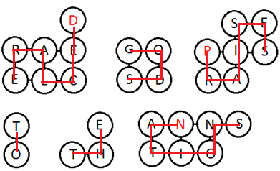9. THOSE WHO BELIEVE IN CHRIST JESUS

10.

DECLARE GOD’S PRAISES

TO THE NATIONS

***MISSIONS IN THE OLD TESTAMENT II***

1. d

2. 10

3. So that men of all nations would come to listen to him

4. the Queen of Sheba

5. Elijah; to Zarephath of Sidon; a widow; the flour and oil didn’t get used up, he resuscitated her son

Elisha; to Syria; Naaman; healed of leprosy

6. b

7. CROSSWORD PUZZLE

Across Down

1. NEBUCHADNEZZAR 1. NATIONS

2. DARIUS 2. DANIEL

3. ABEDNEGO 3. FURNACE

4. PEOPLES 4. DREAM

5. LANGUAGE

6. MOST HIGH

***MISSIONS IN THE NEW TESTAMENT I***

1. c

2. ALL PEOPLE; GENTILES

MC900434409[1]3.

4. Matthew 15:21/28--– the Canaanite woman; Luke 7:1-10 --- the Roman centurion; John 4 --- the Samaritan woman

5. d; the apostles

6. a

7. GOD ALSO GAVE THEM THE HOLY SPIRIT

|  |  |  |  |  |  |  |  |  |  |  |  |  |  |  |
| --- | --- | --- | --- | --- | --- | --- | --- | --- | --- | --- | --- | --- | --- | --- |
|  |  |  |  |  |  |  |  |  |  |  |  | D |  |  |
|  |  | S | U | S | E | J |  |  |  | A | E |  |  |  |
|  |  |  | B |  |  | E |  |  |  | Z |  |  |  |  |
|  |  |  | M |  | P | R |  | E | I | O | E |  |  |  |
|  |  |  | A | I |  | U |  | T |  | T | C |  |  |  |
|  | P |  | L |  |  | S | P | H |  | U | A |  |  |  |
|  | I | I |  |  |  | A |  | I |  | S | D |  |  |  |
|  | H | S |  |  | B | L | G | O | O | D | N | E | W | S |
| P | S |  | A |  |  | E |  | P |  |  | A |  |  |  |
|  | R |  |  | I |  | M |  | I |  |  | C |  |  |  |
|  | O |  |  | G | A | Z | A | A |  |  |  |  |  |  |
|  | W |  |  |  |  | H |  | N |  |  |  |  |  |  |

8. WORD FIND

Philip Gaza

Jerusalem Candace

Worship Good news

Isaiah Ethiopian

Baptized Jesus

Azotus Lamb

9. THE GENTILES

10. a

***MISSIONS IN THE NEW TESTAMENT II***

1. #4 – believe; #1 – send; #2 – preach; #3 – hear

2. economic support, theological studies, spiritual support (prayer), plane tickets, sending agency, etc.

3. d

4. b

5. MULTITUDE, NATION, TRIBE, PEOPLE, LANGUAGE

6. d

8. HEAR – BELIEVE

PREACH – SEND

NATION – TONGUE

GENTILES – ETHNIC GROUP

PRAY – GIVE

***WORLD NEEDS I***

1. b

2. fear of rejection, not knowing what to say, etc.

3. Evangelism: share with friends, youth group, visitation, Christian concerts

Cross-cultural missions: find supporters, learn another language, appreciate another culture, leave family, eat new things

5. Needs evangelizing: 20%, 40%; needs cross-cultural missions: 30%

6. Reached, because the ethnic group (Spanish-speakers in Mexico) is reached.

***WORLD NEEDS II***

1. It would be difficult to name 3 people from unreached ethnic groups.

2. $35,200

3. Your church, family, friends, other churches

4. Calculations will depend on the offerings of your church

5. f

6. economic, religious, cultural, linguistic, persecution, fear, etc.

UNSCRAMBLE

POOREST

LEAST EVANGELIZED

MOST POPULATED

MOST MUSLIMS

MOST HINDUES

MOST BUDDHISTS

TEN FORTY WINDOW

***YOUR PART IN THE GREAT COMMISSION***

1. Prayer

2.b

3. a

4. 2 Thes. 3:1,2 – for the message of the Lord to spread rapidly, deliverance from evil

Phil. 4:15 – economic support

2 Tim. 4:2 – be prepared to preach

5. (Mexican Christians spend an average of US$4.50/week per person on junk food.)

CROSSWORD PUZZLE:

Across Down

1. PRAYER 1. PAUL

2. LANGUAGES 2. GO

3. GREAT COMMISSION 3. ANIMISM

4. DIALECTS 4. ETHNIC GROUP

5. OFFERINGS 5. WINDOW

6. ISLAM 6. TOWER OF BABEL

7. THIRTY 7. BUDDHISM

8. PENTECOST 8. FUNDING

***CONTEST***

HEARTS

A. Go and make disciples of all nations 2. Jesus 3. Matthew, Mark, Luke, John, and Acts, in different forms 4. the Holy Spirit 5. to declare the wonders of God in their own languages 6. Gentiles, peoples, nations 7. a group of people with the same language, culture, and religion 8. A nation is an ethnic group; a country is a political/geographical unit. 9. Berber, Kurds, Bedouin, among others 10. one with a viable church which no longer depends on the help of cross-cultural missionaries

J. about 7,000 Q. at the Tower of Babel K. to bless the nations

DIAMONDS

A. Jews/Hebrews 2. He parted the Red Sea (among many others) 3. Jonah 4. Nebuchadnezzar 5. the Queen of Sheba

6. Nineveh 7. non-Jews 8. the Holy Spirit 9. Jerusalem, Judea, Samaria, and to the ends of the earth 10. Peter J. the Holy Spirit Q. a leper (among others) K. Paul

CLUBS

A. they were persecuted 2. Saul 3. Genesis and Revelation 4. Evangelism requires crossing social barriers; cross-cultural missions requires also crossing economic, cultural, religious, and linguistic barriers. 5. 30% 6. An area between 10° and 40° north of the equator, between the Atlantic and Pacific Oceans 7. in the 10/40 Window 8. Hinduism 9. economic, cultural, religious, linguistic 10. J. Islam Q. about 7,000 K. economic support (among other things)

SPADES

A. Pray 2. courage to preach (among other things) 3. Sacrifice junk food for a week and give the money for missions. 4. Go

5. from churches, family members, friends 6. because the harvest is plentiful but the workers are few 7. people waiting to hear the gospel 8. Here Am I, for example 9. 53 10. Missions bulletin board, program inserts, missions prayer, missions conference, missions speaker, etc. J. Q. to protect their identities in closed countries K. one which doesn’t allow Christian missionaries